**Course Description**

Python is a general-purpose programming language that is becoming ever more popular for data science. Companies worldwide are using Python to harvest insights from their data and gain a competitive edge.

Unlike other Python tutorials, this course focuses on Python specifically for data science. In our Introduction to Python course, you’ll learn about powerful ways to store and manipulate data, and helpful data science tools to begin conducting your own analyses. Start DataCamp’s online Python curriculum now.

**1. Python Basics**

An introduction to the basic concepts of Python. Learn how to use Python interactively and by using a script. Create your first variables and acquaint yourself with Python's basic data types.

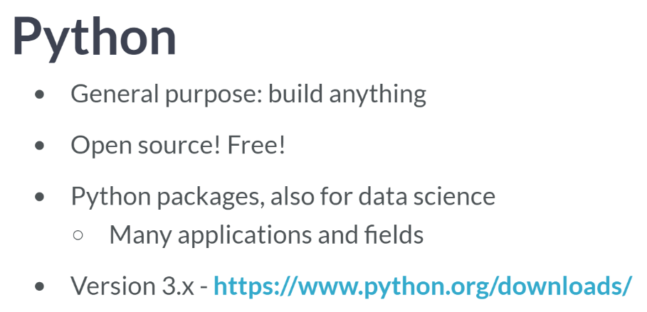  
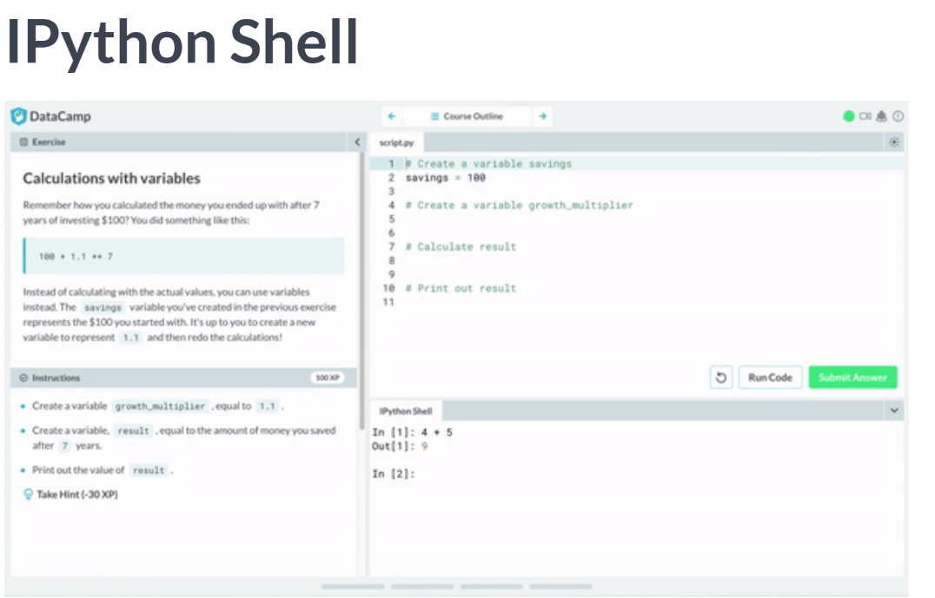  
The Python shell that's used here is actually not the original one; we are using IPython, short for Interactive Python, which is some kind of juiced up version of regular Python that will be useful later on. IPython was created by Fernando Perez and is part of the broader Jupyter ecosystem.

Apart from interactively working with Python, you can also have Python run so called python script.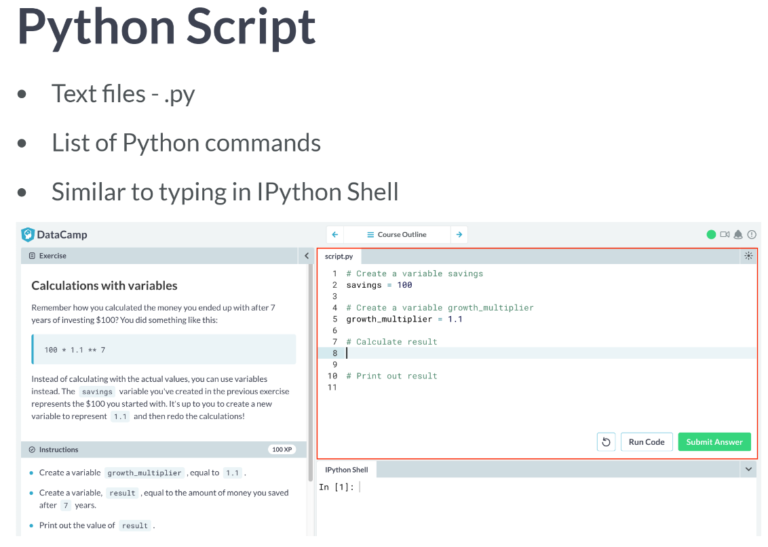  
These python scripts are simply text files with the extension *".py"*. It's basically a list of Python commands that are executed, almost as if you were typing the commands in the shell yourself, line by line.

Let's put command from before in a script now, that can be found here in DataCamp's interface. The next step is executing the script, by clicking the 'Submit Answer'.

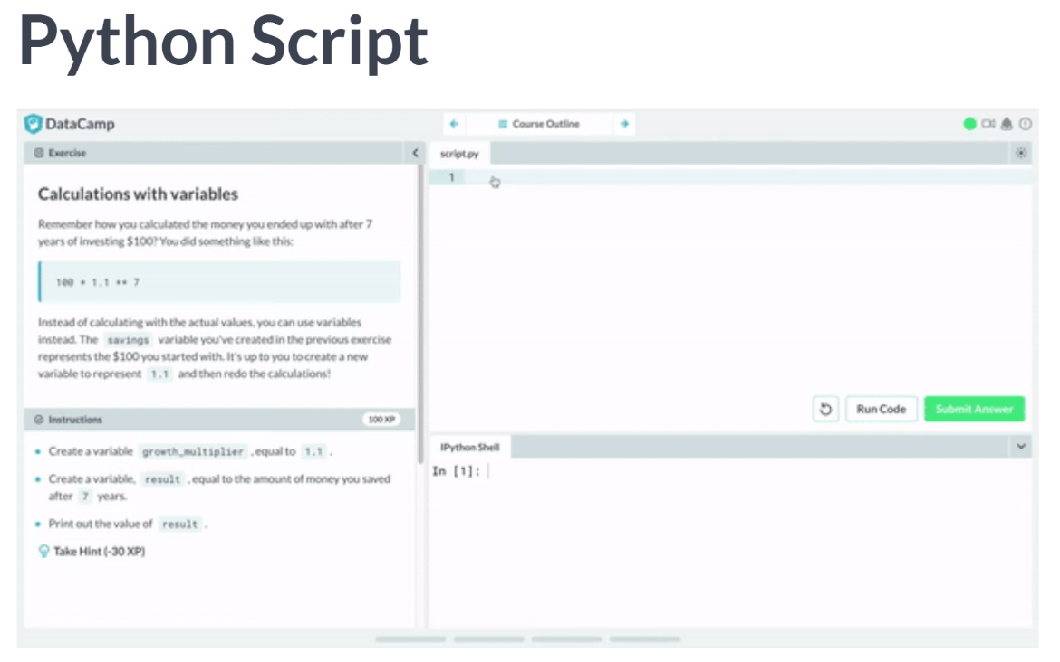  
If you execute this script in the DataCamp interface, there's nothing in the output pane. That's because you have to use *print()* inside scripts if you want to generate output during execution. Let's wrap our previous calculation in a print call and rerun the script.

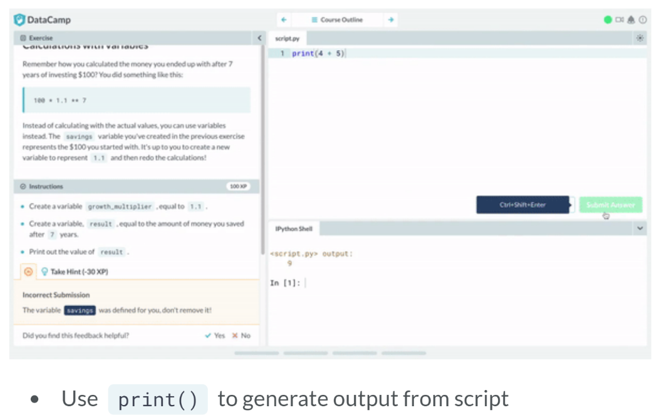  
This time, the same output as before is generated, great! Putting your code in Python scripts instead of manually retyping every step interactively will help you to keep structure and avoid retyping everything over and over again if you want to make a change; you simply make the change in the script and rerun the entire thing.

# The Python Interface

In the Python script on the right, you can type Python code to solve the exercises. If you hit Run Code or Submit Answer, your python script (script.py) is executed and the output is shown in the IPython Shell. Submit Answer checks whether your submission is correct and gives you feedback.

You can hit Run Code and Submit Answer as often as you want. If you're stuck, you can click Get Hint, and ultimately Get Solution.

You can also use the IPython Shell interactively by simply typing commands and hitting Enter. When you work in the shell directly, your code will not be checked for correctness so it is a great way to experiment.

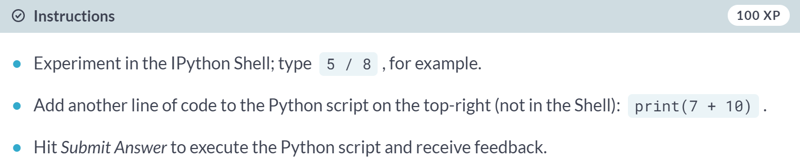

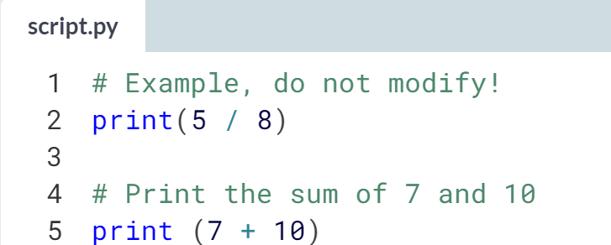

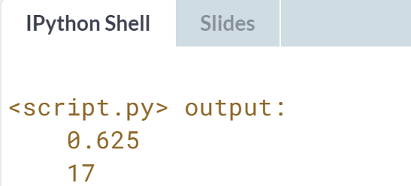

# When to use Python?

Python is a pretty versatile language. For which applications can you use Python?

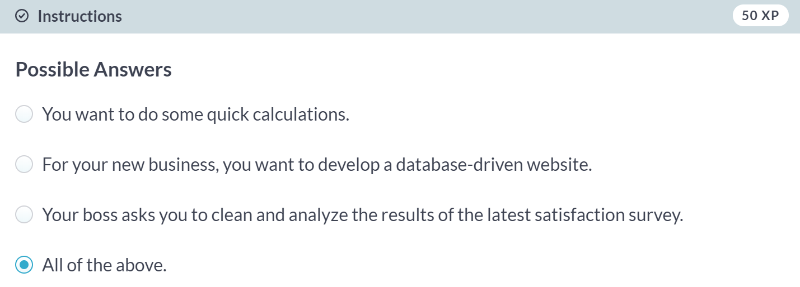  
Correct! Python is an extremely versatile language.

# Any comments?

Something that Hugo didn't mention in his videos is that you can add **comments** to your Python scripts. Comments are important to make sure that you and others can understand what your code is about.

To add comments to your Python script, you can use the # tag. These comments are not run as Python code, so they will not influence your result. As an example, take the comment on the right, # Division; it is completely ignored during execution.

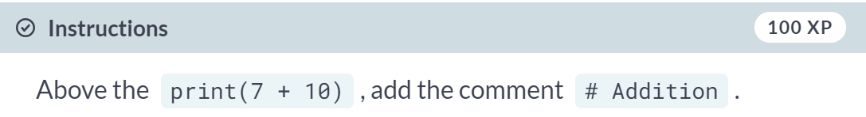  
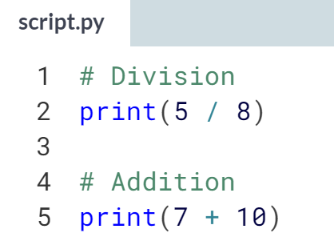 Great!

# Python as a calculator

Python is perfectly suited to do basic calculations. Apart from addition, subtraction, multiplication and division, there is also support for more advanced operations such as:

* Exponentiation: **. This operator raises the number to its left to the power of the number to its right. For example, 4**2 will give 16.
* Modulo: %. This operator returns the remainder of the division of the number to the left by the number on its right. For example, 18 % 7 equals 4.

The code in the script on the right gives some examples.

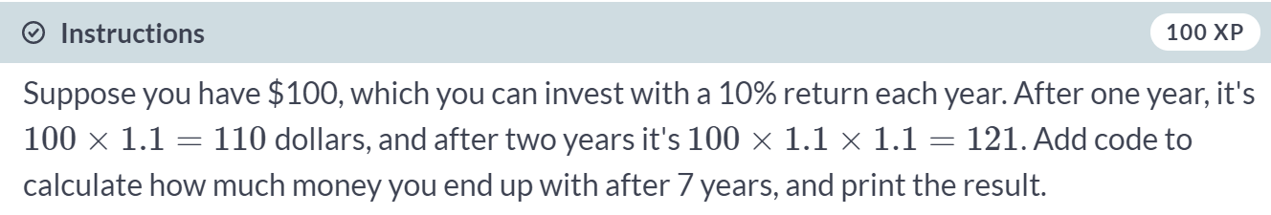  
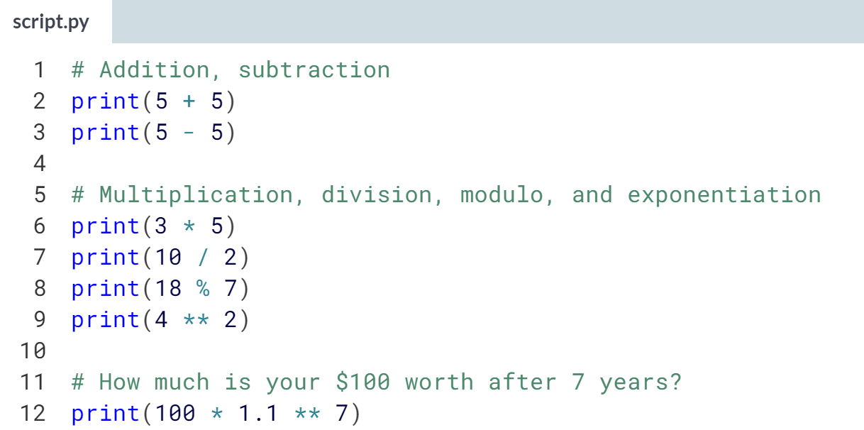  
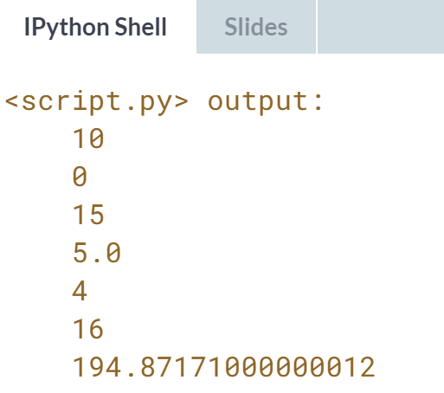



If you want to do some more complex calculation though, you will want to save values while you are coding along. You can do this by defining a variable, with a specific, case-sensitive name. Once you create (or declare) such a variable, you can later call up its value by typing the variable name.

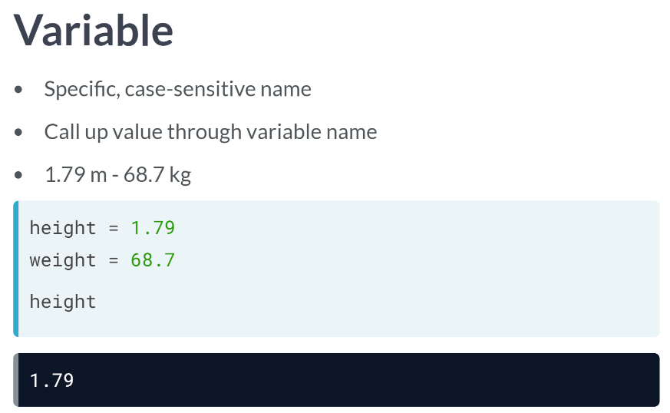  
Suppose you measure your height and weight, in metric units: you are 1.79 meters tall and weigh 68.9 kg. You can assign these values to two variables, named height and weight, with an equals sign: If you now type the name of the variable, height, Python looks for the variable name, retrieves its value, and prints it out.

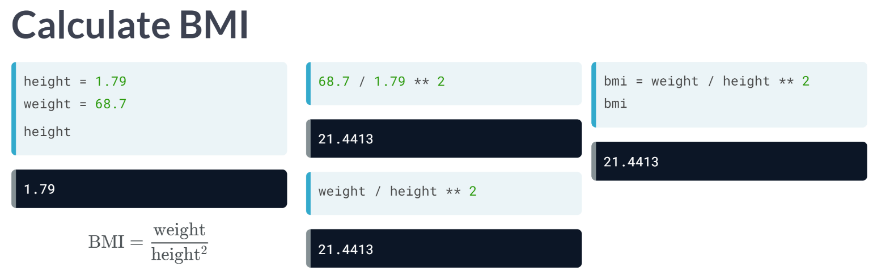

Let's now calculate the BMI, which is calculated as follows, with weight in *kg* and height in *m*. You can do this with the actual values, but you can just as well use the variable height and weight, like in here.

Every time you type the variable's name, you are asking Python to change it with the actual value of the variable: weight corresponds to 68.7, and height to 1.79.

Finally, Python stores the result in a new variable, *bmi*, which contains the same value as the one you calculated earlier. In Python, variables are used all the time.

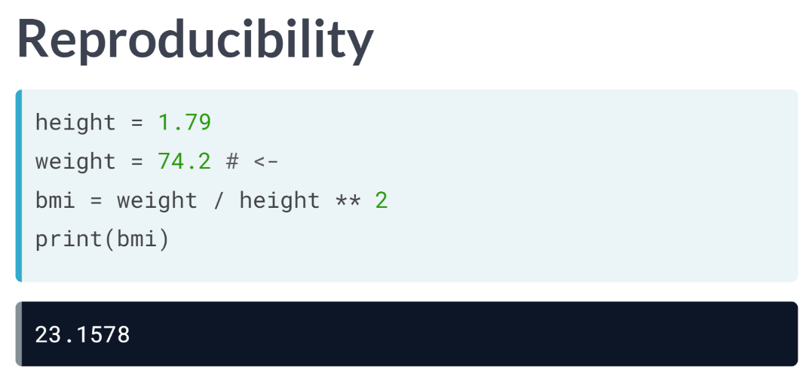

Suppose the code to create the height, weight, and bmi variable are in a script, like this.

If you want to calculate the bmi for another weight, simply change the declaration of the weight variable and rerun the script. It makes the result very reproducible.

So far, we've only worked with numerical values, such as height and weight.

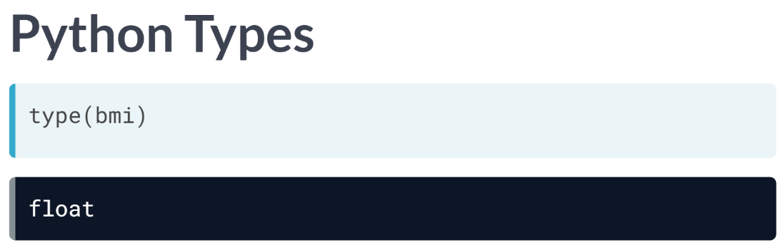  
In Python, these numbers all have a specific type. You can check out the value with the type function. To see the type of *bmi* value, simply write type and then bmi inside parentheses.

You can see that it's a float, which is Python’s way for representing a real number, so a number which can both have an integer part and a fractional part.

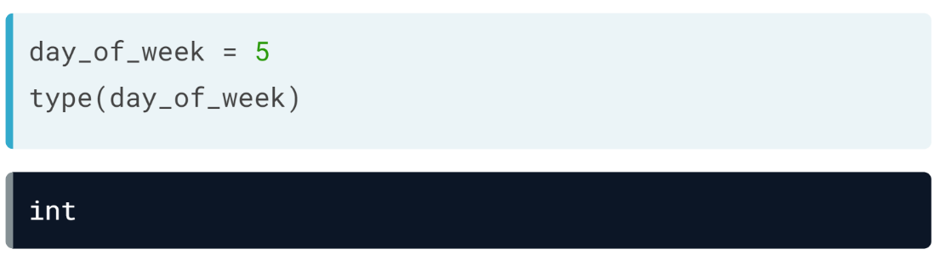  
Python also has *int* value, like this example above.

To do data science, you'll need more than *ints* and *floats*, though. Python features tons of other data types.

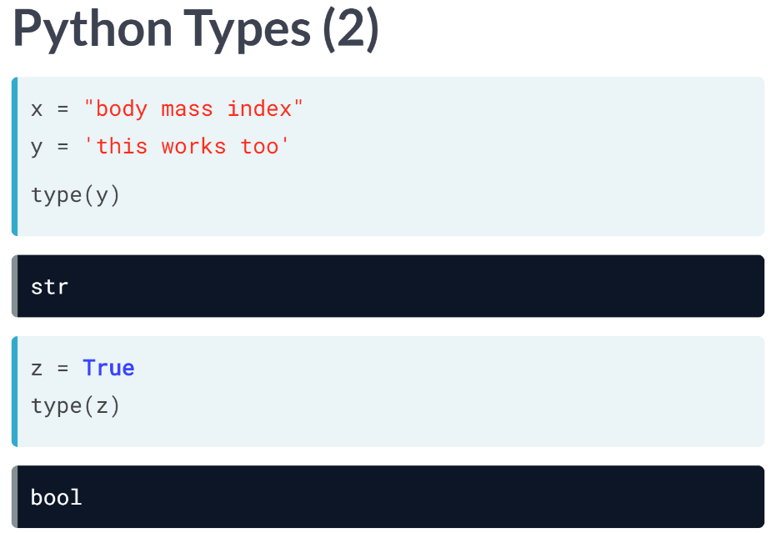  
The most common ones are strings and Booleans. A string is Python's way to represent text. We can use both double and single quotes to build a string, as you can see from these examples. If you print the type of the last variable here, you see that it's str, short for string.

The Boolean is a type that can be either TRUE or FALSE. You can think of it as 'Yes' and 'No' in everyday language. Booleans will be very useful in the future, to perform filtering operations on your data for example.

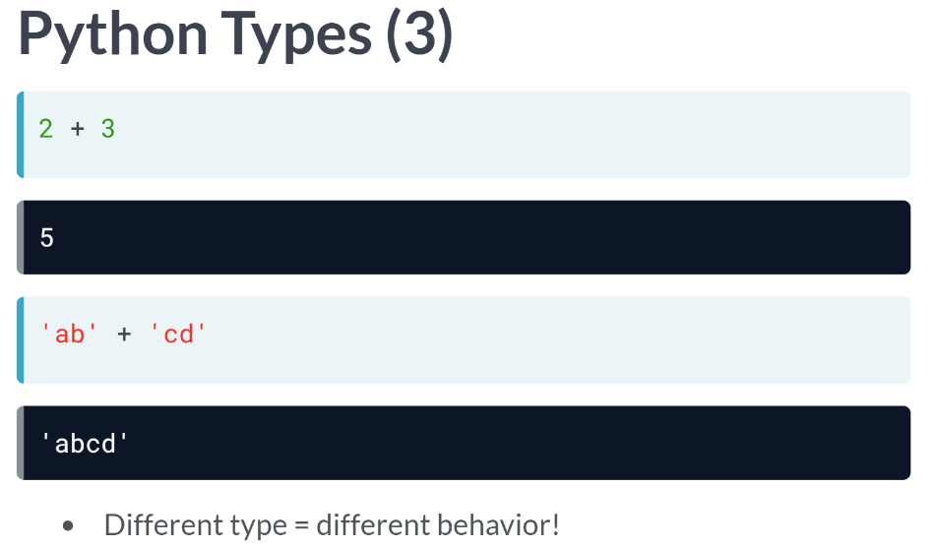  
There's something special about Python data types. Have a look at this line of code, that sums two integers and then this line of code, that sums two strings. For the integers, the values were summed, while for the strings, the strings were pasted together.

The plus operator behaved differently for different data types. This is a general principle: how the code behaves depends on the types you are working with.

# Variable Assignment

In Python, a variable allows you to refer to a value with a name. To create a variable use =, like this example:

x = 5

You can now use the name of this variable, x, instead of the actual value, 5.

Remember, = in Python means assignment, it doesn't test equality!

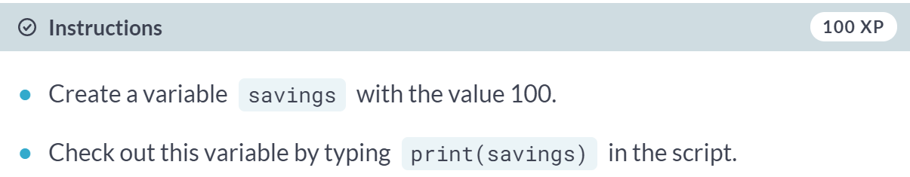

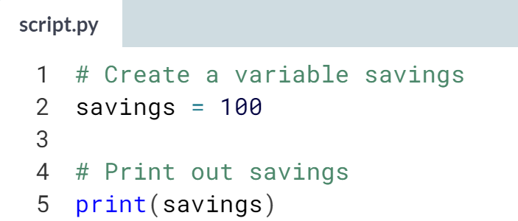

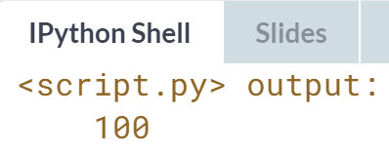  
Great! Let's try to do some calculations with this variable now!

# Calculations with variables

Remember how you calculated the money you ended up with after 7 years of investing $100? You did something like this:

100 * 1.1 ** 7

Instead of calculating with the actual values, you can use variables instead. The savings variable you've created in the previous exercise represents the $100 you started with. It's up to you to create a new variable to represent 1.1 and then redo the calculations!

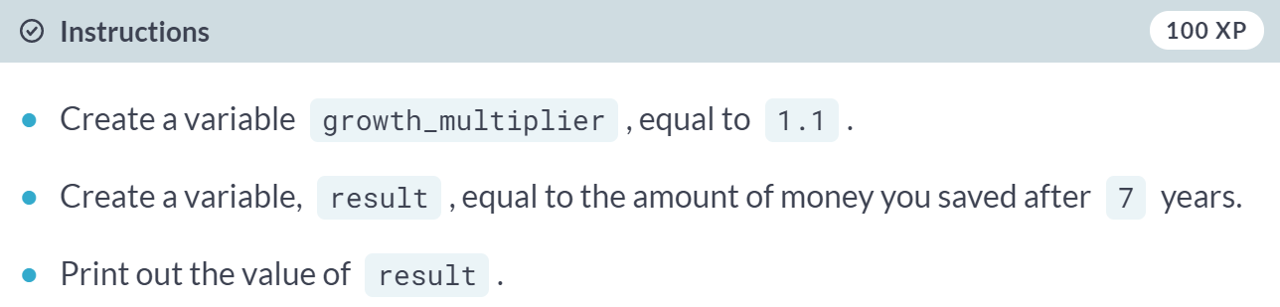

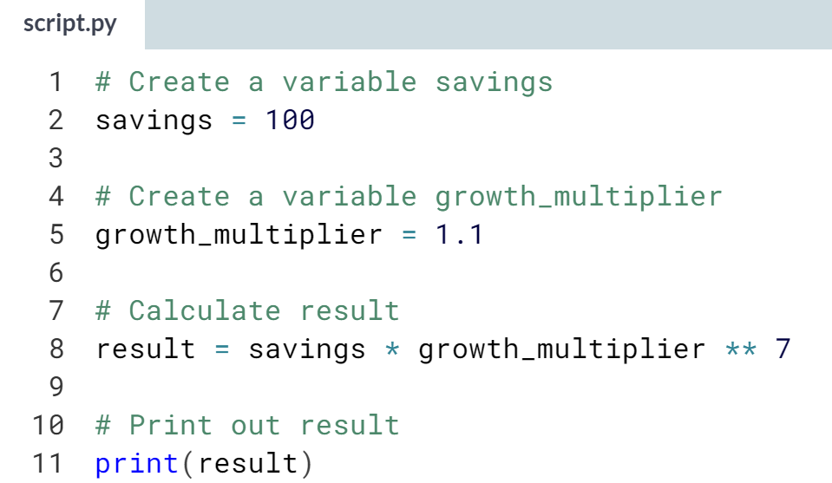  
  
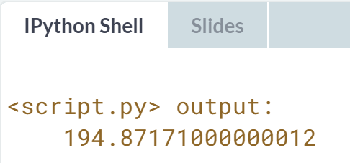

# Other variable types

In the previous exercise, you worked with two Python data types:

* int, or integer: a number without a fractional part. savings, with the value 100, is an example of an integer.
* float, or floating point: a number that has both an integer and fractional part, separated by a point. growth_multiplier, with the value 1.1, is an example of a float.

Next to numerical data types, there are two other very common data types:

* str, or string: a type to represent text. You can use single or double quotes to build a string.
* bool, or Boolean: a type to represent logical values. Can only be True or False (the capitalization is important!).

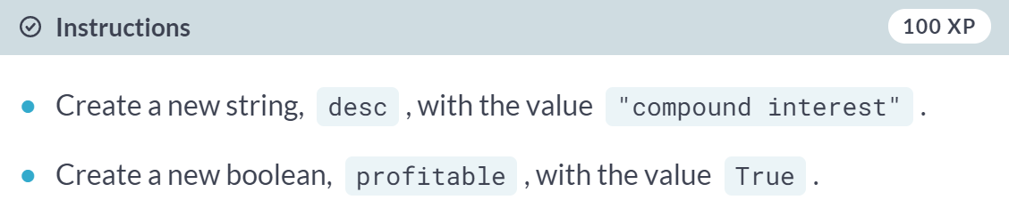  
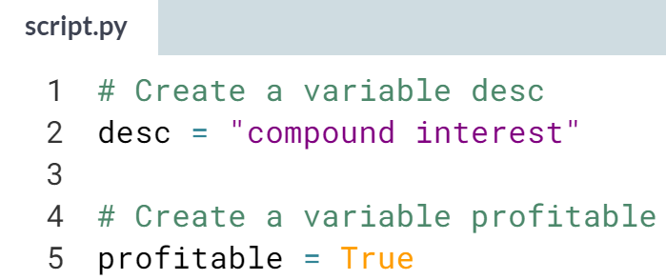Nice!

# Guess the type

To find out the type of a value or a variable that refers to that value, you can use the [**type()**](https://docs.python.org/3/library/functions.html#type) function. Suppose you've defined a variable a, but you forgot the type of this variable. To determine the type of a, simply execute:

type(a)

We already went ahead and created three variables: a, b and c. You can use the IPython shell on the right to discover their type. Which of the following options is correct?

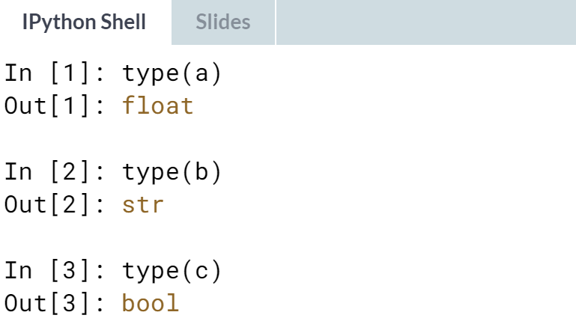

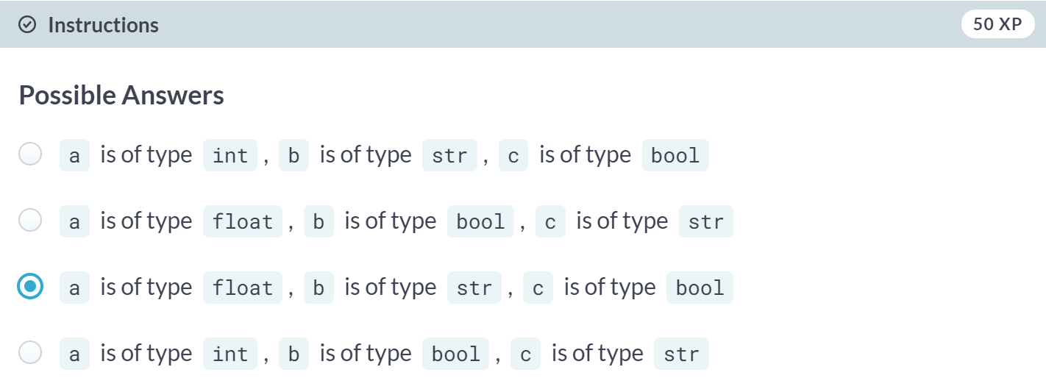

# Operations with other types

Hugo mentioned that different types behave differently in Python.

When you sum two strings, for example, you'll get different behavior than when you sum two integers or two Booleans.

In the script some variables with different types have already been created. It's up to you to use them.

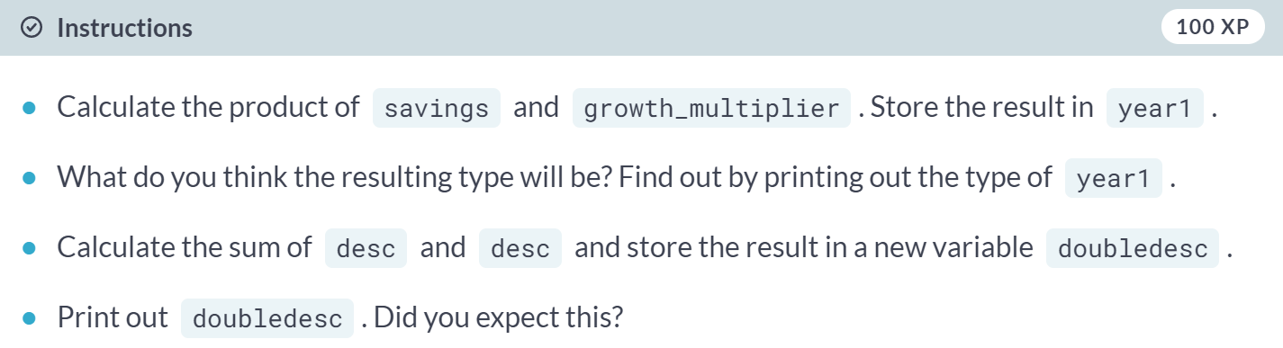

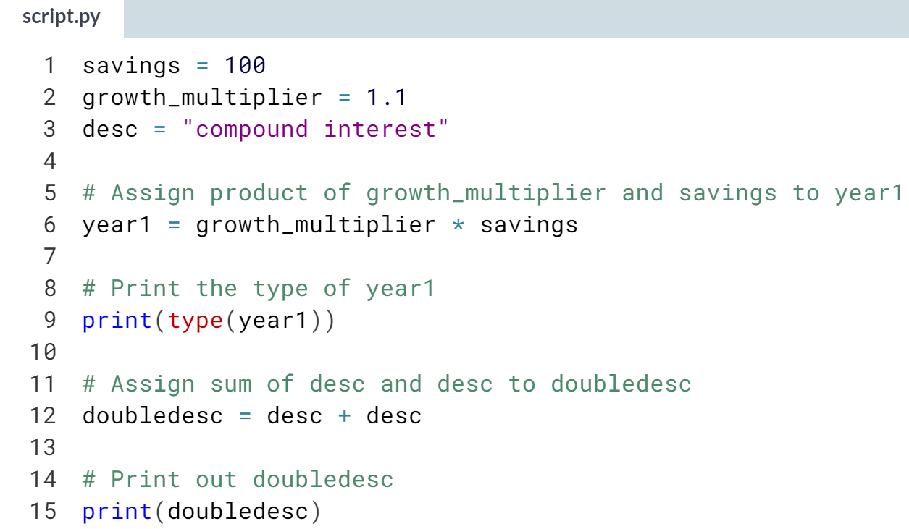  
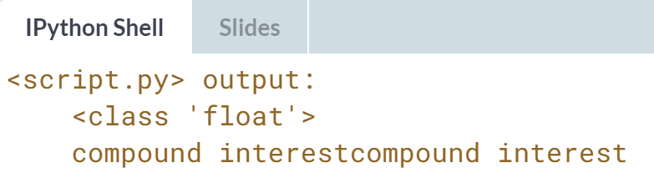  
Nice. Notice how *desc + desc* causes *"compound interest"* and *"compound interest"* to be pasted together.

# Type conversion

Using the + operator to paste together two strings can be very useful in building custom messages.

Suppose, for example, that you've calculated the return of your investment and want to summarize the results in a string. Assuming the integer savings and float result are defined, you can try something like this:

print("I started with $" + savings + " and now have $" + result + ". Awesome!")

This will not work, though, as you cannot simply sum strings and integers/floats.

To fix the error, you'll need to explicitly convert the types of your variables. More specifically, you'll need [**str()**](https://docs.python.org/3/library/functions.html#func-str), to convert a value into a string. str(savings), for example, will convert the integer savings to a string.

Similar functions such as [**int()**](https://docs.python.org/3/library/functions.html#int), [**float()**](https://docs.python.org/3/library/functions.html#float) and [**bool()**](https://docs.python.org/3/library/functions.html#bool) will help you convert Python values into any type.

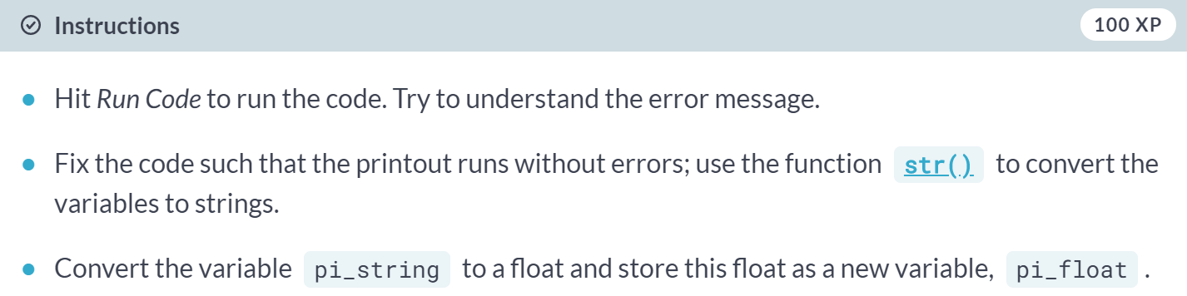

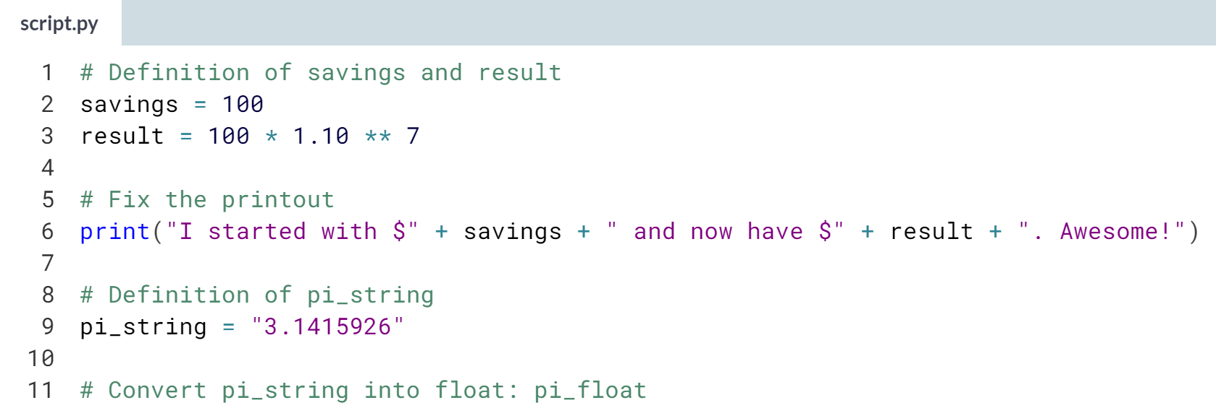  
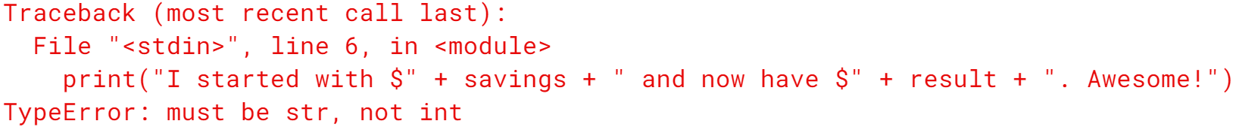

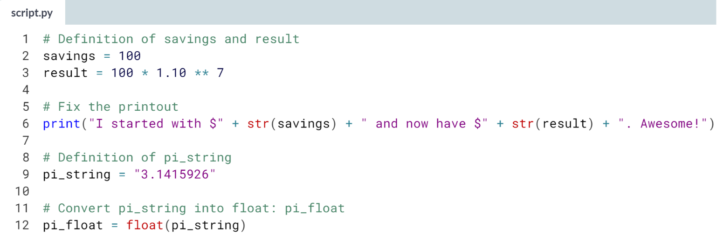

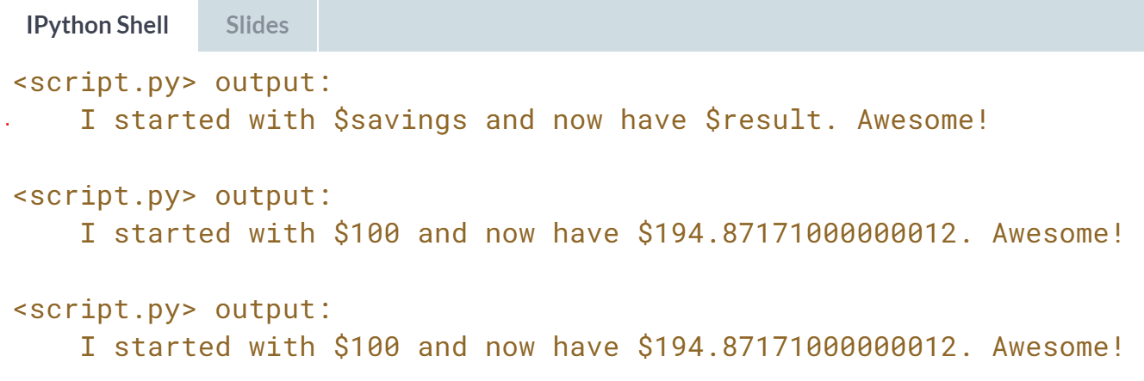  
Great! You have a profit of around $95; that's pretty awesome indeed!

# Can Python handle everything?

Now that you know something more about combining different sources of information, have a look at the four Python expressions below. Which one of these will throw an error? You can always copy and paste this code in the IPython Shell to find out!

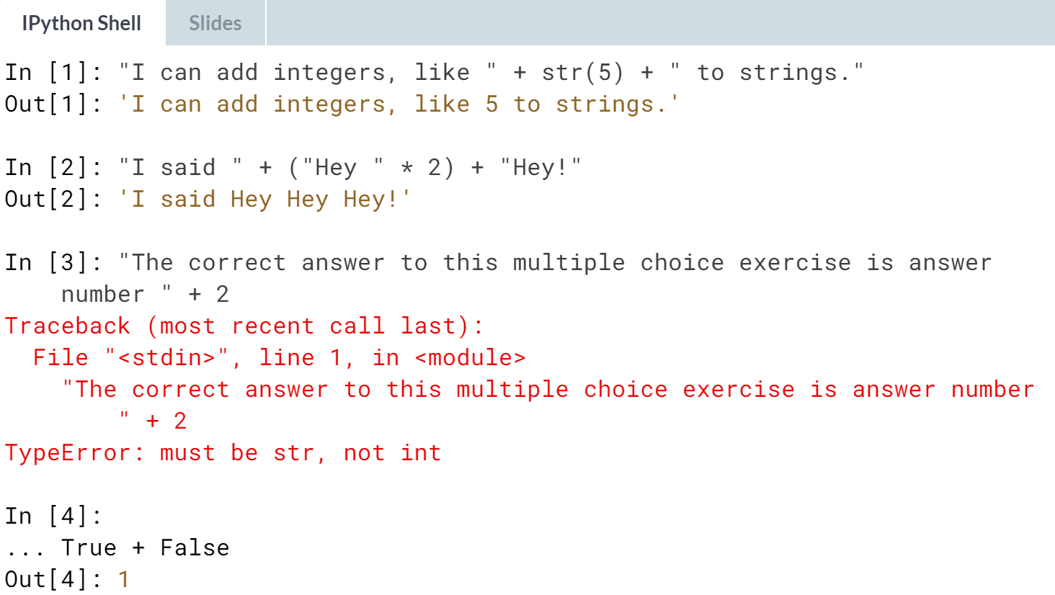

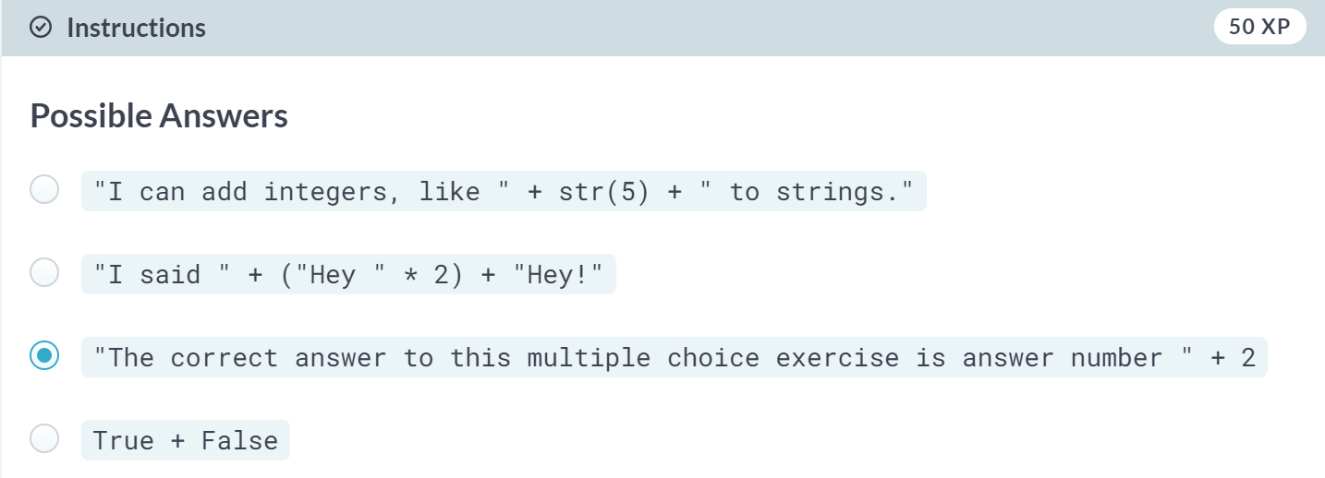  
Correct! Because you're not converting 2 to a string with ***str()***, this will give an error.

**2. Python Lists**

Learn to store, access, and manipulate data in lists: the first step toward efficiently working with huge amounts of data.

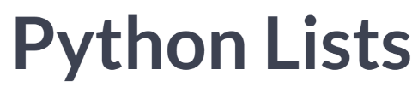

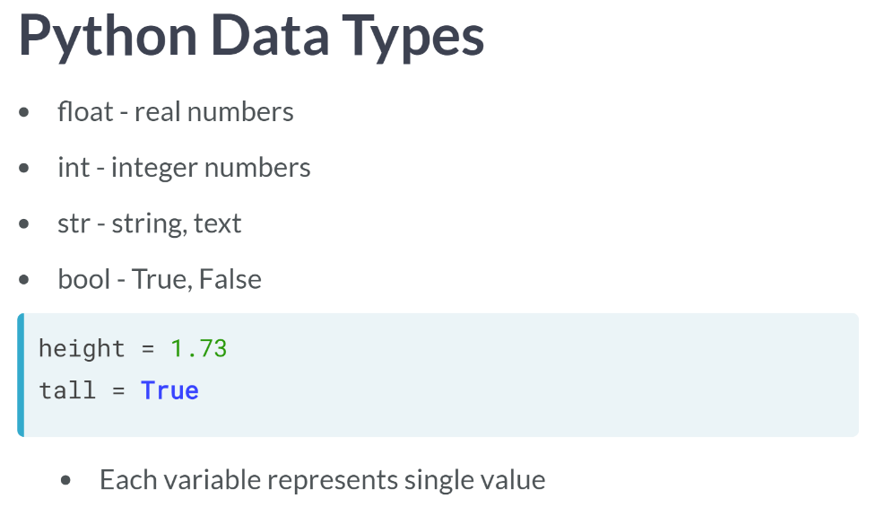  
On the number side, there's the float, to represent a real number, and the int, to represent an integer. Next, we also have str, short for string, to represent text in Python, and bool, which can be either TRUE or FALSE. You can save these values as a variable, like these examples show. Each variable then represents a single value.

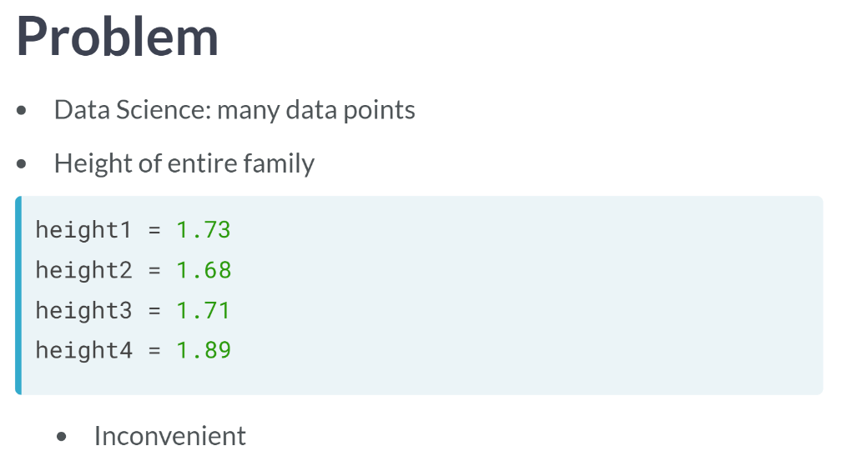  
  
As a data scientist, you'll often want to work with many data points. For example, if you want to measure the height of everybody in your family and store this information, it'd be inconvenient to create a new python variable for each point you collected, right?

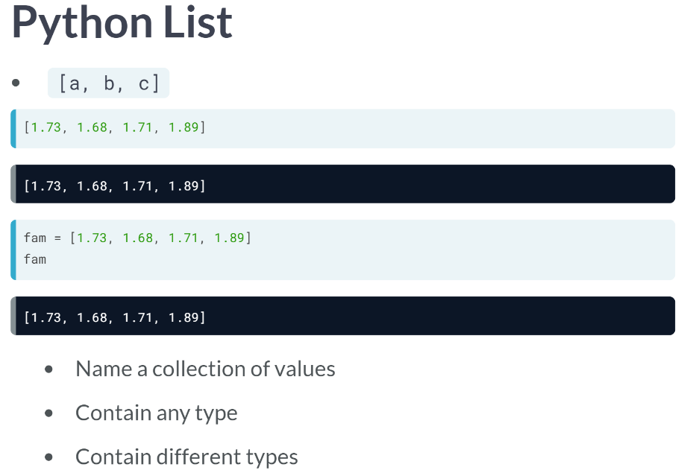  
What you can do instead, is store all this information in a Python list. You can build such a list with square brackets. Suppose you asked your two sisters and parents for their height, in meters. You can build a list like the above.

Also, this data structure can be referenced to with a variable. Simply put the variable name and the equal sign in front.

A list is a way to give a single name to a collection of values. These values or elements can have any type; they can be floats, integers, Booleans, strings, but also more advanced Python types, even lists.

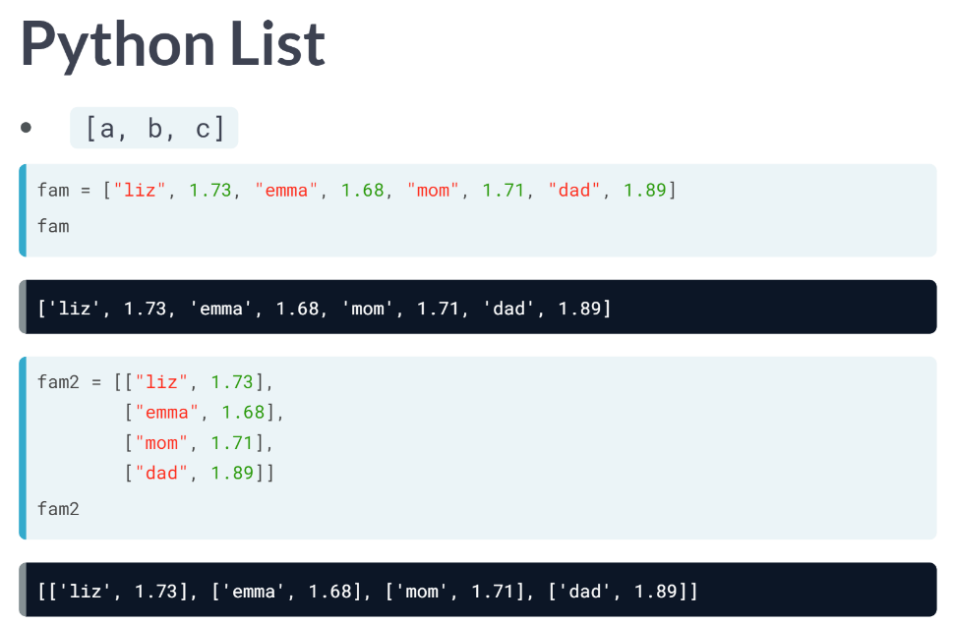  
It's perfectly possible for a list to contain different types as well. Suppose, for example, that you want to add the names of your sisters and parents to the list, so that you know which height belongs to who. You can throw in some strings without issues. But that's not all. Keep in mind that lists can also contain lists themselves.

Instead of putting the strings in between the numbers, you can create little sublists for each member of the family: One for Liz, one for Emma, and so on. Now, you can tell Python that these sublists are the elements of another list, that I named *fam2*: the little lists are wrapped in a square bracket and separated with commas. If you now print out fam2, you see that we have a list of lists. The main list contains four sub-lists.

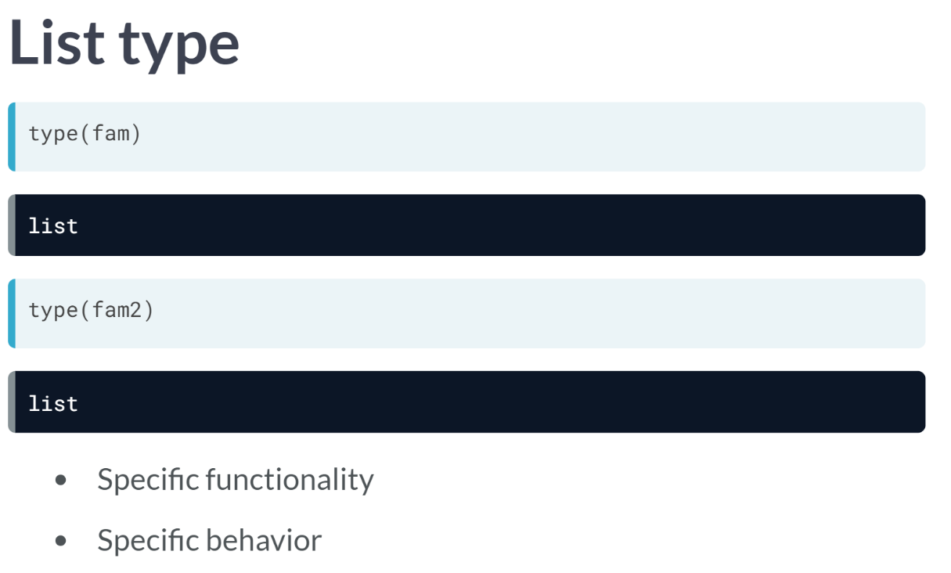  
These calls show that both *fam* and *fam2* are lists. Remember that each type has specific functionality and behavior associated? This is also true for list.

Python lists host a bunch of tools to subset and adapt them.

# Create a list

As opposed to int, bool etc., a list is a **compound data type**; you can group values together:

a = "is"

b = "nice"

my_list = ["my", "list", a, b]

After measuring the height of your family, you decide to collect some information on the house you're living in. The areas of the different parts of your house are stored in separate variables for now, as shown in the script.

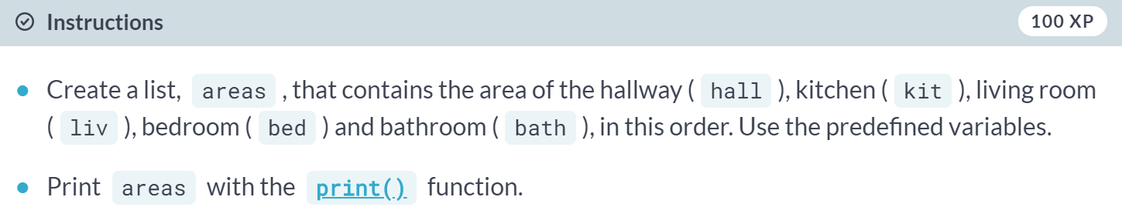

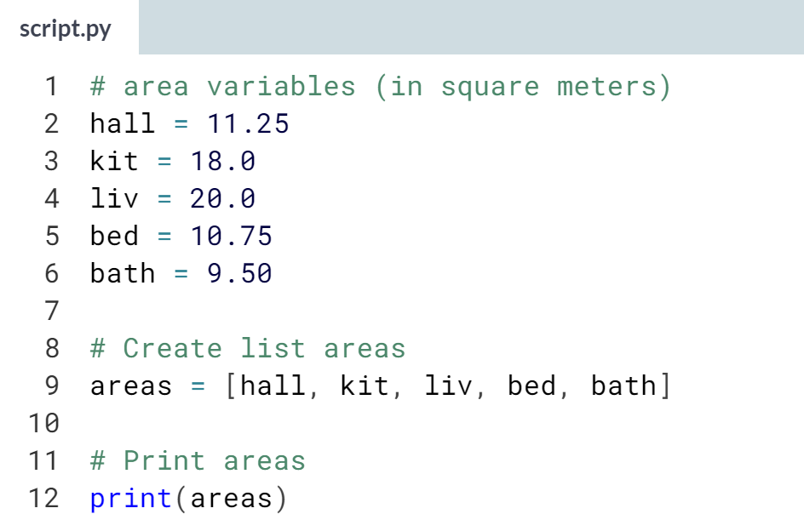

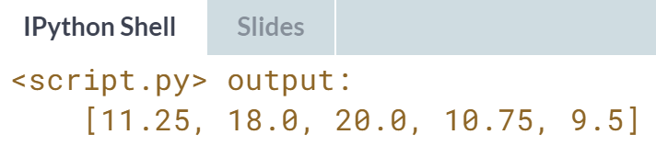  
Nice! A list is way better here, isn't it?

# Create list with different types

A list can contain any Python type. Although it's not really common, a list can also contain a mix of Python types including strings, floats, Booleans, etc.

The printout of the previous exercise wasn't really satisfying. It's just a list of numbers representing the areas, but you can't tell which area corresponds to which part of your house.

The code on the right is the start of a solution. For some of the areas, the name of the corresponding room is already placed in front. Pay attention here! "bathroom" is a string, while bath is a variable that represents the float 9.50 you specified earlier.

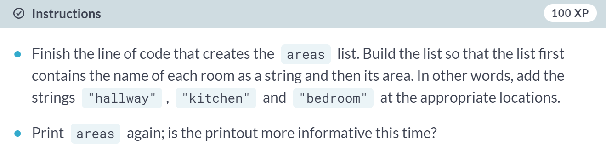

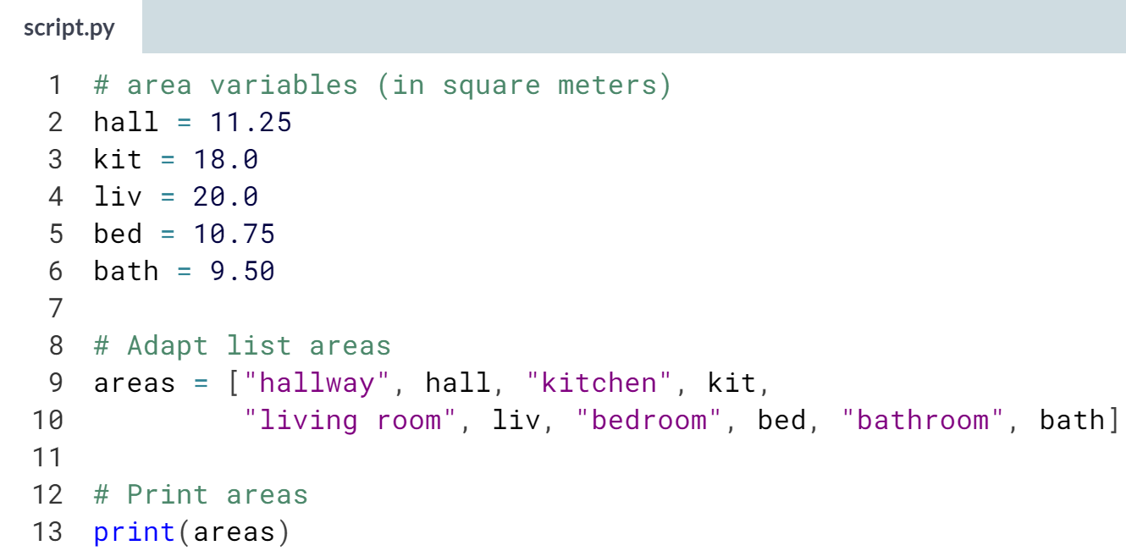

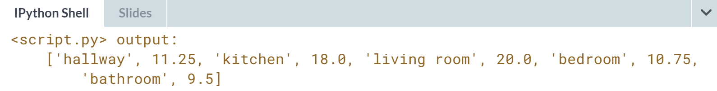  
Nice! This list contains both strings and floats, but that's not a problem for Python!

# Select the valid list

A list can contain any Python type. But a list itself is also a Python type. That means that a list can also contain a list! Python is getting funkier by the minute, but fear not, just remember the list syntax:

my_list = [el1, el2, el3]

Can you tell which ones of the following lines of Python code are valid ways to build a list?

A. [1, 3, 4, 2] B. [[1, 2, 3], [4, 5, 7]] C. [1 + 2, "a" * 5, 3]

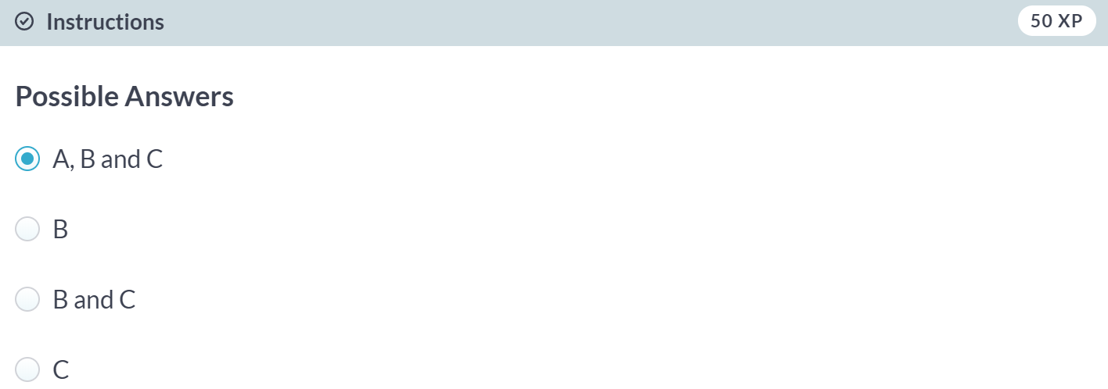

Correct! As funny as they may look, all these commands are valid ways to build a Python list.

# List of lists

As a data scientist, you'll often be dealing with a lot of data, and it will make sense to group some of this data.

Instead of creating a flat list containing strings and floats, representing the names and areas of the rooms in your house, you can create a list of lists. The script on the right can already give you an idea.

Don't get confused here: "hallway" is a string, while hall is a variable that represents the float 11.25 you specified earlier.

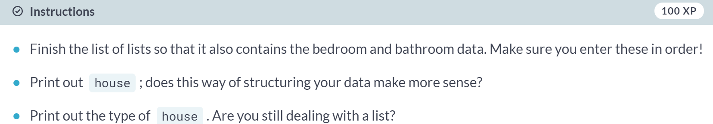

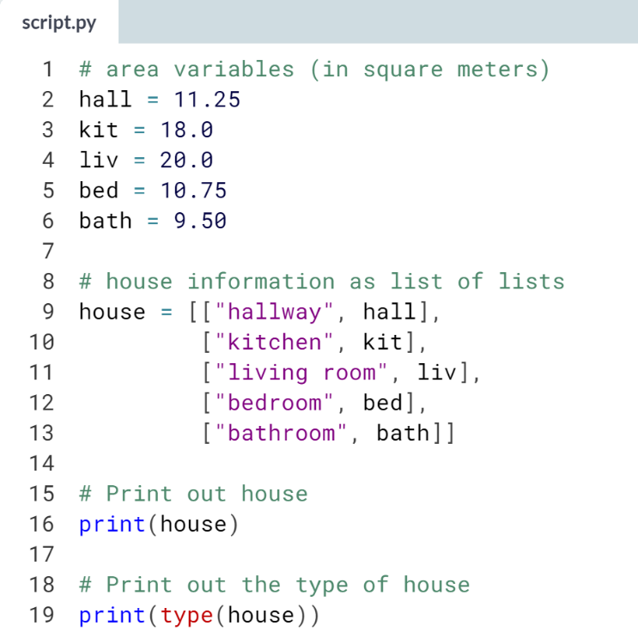

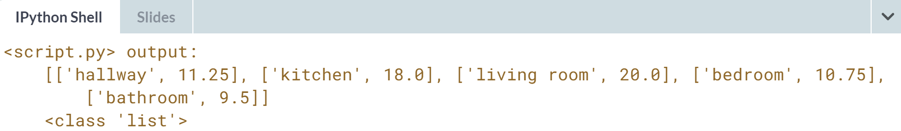  
Great! Get ready to learn about list subsetting!



After you've created your very own Python's list, you will need to know how you can assess information in the list.

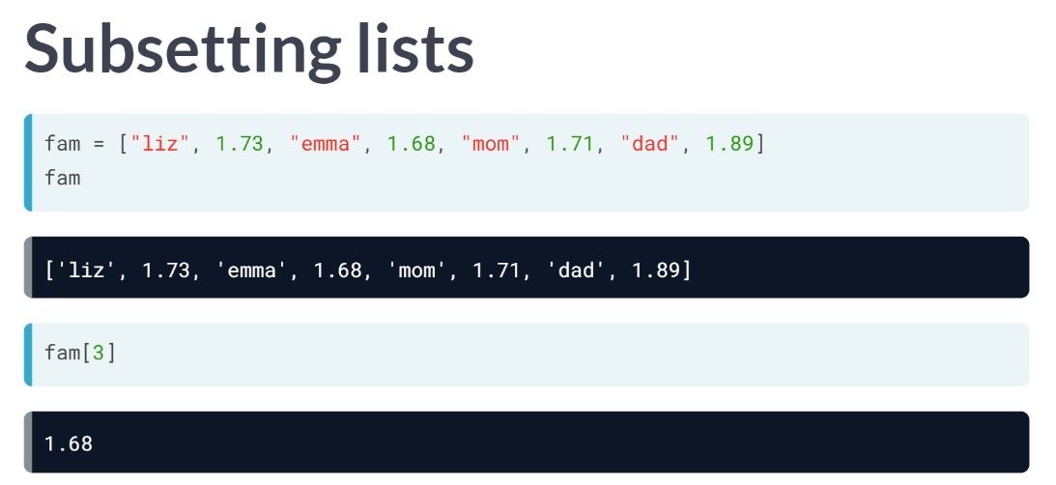

Python uses the index to do this. Let's have a look at the fam list here again. The first element in the list has index 0, the second element has index 1, and so on.

Suppose that you want to select the height of Emma, the float of 1.68. It's the four elements, so it has index 3. To select it, you use 3 inside square brackets.

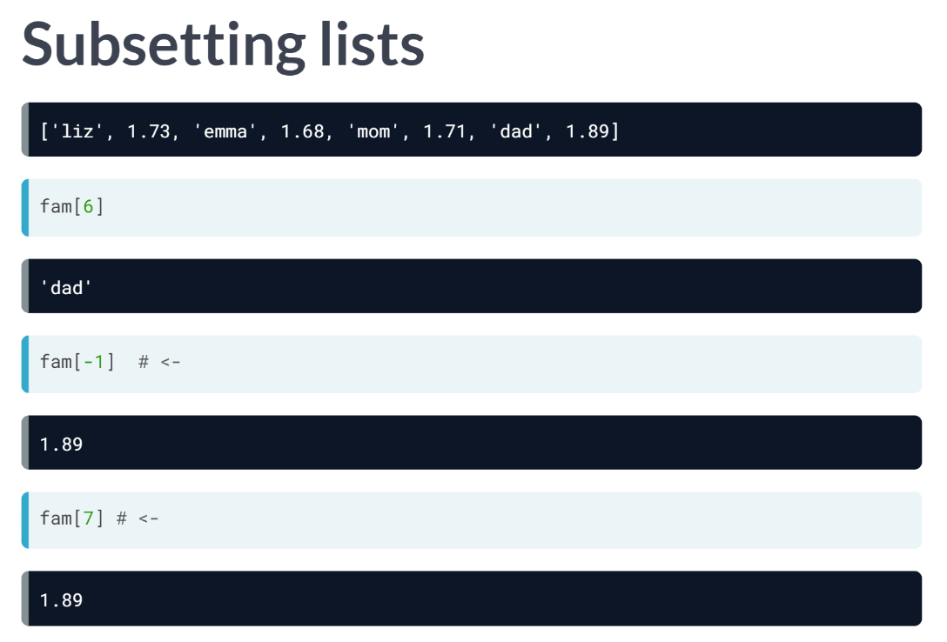  
Similarly, to select the string "dad" from the list, which is the seventh elements in the list, you'll need to put the index 6 inside square brackets. You can also count backwards, using negative indexes. This is useful if you want to get some elements at the end of your list.

To get your dad's height, for example, you will need the index -1. These are the negative indexes for all list elements. This means that both these lines return the exact same results.

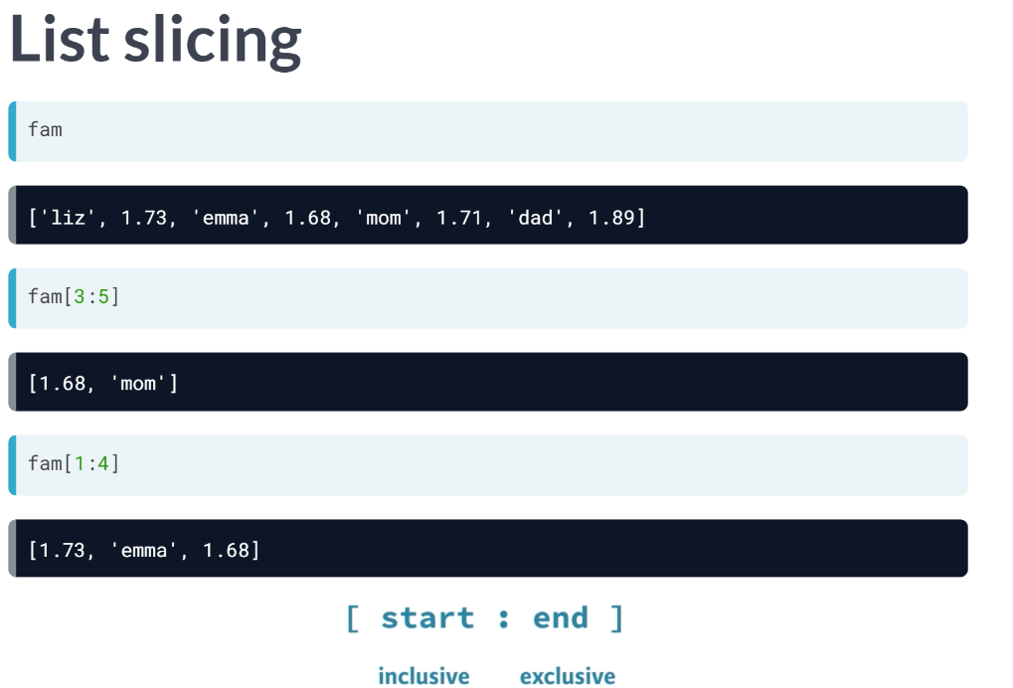  
Apart from indexing, there's also something called slicing, which allows you to select multiple elements from a list, thus creating a new list. You can do this by specifying a range, using a colon. Let's first have another look at the first and then try this piece of code. Can you guess what it will return? A list with the float 1.68, the string "mom" and the float 1.71.

Corresponding to the 4th, 5th, and 6th element in the list maybe? Apparently, only elements with index 3 and 4 get returned. The element with index 5 is not included. In general, this is the syntax: the index you specify before the colon, so where the slice starts, is included, while the index you specify after the colon, where the slice ends, is not.

With this in mind, can you tell what this code, fam[1:4], will return? Yes, this call gives you a list with three elements, corresponding to the elements with index 1, 2, and 3 of the *fam* list.

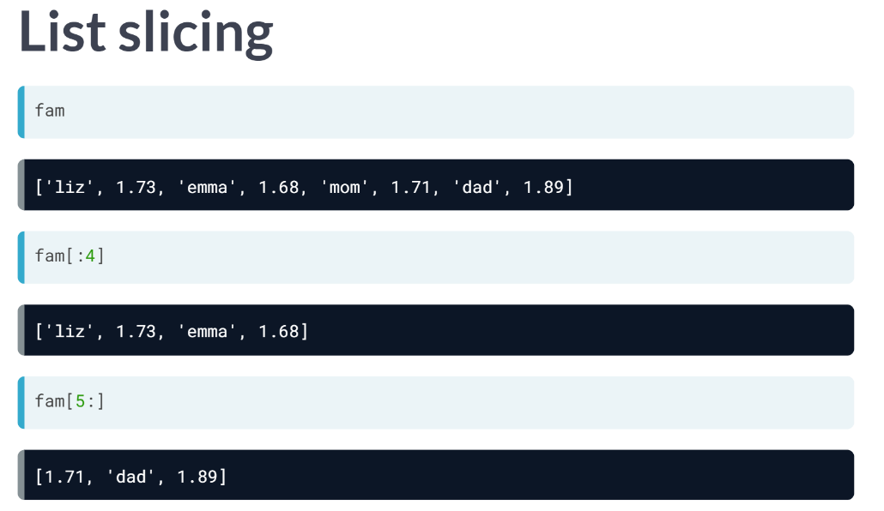

You can also choose to just leave out the index before or after the colon. If you leave out the index where the slice should begin, you are telling Python to start the slice from index 0, like the second example.

If you leave out the index where the slice should end, you include all elements up to and including the last elements in the list, like third example above.

# Subset and conquer

Subsetting Python lists is a piece of cake. Take the code sample below, which creates a list x and then selects "b" from it. Remember that this is the second element, so it has index 1. You can also use negative indexing.

x = ["a", "b", "c", "d"]

x[1]

x[-3] # same result!

Remember the areas list from before, containing both strings and floats? Its definition is already in the script. Can you add the correct code to do some Python subsetting?

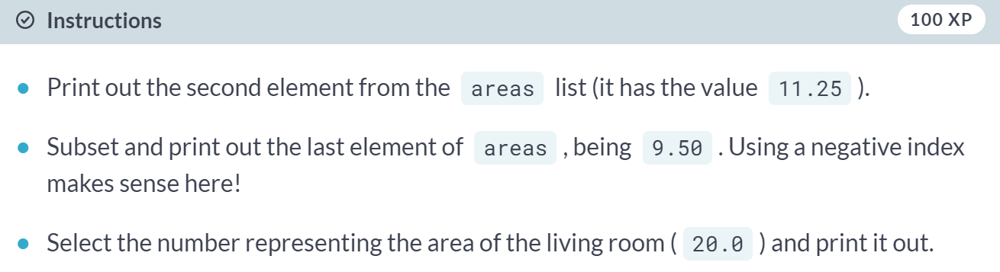

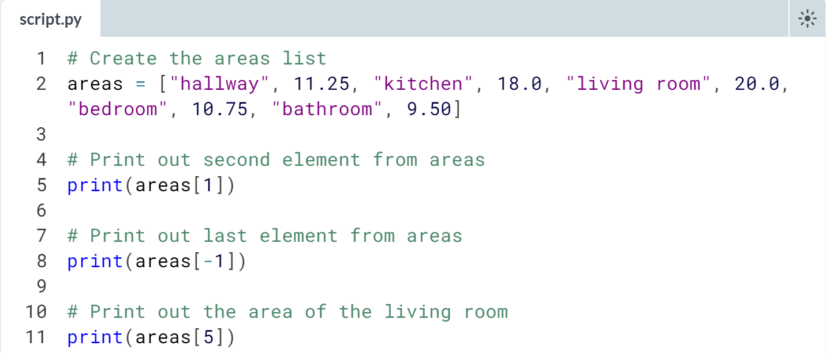

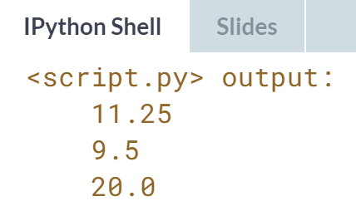

# Subset and calculate

After you've extracted values from a list, you can use them to perform additional calculations. Take this example, where the second and fourth element of a list x are extracted. The strings that result are pasted together using the + operator:

x = ["a", "b", "c", "d"]

print(x[1] + x[3])

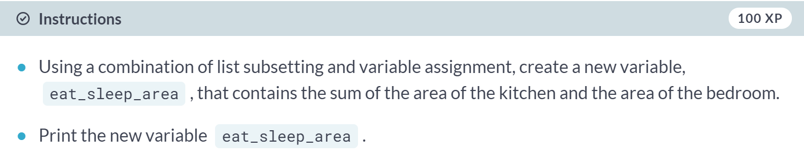

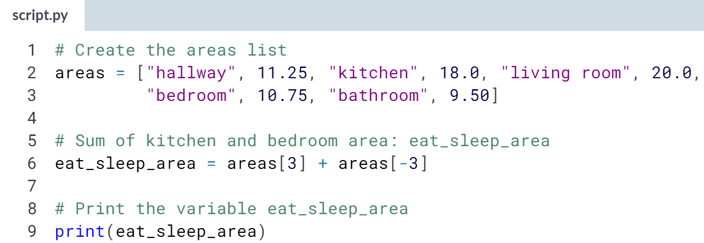

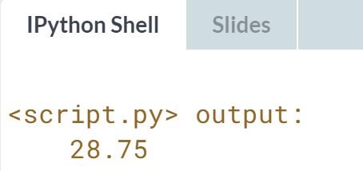

# Slicing and dicing

Selecting single values from a list is just one part of the story. It's also possible to slice your list, which means selecting multiple elements from your list. Use the following syntax:

my_list[start:end]

The start index will be included, while the end index is not.

The code sample below shows an example. A list with "b" and "c", corresponding to indexes 1 and 2, are selected from a list x:

x = ["a", "b", "c", "d"]

x[1:3]

The elements with index 1 and 2 are included, while the element with index 3 is not.

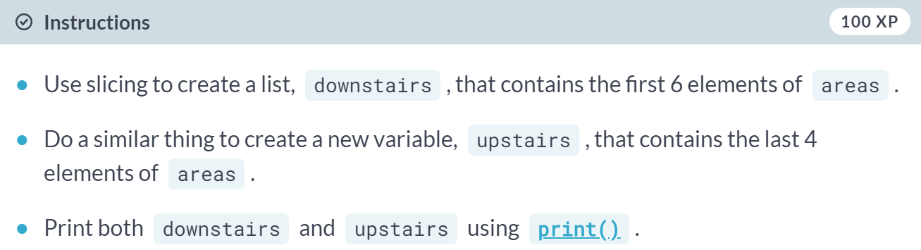

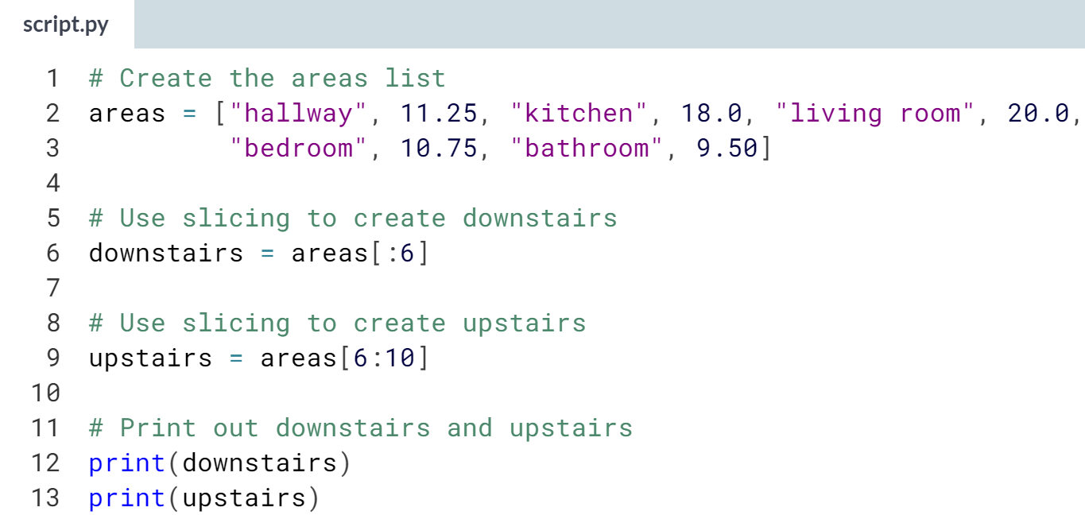  
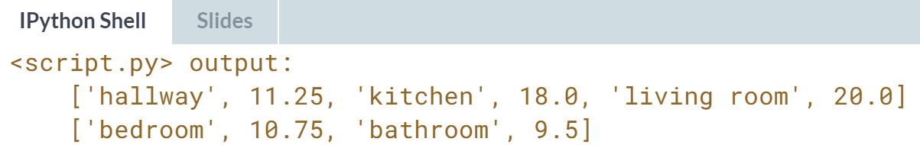

# Slicing and dicing (2)

In the video, Hugo first discussed the syntax where you specify both where to begin and end the slice of your list:

my_list[begin:end]

However, it's also possible not to specify these indexes. If you don't specify the begin index, Python figures out that you want to start your slice at the beginning of your list. If you don't specify the end index, the slice will go all the way to the last element of your list. To experiment with this, try the following commands in the IPython Shell:

x = ["a", "b", "c", "d"]

x[:2]

x[2:]

x[:]

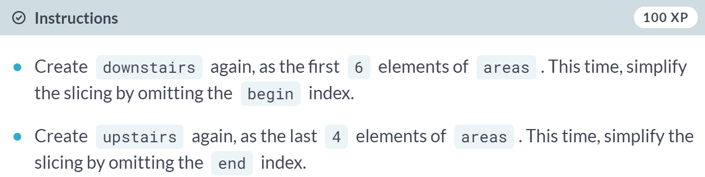

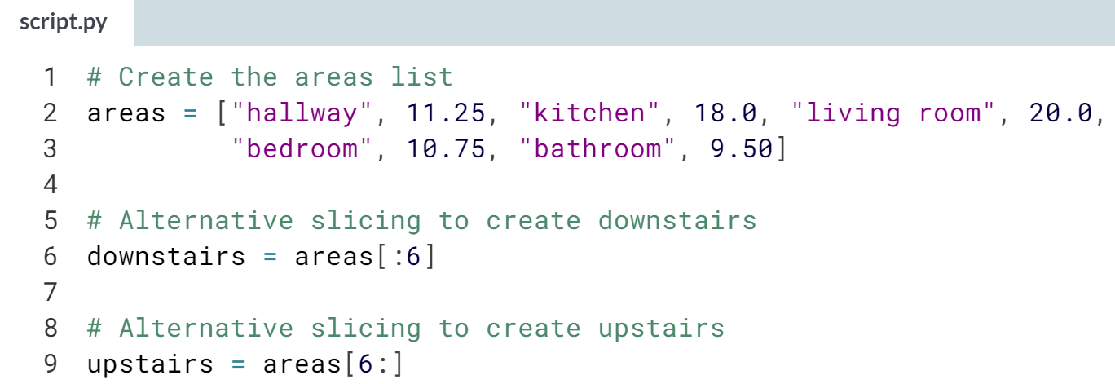

# Subsetting lists of lists

You saw before that a Python list can contain practically anything; even other lists! To subset lists of lists, you can use the same technique as before: square brackets. Try out the commands in the following code sample in the IPython Shell:

x = [["a", "b", "c"],

["d", "e", "f"],

["g", "h", "i"]]

x[2][0]

x[2][:2]

x[2] results in a list, that you can subset again by adding additional square brackets.

What will house[-1][1] return? house, the list of lists that you created before, is already defined for you in the workspace. You can experiment with it in the IPython Shell.

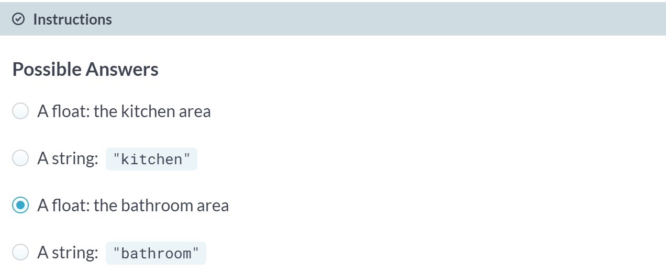

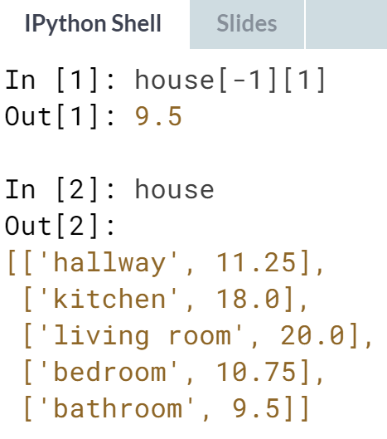

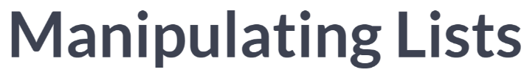

So now, after creation and subsetting, the final piece of the Python lists puzzle is manipulation, so ways to change elements in your list, or to add elements to and remove elements from your list.

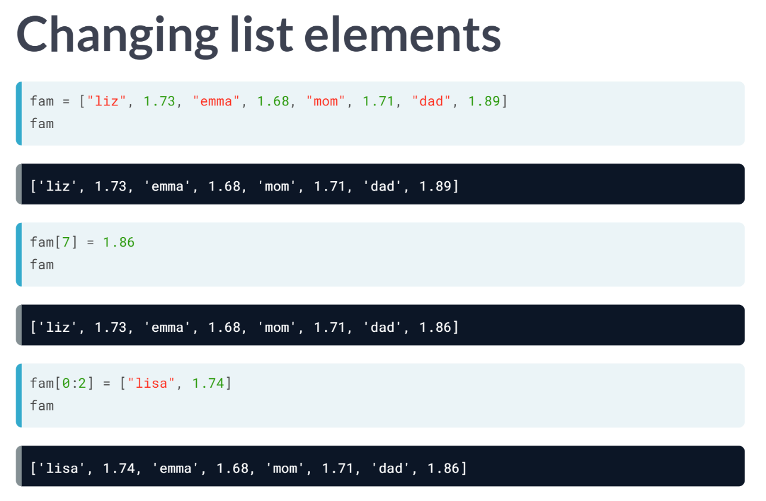  
Changing list elements ins pretty straightforward. You use the same square brackets that we've used to subset list and then assign new elements to it using the equals sign.

Suppose that after another look at fam, you realize that your dad's height is not up to data anymore, as he's shrinking with age. Instead of 1.89 meters, it should be 1.86 meters. To change this list element, which is at index 7, you can use this line of code. If you now check out fam, you will see that the value is updated.

You can even change the entire list slice at once. To change the elements "liz" and 1.73, you access the first two elements with 0:2, and then assign a new list to it.

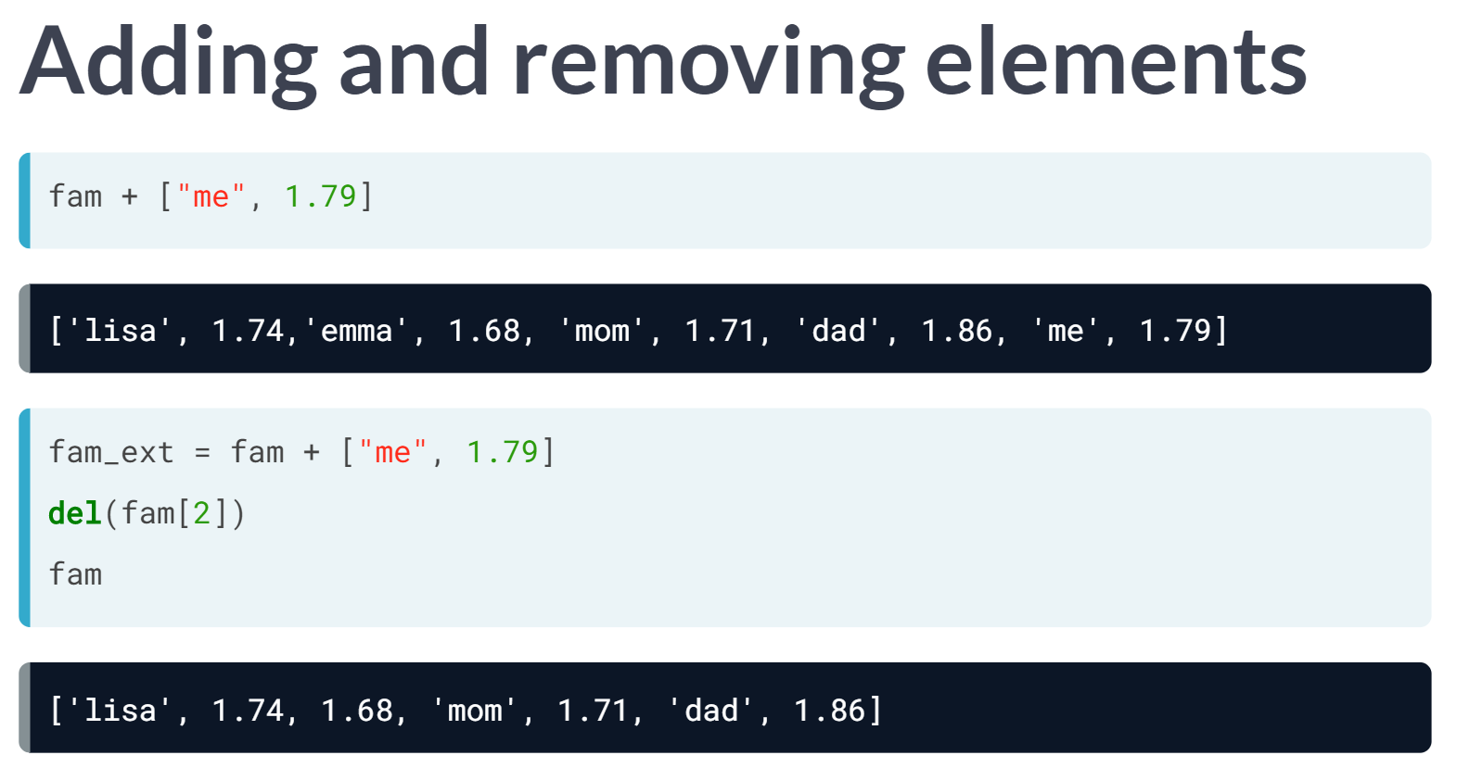

Do you still remember how the plus operator was different for strings and integers? Well, it's again different for lists.

If you use the plus sign with two lists, Python simply pastes together their contents in a single list. Suppose you want to add your own name and height to the fam height list. This will do the trick. Of course, you can also store this new list in a variable, *fam_ext* for example.

Finally, deleting elements from a list is also pretty straightforward, you will have to use *del* here. Take this line above, for example, that deletes the element with index 2, so "emma", from the list. If you check out fam now, you will see that the "emma" string is gone. Because you've removed an index, all elements that came after "emma" scooted over by one index. If you again run the same line, you are again removing the element at index 2, which is Emma's height, 1.68 meters now.

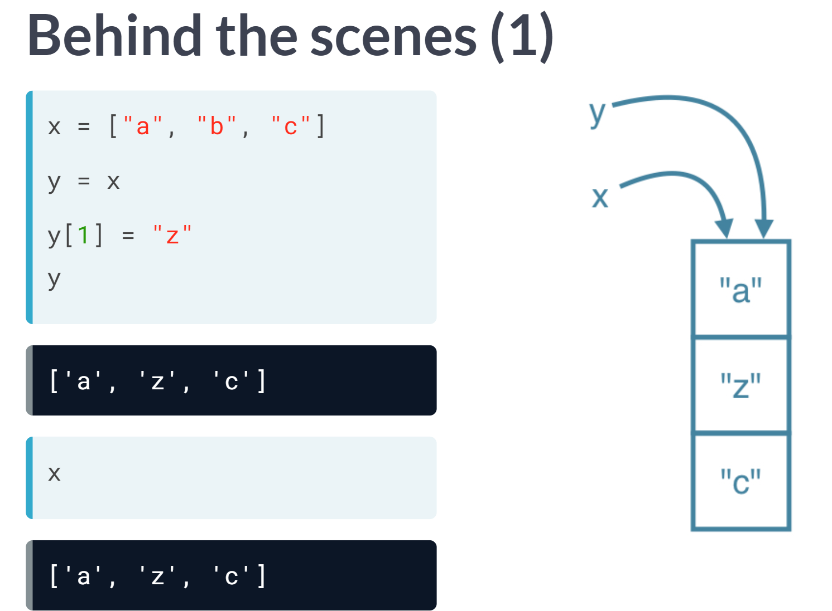

Understanding how Python lists actually work behind the scenes becomes pretty important now. What happens when you create a new list, x, like this? Well, in a simplified sense, you are storing a list in your computer memory, and store the "address" of that list, so where the list is in your computer memory, in x. Now this means that x does not actually contain all the list elements, it rather contains a reference to the list.

For basic operations, the difference is not that important, it becomes more so when you start copying lists. Let's clarify this with an example.

Let's store the list x as a new variable y, by simply using the equals sign. Let's now change the element with index one in the list y, like this. The funky thing is that if you now check out x again, also here the second element was changed. That is because when you copied x to y with equals sign, you copied the reference to the list, not the actual values themselves.

When you are updating an element in the list, it is one and the same list in the computer memory you are changing. Both x and y point to this list, so the update is visible from both variables.

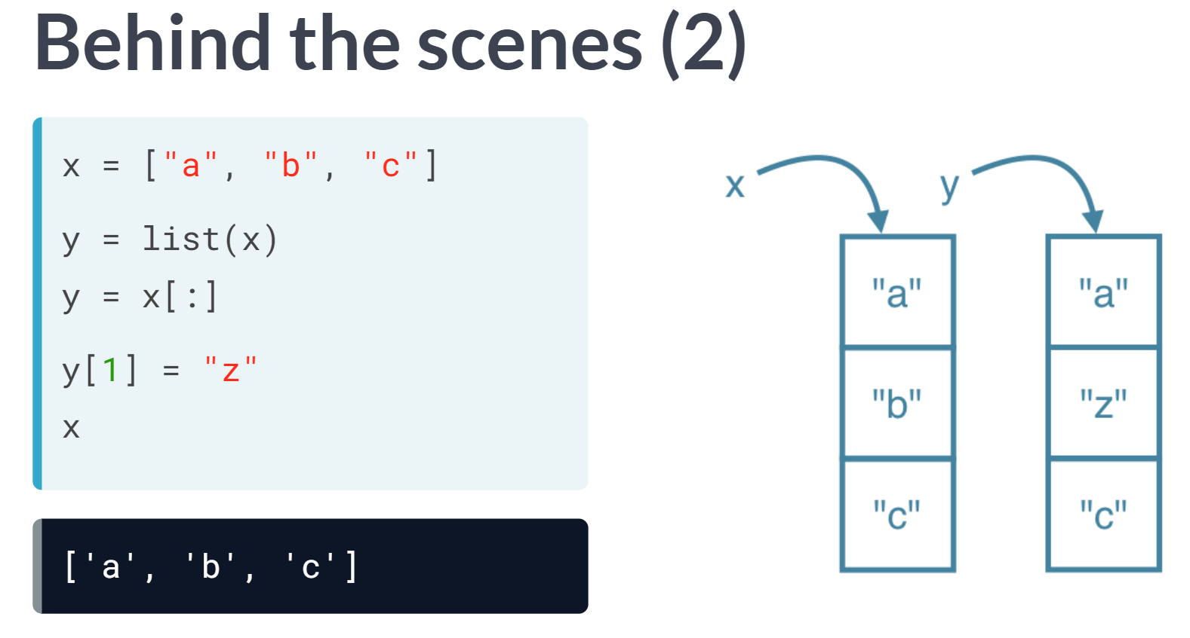  
If you want to create a list y that points to a new list in the memory with the same values, you will need to use something else than the equals sign.

You can use the list function, like this, or use slicing to select all list elements explicitly. If you now make a change to the list y points to, x is not affected.

# Replace list elements

Replacing list elements is pretty easy. Simply subset the list and assign new values to the subset. You can select single elements or you can change entire list slices at once.

Use the IPython Shell to experiment with the commands below. Can you tell what's happening and why?

x = ["a", "b", "c", "d"]

x[1] = "r"

x[2:] = ["s", "t"]

For this and the following exercises, you'll continue working on the areas list that contains the names and areas of different rooms in a house.

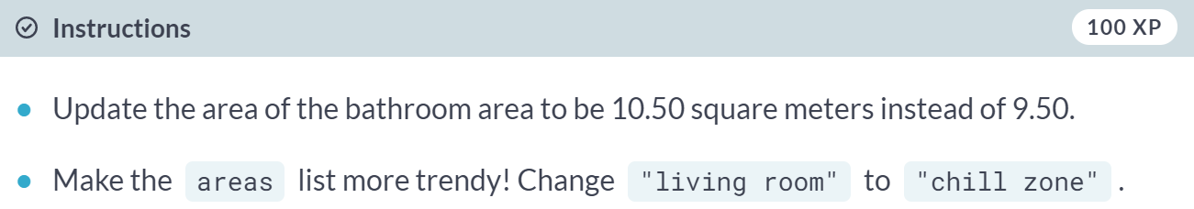

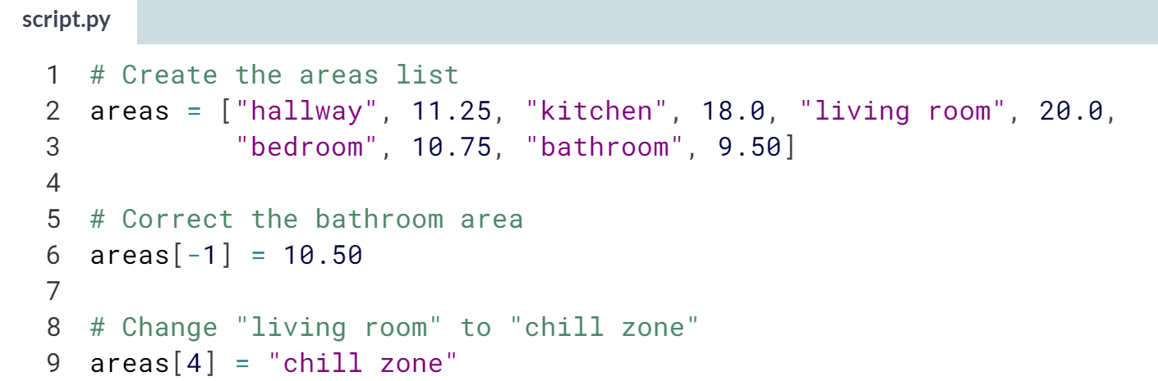

Sweet! As the code sample showed, you can also slice a list and replace it with another list to update multiple elements in a single command.

# Extend a list

If you can change elements in a list, you sure want to be able to add elements to it, right? You can use the + operator:

x = ["a", "b", "c", "d"]

y = x + ["e", "f"]

You just won the lottery, awesome! You decide to build a pool house and a garage. Can you add the information to the areas list?

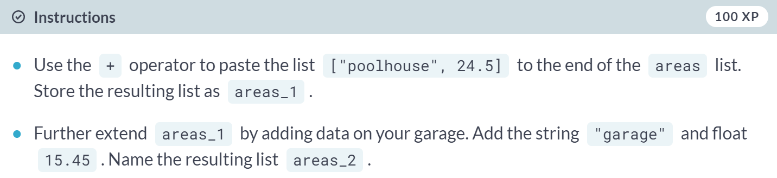

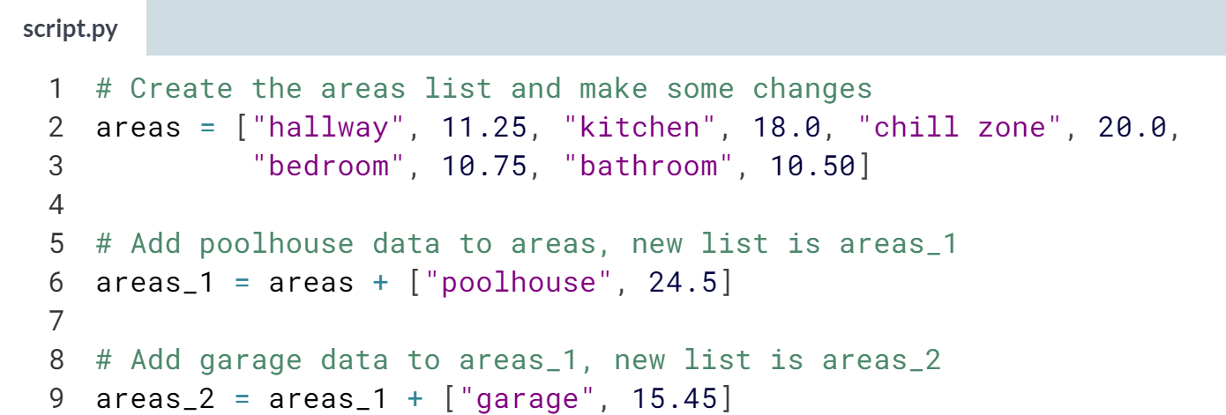  
Cool! The list is shaping up nicely!

# Delete list elements

Finally, you can also remove elements from your list. You can do this with the del statement:

x = ["a", "b", "c", "d"]

del(x[1])

Pay attention here: as soon as you remove an element from a list, the indexes of the elements that come after the deleted element all change!

The updated and extended version of areas that you've built in the previous exercises is coded below. You can copy and paste this into the IPython Shell to play around with the result.

areas = ["hallway", 11.25, "kitchen", 18.0,

"chill zone", 20.0, "bedroom", 10.75,

"bathroom", 10.50, "poolhouse", 24.5,

"garage", 15.45]

There was a mistake! The amount you won with the lottery is not that big after all and it looks like the pool house isn't going to happen. You decide to remove the corresponding string and float from the areas list.

The ; sign is used to place commands on the same line. The following two code chunks are equivalent:

# Same line

command1; command2

# Separate lines

command1

command2

Which of the code chunks will do the job for us?

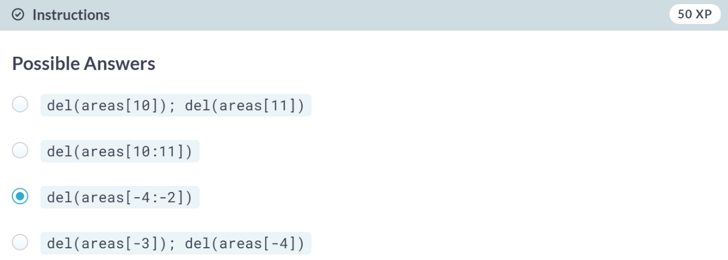  
Correct! You'll learn about easier ways to remove specific elements from Python lists later on.

# Inner workings of lists

At the end of the video, Hugo explained how Python lists work behind the scenes. In this exercise you'll get some hands-on experience with this.

The Python code in the script already creates a list with the name areas and a copy named areas_copy. Next, the first element in the areas_copy list is changed and the areas list is printed out. If you hit Run Code you'll see that, although you've changed areas_copy, the change also takes effect in the areas list. That's because areas and areas_copy point to the same list.

If you want to prevent changes in areas_copy from also taking effect in areas, you'll have to do a more explicit copy of the areas list. You can do this with [**list()**](https://docs.python.org/3/library/functions.html#func-list) or by using [:].

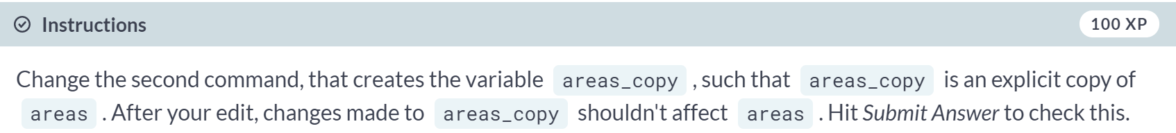

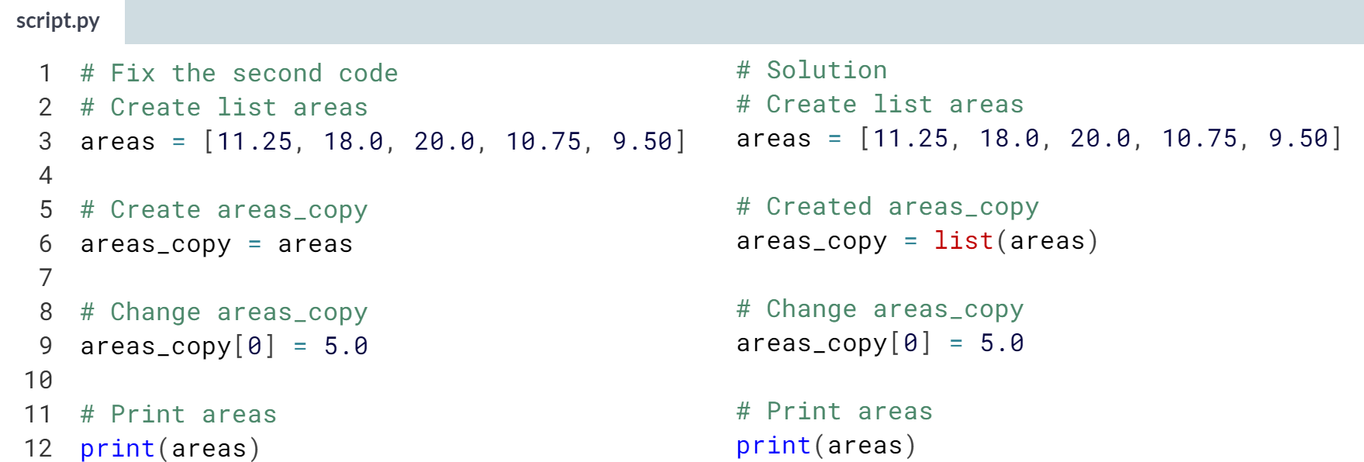

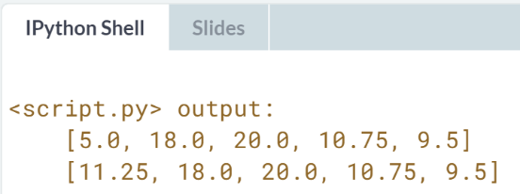

Nice! Simply adding list() function makes it possible to edit the list. The difference between explicit and reference-based copies is subtle but can be really important. Try to keep in mind how a list is stored in the computer's memory.

**3. Functions and Packages**

You'll learn how to use functions, methods, and packages to efficiently leverage the code that brilliant Python developers have written. The goal is to reduce the amount of code you need to solve challenging problems!

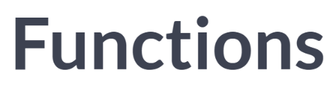

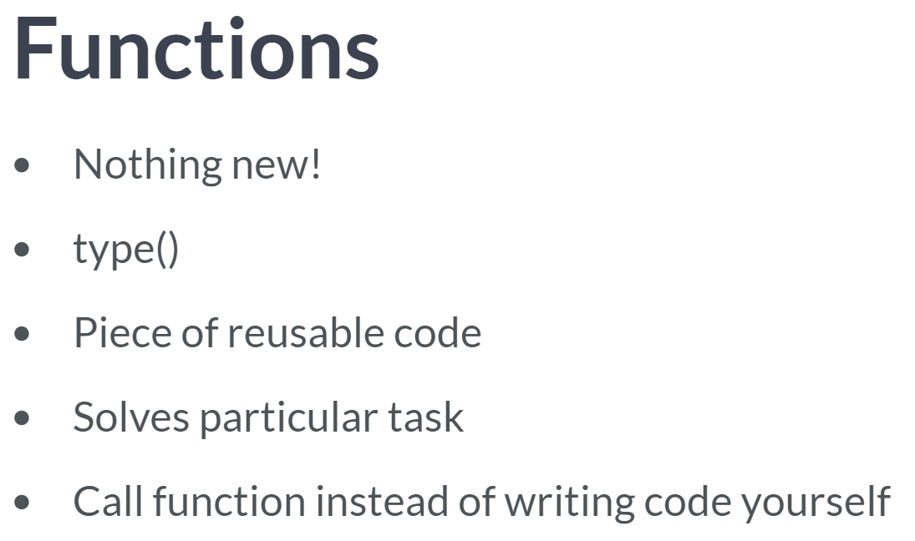  
Functions are nothing new. A function, type(), for example, is a function that returns the type of a value. But what is a function?

Simply put, a function is a piece of reusable code, aimed at solving a particular task. You can call functions instead of having to write code yourself.

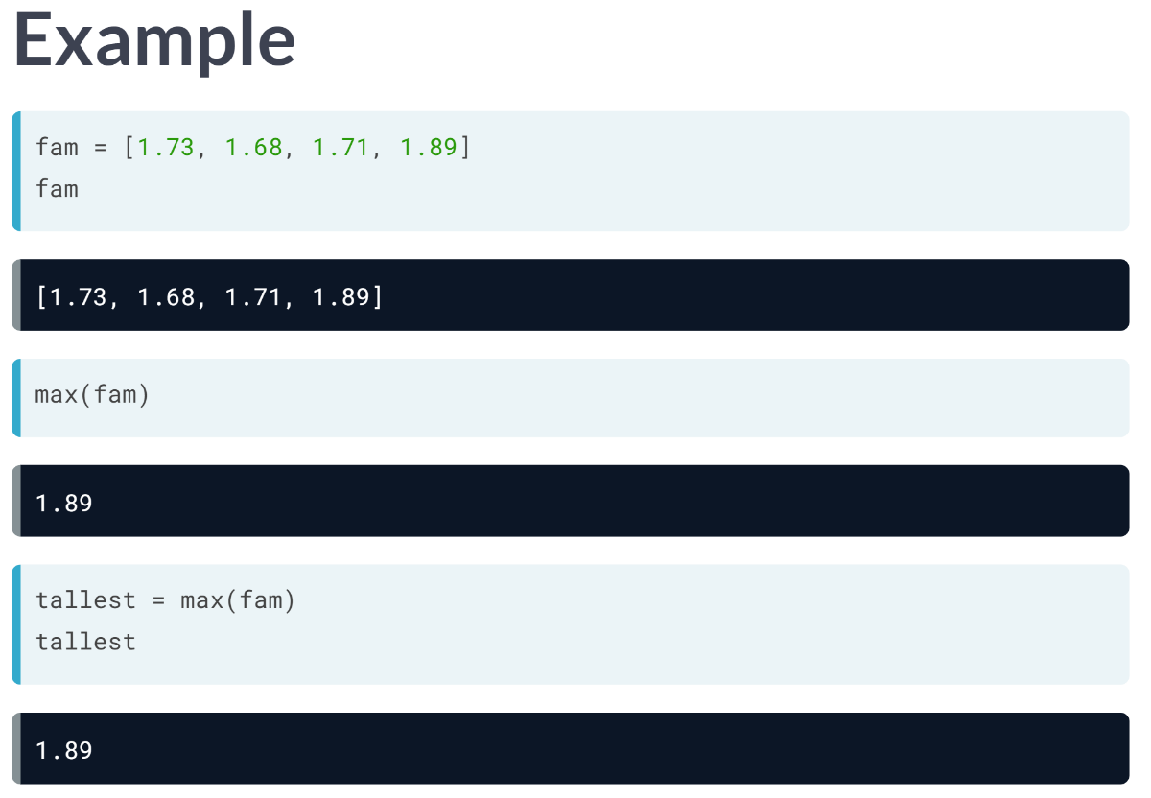  
Suppose you have the list containing only the heights of your family, fam: Say that you want to get the maximum value in this list. Instead of writing your own piece of Python code that goes through the list and finds the highest value, you can also use Python's ***max()*** function. This is one of Python's built-in functions, just like type.

We simply pass fam to max inside parentheses. The output makes sense: 1.89, the highest number in the list. ***max()*** worked kind of like a black box here. You passed it a list, then the implementation of max, that you don't know, did its magic and produce the output. How max actually did this, is not important to you, it just does what it's supposed to do, and you didn't have to write your own code, which made your life easier.

Of course, it's possible to also assign the result of a function call to a new variable, like here. Now tallest is just like any variable; you can use to continue your fancy calculations.

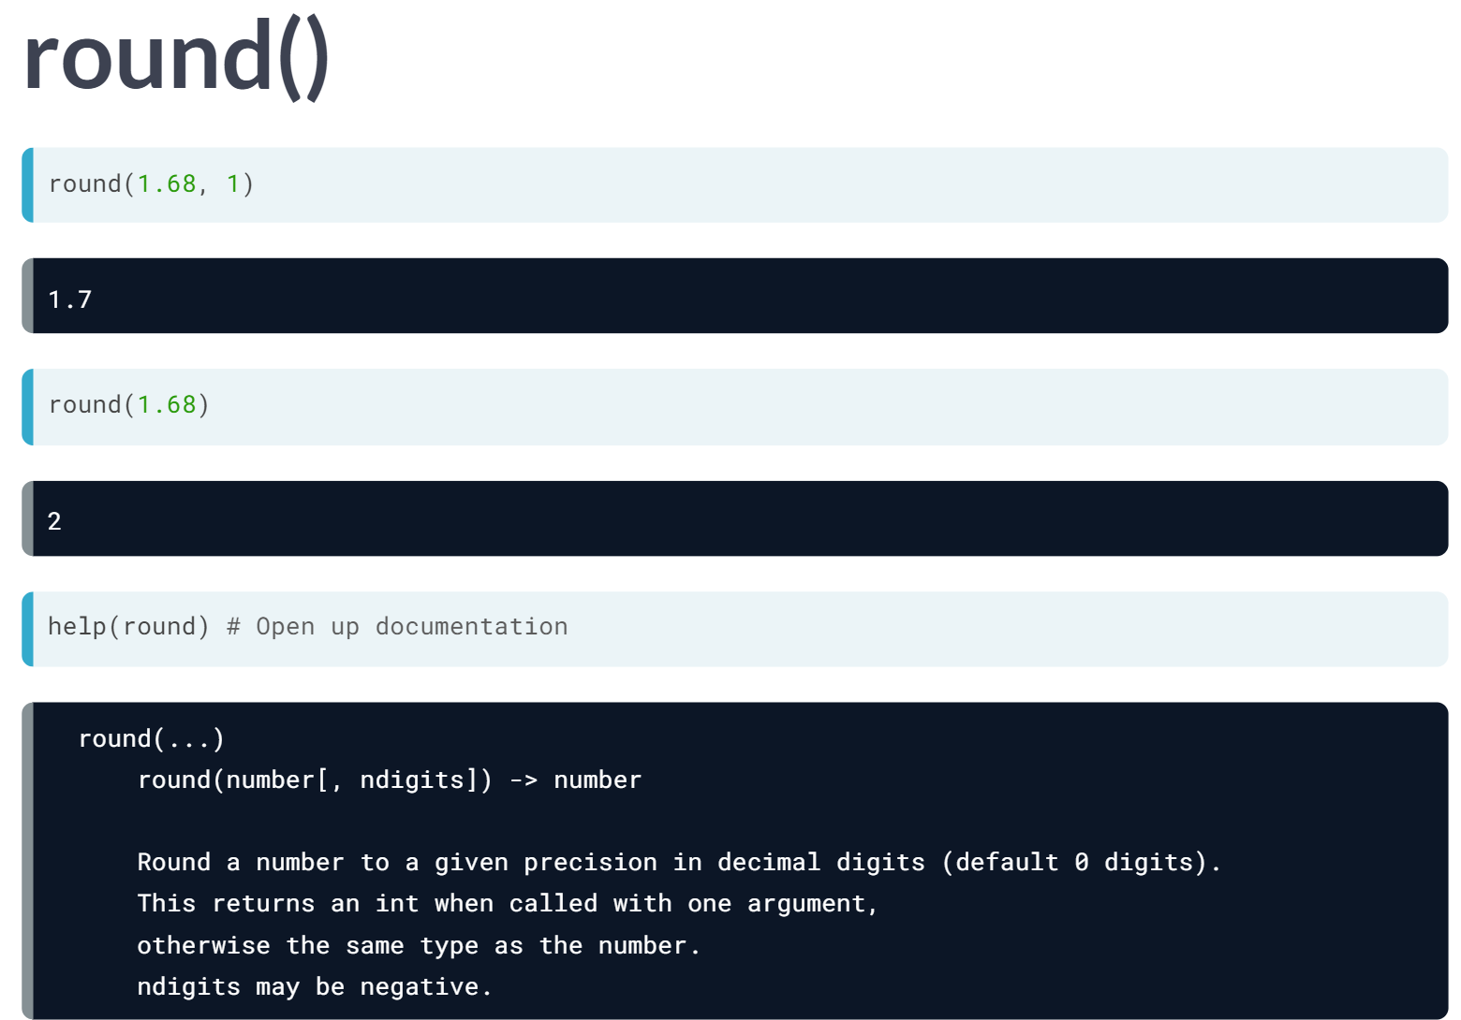  
Another one of these built-in functions is ***round()***. It takes two inputs: first, a number you want to round, and second, the precision with which to round, so how many digits behind the decimal point you want to keep. Say you want to round 1.68 to one decimal place.

As you can see above, you separate the inputs with a comma. It's perfectly possible to call the round() function with only one input, like this. Python automatically rounds the number to the nearest integer.

To understand why both approaches work, let's open up the documentation. You can do this with ***help()*** function

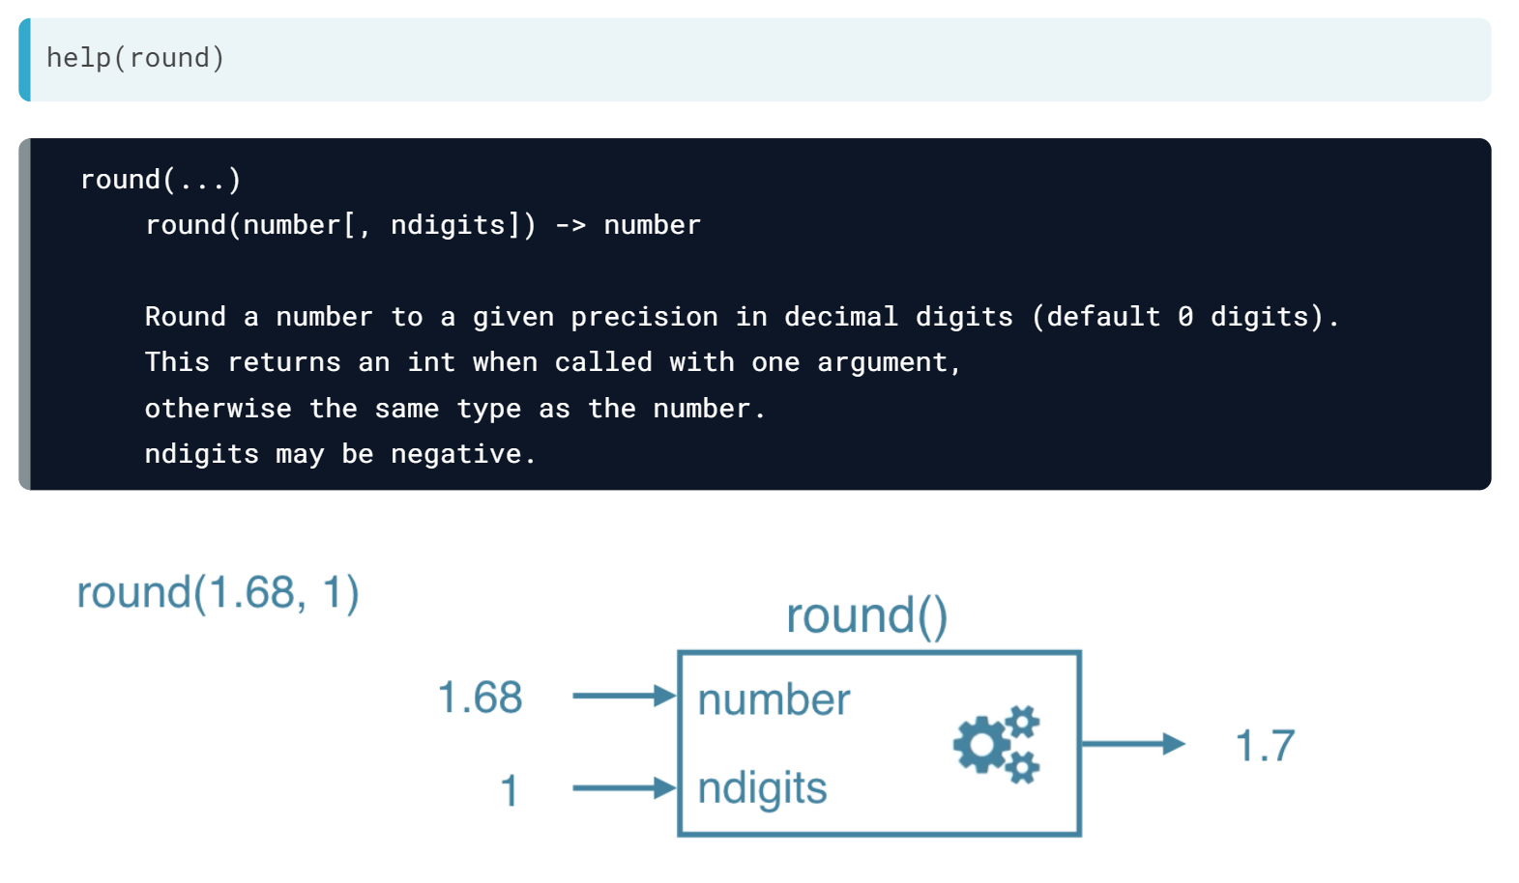  
In Python, these inputs, also called arguments, have names: *number* and *ndigits*. When you call the function ***round()*** with these two inputs, Python matches the inputs to the arguments: the number is set to 1.68 and *ndigits* is set to 1.

The ***round()*** function does its calculations with *number* and *ndigits* as if they are variables in a Python script. We don't know exactly what code Python executes. What is important is that the function produces an output, namely the number 1.68 rounded to 1 decimal place.

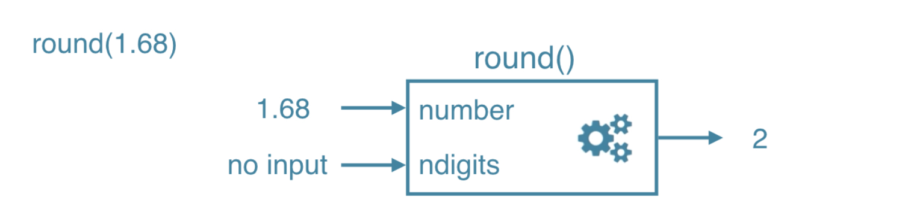  
If you call the function round with only one input, Python again tries to match the inputs to the arguments. There's no input to match to the ndigits arguments though. Luckily, the internal machinery of the ***round()***function knows how to handle this. When ndigits is not specified, the function simply rounds to the closest integer and returns to that integer. That's why we've got the number 2.

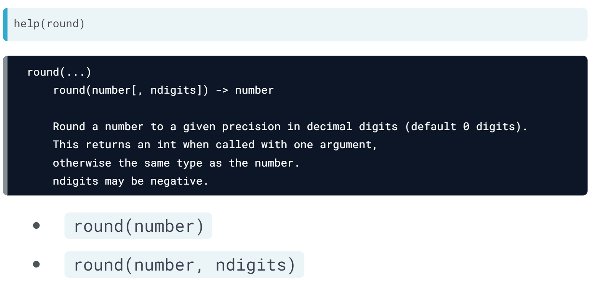Now how was I so sure that calling the function with a single input would work? Well, in the documentation, there are square brackets around the comma and the *ndigits* here. This tells us that you can call round in this form, as well as in this one.

Simply put, *ndigits* is an optional argument. Actually, Python offers yet another way to show that a function has optional arguments, but that's something for the exercises.

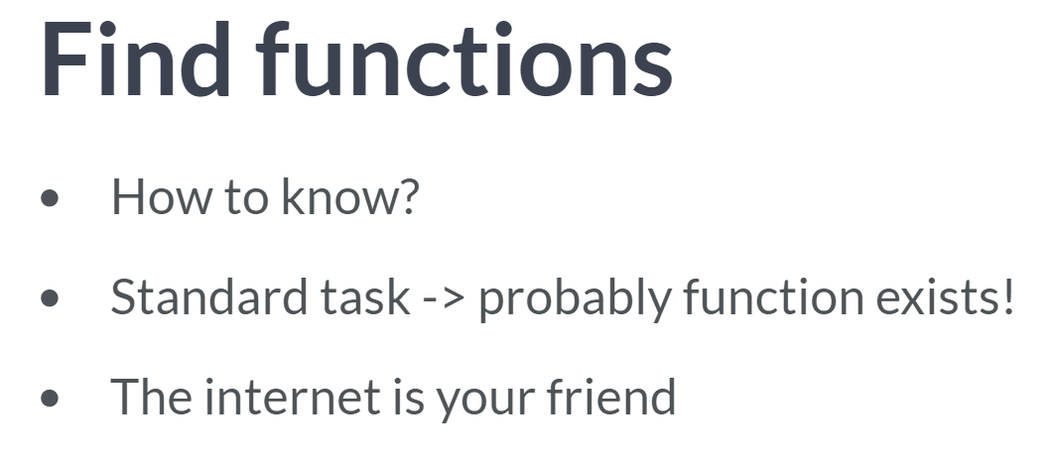  
By now, you have an idea about how to use max and round, but how could you know that a function such as round exists in Python in the first place? Well, this is something you will learn with time.

Whenever you are doing a rather standard task in Python, you can be pretty sure that there's already a function that can do this for you. In this case, you should definitely use it. Just do a quick internet search and you will find the function you need with a nice usage example.

# Familiar functions

Out of the box, Python offers a bunch of built-in functions to make your life as a data scientist easier. You already know two such functions: [**print()**](https://docs.python.org/3/library/functions.html#print) and [**type()**](https://docs.python.org/3/library/functions.html#type). You've also used the functions [**str()**](https://docs.python.org/3/library/functions.html#func-str), [**int()**](https://docs.python.org/3/library/functions.html#int), [**bool()**](https://docs.python.org/3/library/functions.html#bool) and [**float()**](https://docs.python.org/3/library/functions.html#float) to switch between data types. These are built-in functions as well.

Calling a function is easy. To get the type of 3.0 and store the output as a new variable, result, you can use the following:

result = type(3.0)

The general recipe for calling functions and saving the result to a variable is thus:

output = function_name(input)

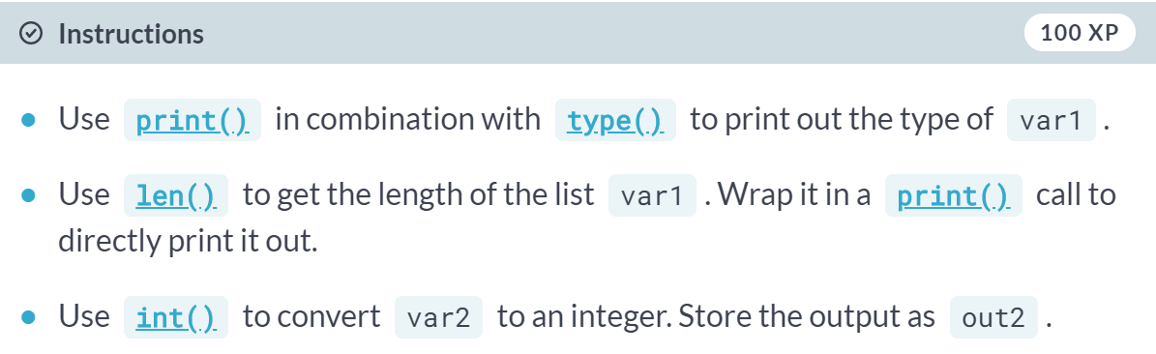

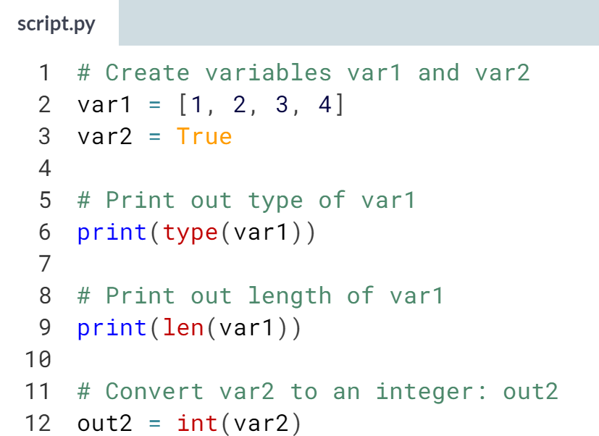  
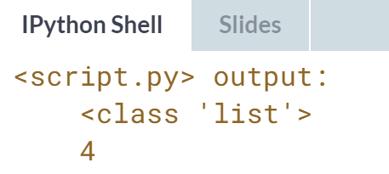  
Great job! The ***len()***function is extremely useful; it also works on strings to count the number of characters!

# Help!

Maybe you already know the name of a Python function, but you still have to figure out how to use it. Ironically, you have to ask for information about a function with another function: [**help()**](https://docs.python.org/3/library/functions.html#help). In IPython specifically, you can also use ? before the function name.

To get help on the [**max()**](https://docs.python.org/3/library/functions.html#max) function, for example, you can use one of these calls:

help(max)

?max

Use the Shell on the right to open up the documentation on [**complex()**](https://docs.python.org/3/library/functions.html#complex). Which of the following statements is true?

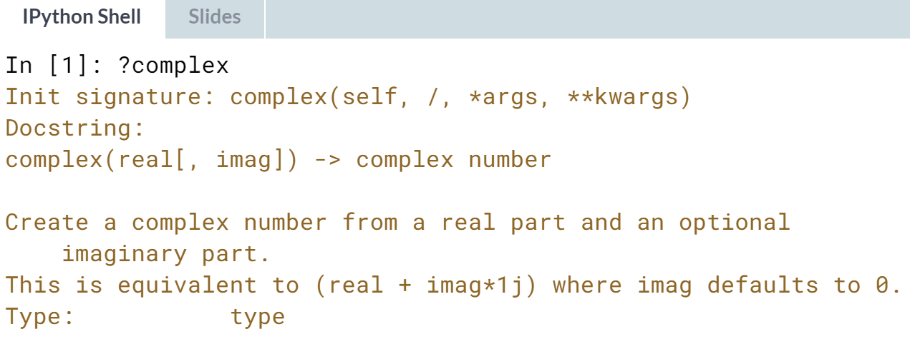

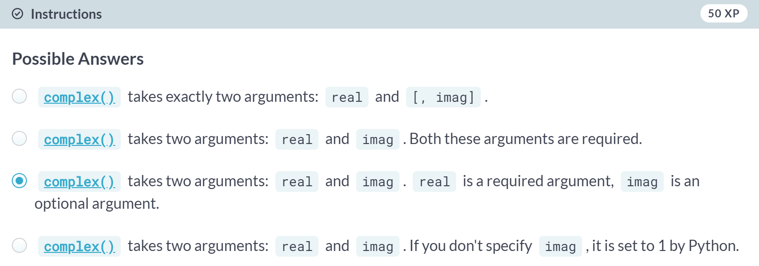

# Multiple arguments

In the previous exercise, the square brackets around imag in the documentation showed us that the imag argument is optional. But Python also uses a different way to tell users about arguments being optional.

Have a look at the documentation of [**sorted()**](https://docs.python.org/3/library/functions.html#sorted) by typing help(sorted) in the IPython Shell.

You'll see that [**sorted()**](https://docs.python.org/3/library/functions.html#sorted) takes three arguments: iterable, key and reverse.

key=None means that if you don't specify the key argument, it will be None. reverse=False means that if you don't specify the reverse argument, it will be False.

In this exercise, you'll only have to specify iterable and reverse, not key. The first input you pass to [**sorted()**](https://docs.python.org/3/library/functions.html#sorted) will be matched to the iterable argument, but what about the second input? To tell Python you want to specify reverse without changing anything about key, you can use =:



Two lists have been created for you on the right. Can you paste them together and sort them in descending order?

Note: For now, we can understand an [**iterable**](https://docs.python.org/2/glossary.html#term-iterable) as being any collection of objects, e.g. a List.

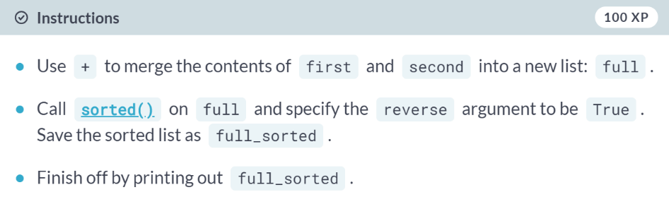  
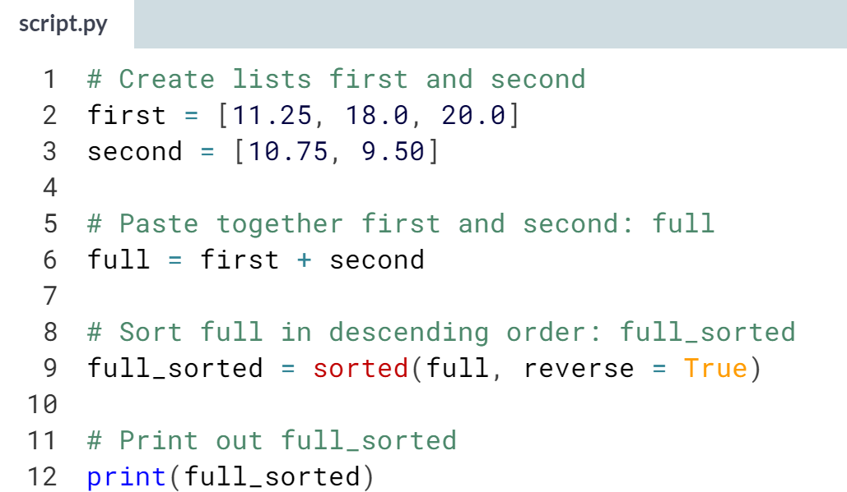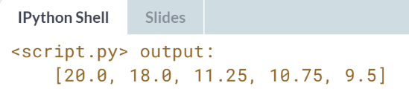



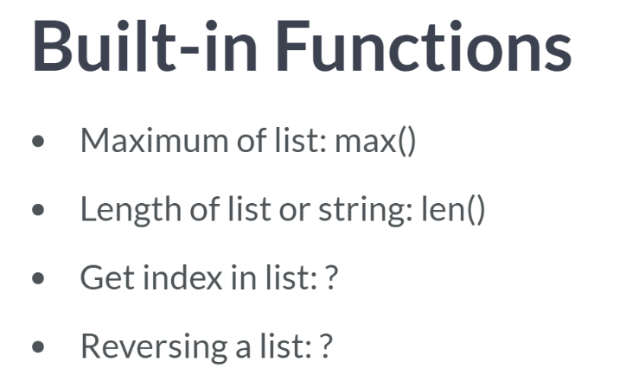  
Built-in functions are only one part of the Python story. You already know about functions such as ***max()***, to get the maximum of a list, ***len()***, to get the length of a list or a string, and so on. But what about other basic things, such as getting the index of a specific element in the list, or reversing a list? You can look very hard for built-in functions that do this, but you won't find them.

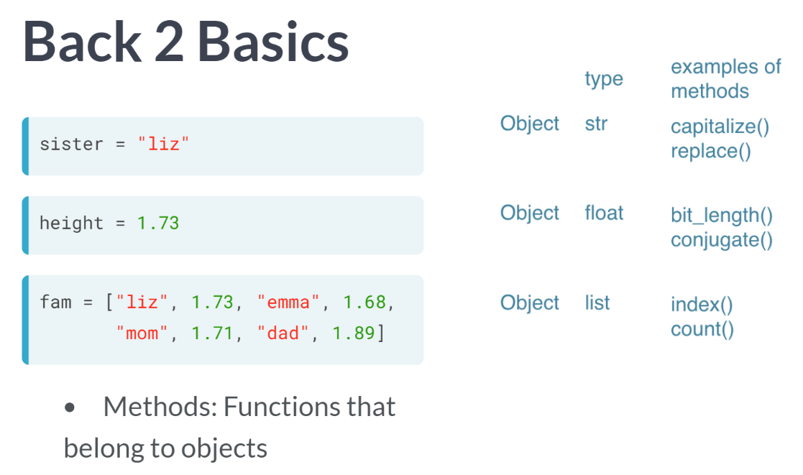  
In the past exercises, you've already created a bunch of variables. Among other Python types, you've created *strings, floats* and *lists*, like the ones you see here. Each one of these values or data structures are so-called Python objects. This *string* is an object, this *float* is an object, but this *list* is also, you got it, an object.

These objects have a specific type that you already know: string, float, and list, and of course they represent the values you gave them, such as "liz", 1.73, and an entire list. But in addition to this, Python objects also come with a bunch of so-called *"methods"*. You can think of methods as functions that "belong to" Python objects.

A Python object of type *string* has methods, such as ***capitalize()*** and ***replace()***, but also objects of type float and list have specific methods depending on the type. Enough for the theory now; let's try to use a method.

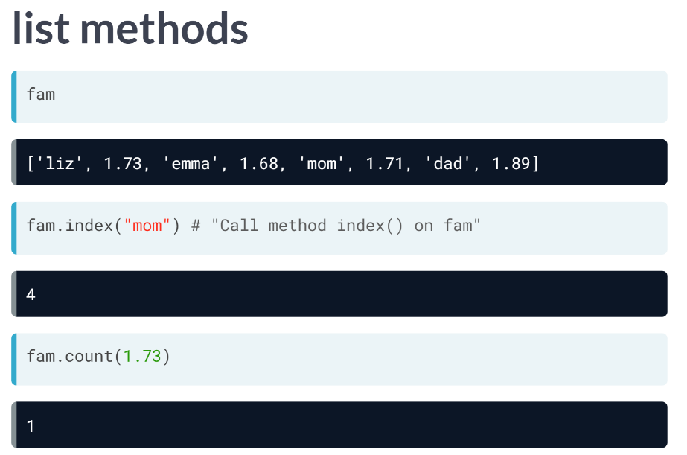  
Suppose you want to get the index of the string "mom" in the fam list, which is a Python object with the type list and has a method named index.

To call the method, you use the dot notation, like this. The only input is the string *"mom"*, the element you want to get the index for. Python returns 4, which is an index of the string *"mom"*.

We called the index method "on" the fam list here, and the output was 4. Similarly, we can use the count method on the fam list to count the number of times 1.73 in the list. Python returns 1, which makes sense given only Liz is 1.73 meters tall.

But lists are not the only Python objects that have methods associated. Also, floats, integers, Booleans, and strings are Python objects that have specific methods associated with them.  
  
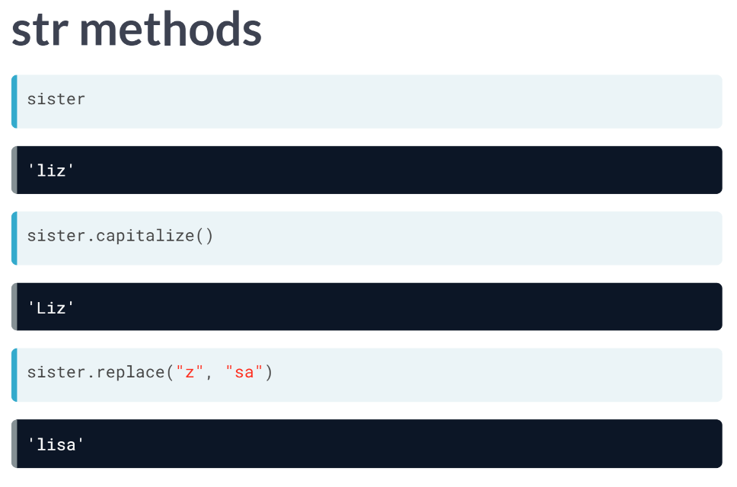  
Take the variable 'sister' for example, that represents a string. You can call the method capitalize on sister, with any inputs. It returns a string where the first letter is capitalized now. Or what if you want to replace some parts of the string with other parts? Not a problem. Just call the method replace on sister, with two appropriate inputs. In the output, *"z"* is replaced with *"sa"*.

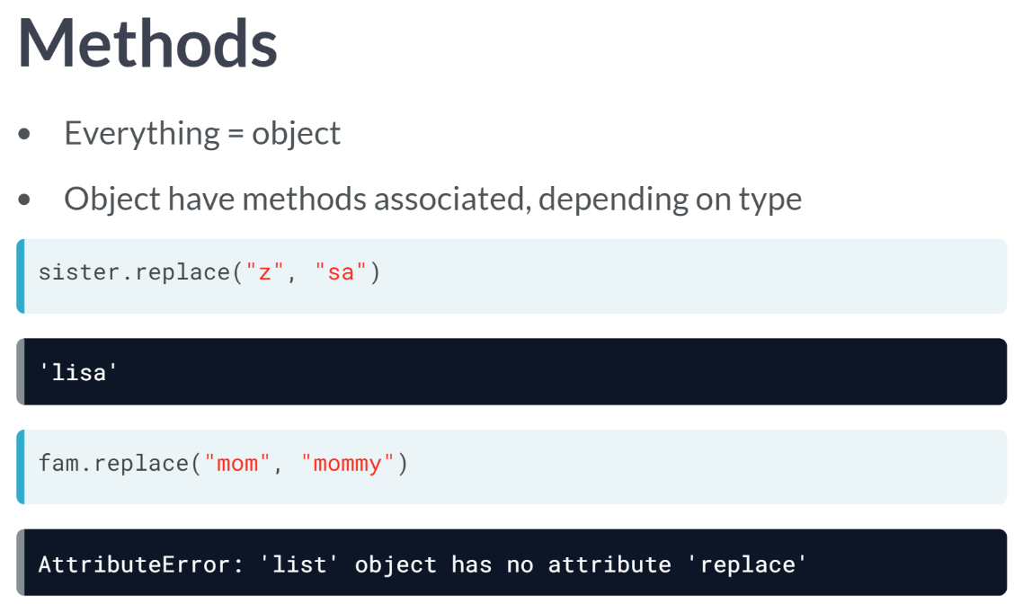  
To be absolutely clear: in Python, everything is an object, and each object has specific methods associated. Depending on the type of the object, list, string, float, whatever, the available methods are different. A string object like sister has a replace method, but a list like fam doesn't have this, as you can see from this error message above.

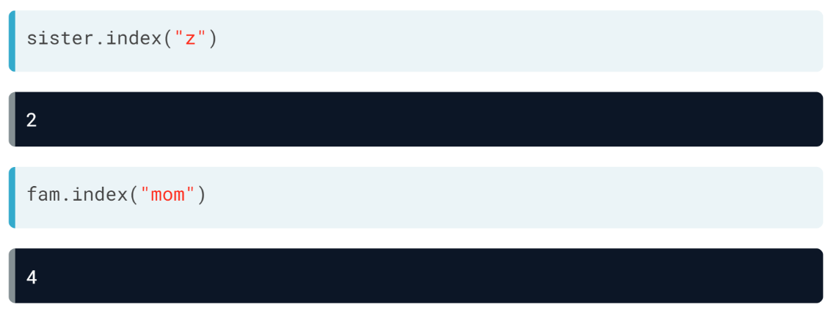  
Objects of different types can have methods with the same name: Take the index method. It's available for both strings and lists. If you call it on a string, you get the index of the letters in the string; if you call it on the list, you get the index of the element in the list.

This means that the method behaves differently depending on the type of the object. Before I unleash you on some exercise on methods, there's one more thing I want to tell you.

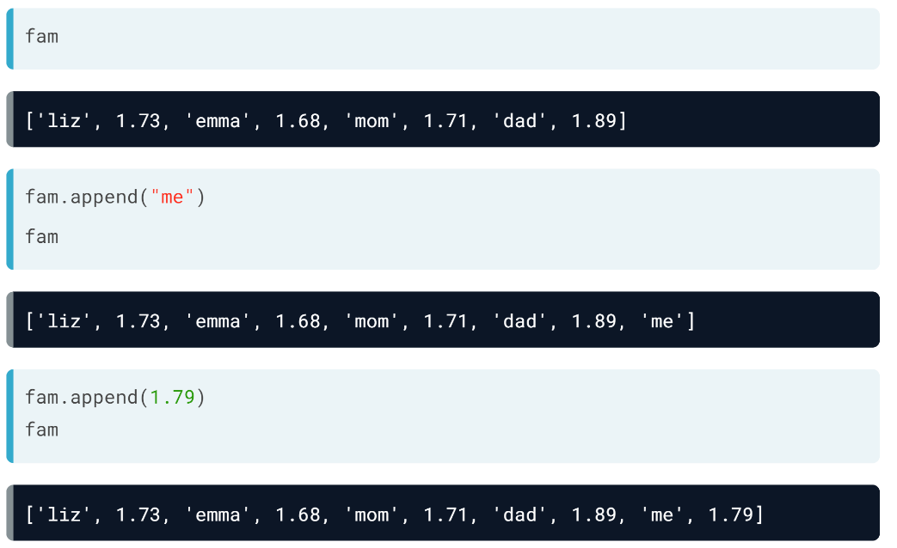  
Some methods can change the objects they are called on. Let's take the fam list and call the append method on it. As the input, we pass a string we want to add to the list. Python doesn't generate an output, but if we check the fam list again, we see that it has been extended with the string *"me"*.

Let's do this again, this time to add my height in meters to the list. Again, the fam list was extended. This is pretty cool, because you can write very concise code to update your data structure on the fly, but it can also be pretty dangerous.

Some method calls don't change the object they're called on, while others do, so watch out.

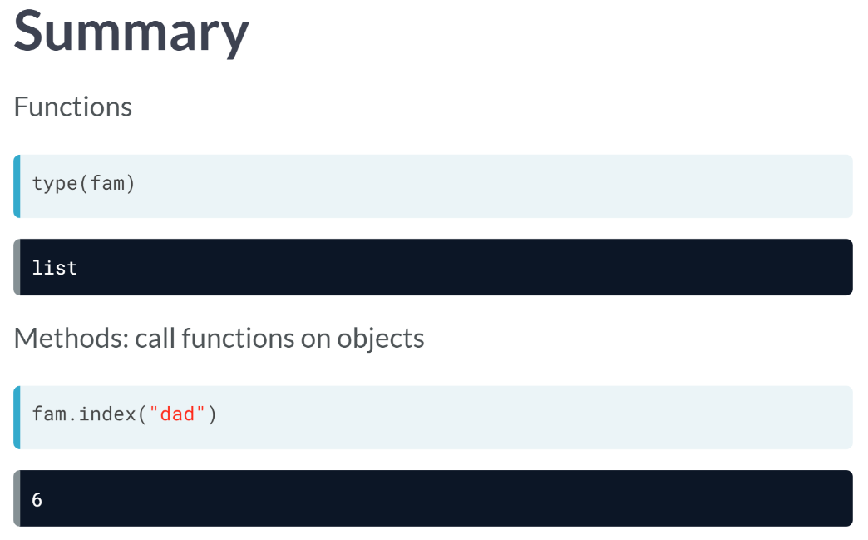  
Let's take a step back here and summarize this. You have Python functions, like type, max, and round, that you can call like this. There are also methods, which are functions that are specific to Python objects. Depending on the type of the Python objects you are dealing with, you'll be able to use different methods and they behave differently.

You can call methods on the objects with the dot notation like this above, for example. There's much more to tell about Python objects, methods, and how Python work internally, but for now, let's practice what we've discussed so far.

# String Methods

Strings come with a bunch of methods. Follow the instructions closely to discover some of them. If you want to discover them in more detail, you can always type help(str) in the IPython Shell.

A string place has already been created for you to experiment with.

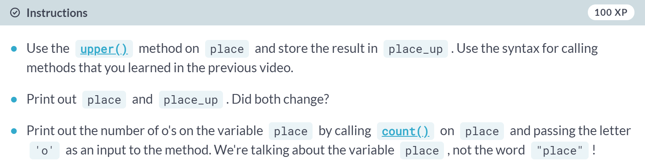

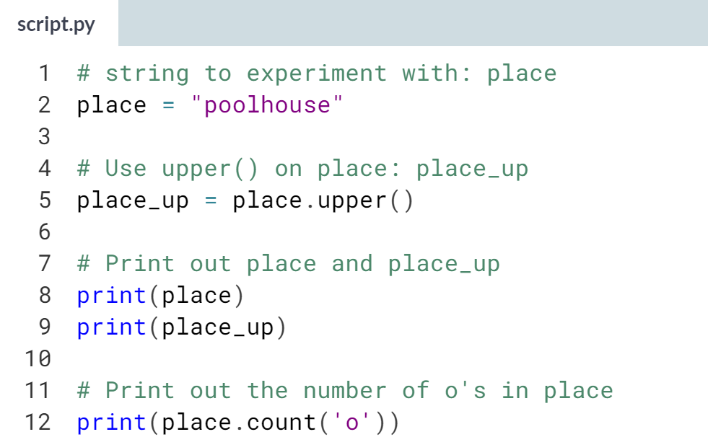

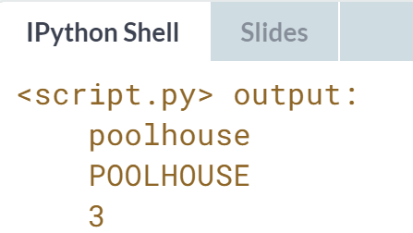  
Nice! Notice from the printouts that the ***upper()*** method does not change the object it is called on. This will be different for lists in the next exercise!

# List Methods

Strings are not the only Python types that have methods associated with them. Lists, floats, integers and Booleans are also types that come packaged with a bunch of useful methods. In this exercise, you'll be experimenting with:

* [**index()**](https://docs.python.org/3/library/stdtypes.html#str.index), to get the index of the first element of a list that matches its input and
* [**count()**](https://docs.python.org/3/library/stdtypes.html#str.count), to get the number of times an element appears in a list.

You'll be working on the list with the area of different parts of a house: areas.

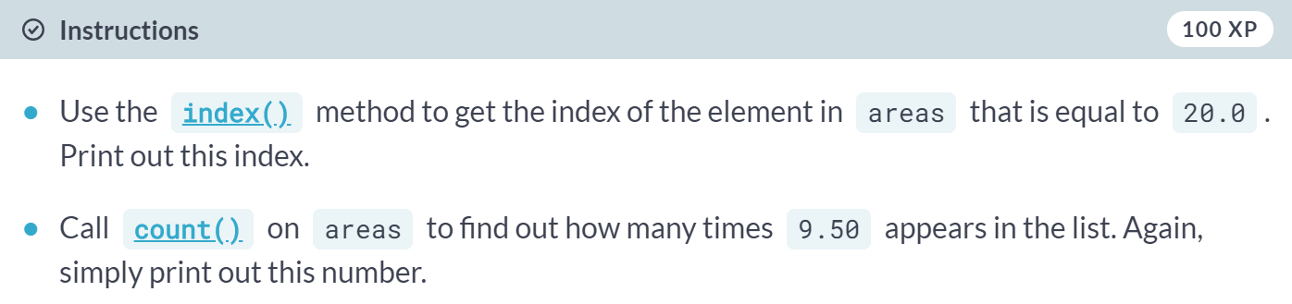

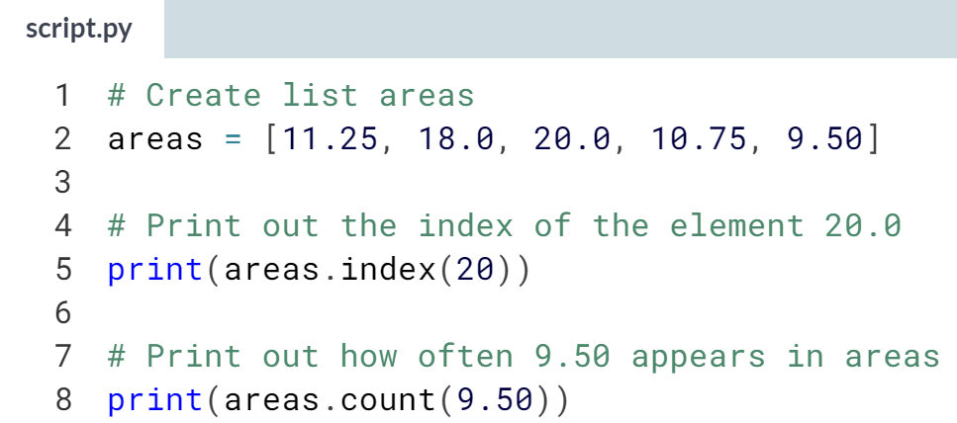

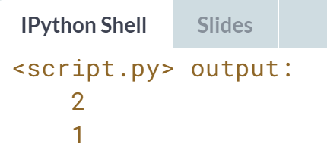

Nice! These were examples of list methods that did not change the list they were called on.

# List Methods (2)

Most list methods will change the list they're called on. Examples are:

* [**append()**](https://docs.python.org/3/library/stdtypes.html#typesseq-mutable), that adds an element to the list it is called on,
* [**remove()**](https://docs.python.org/3/library/stdtypes.html#typesseq-mutable), that removes the first element of a list that matches the input, and
* [**reverse()**](https://docs.python.org/3/library/stdtypes.html#typesseq-mutable), that reverses the order of the elements in the list it is called on.

You'll be working on the list with the area of different parts of the house: areas.

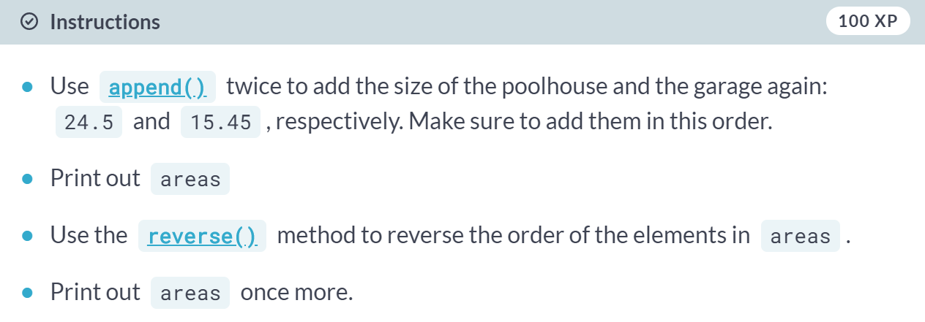

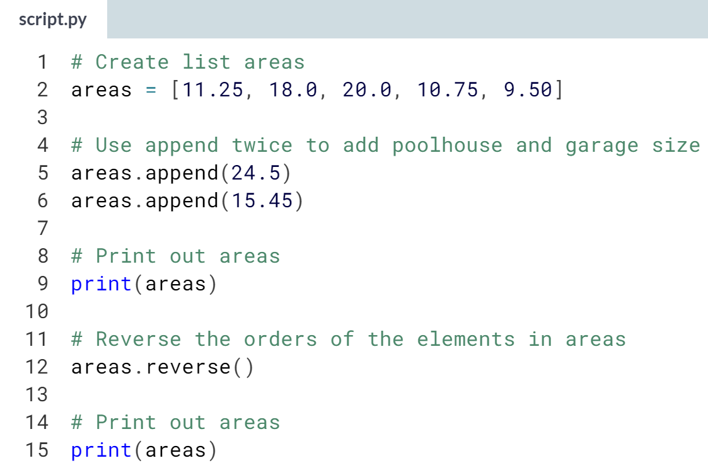  
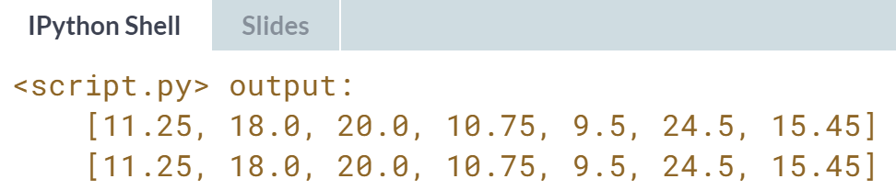

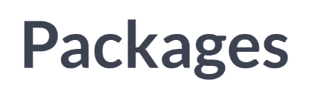

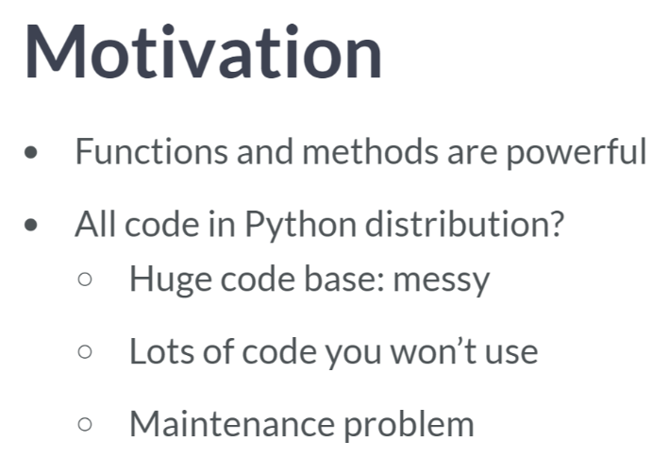  
Python function and method are extremely powerful: you can basically use other people's code to solve your own problems. However, adding all functions and methods that have been written up to now to the same Python distribution would be a mess. There would be tons and tons of code in there, that you will never use. Also, maintaining all of this code would be a real pain. And this is point where packages come into play.

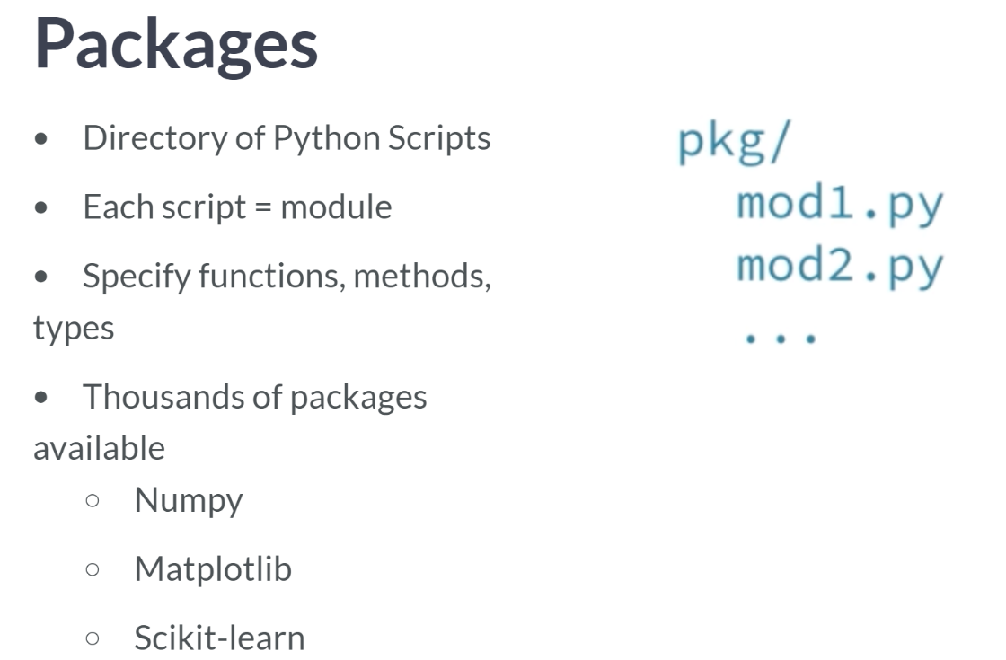  
You can think of packages as a directory of Python scripts. Each such script is a so-called module. These modules specify functions, methods, and new Python types aimed at solving particular problems. There are thousands of Python packages available from the internet.

Among them are packages for data science: there's NumPy to efficiently work with arrays, matplotlib for data visualization, and scikit-learn for machine learning. Not all of these packages are available in Python by default.

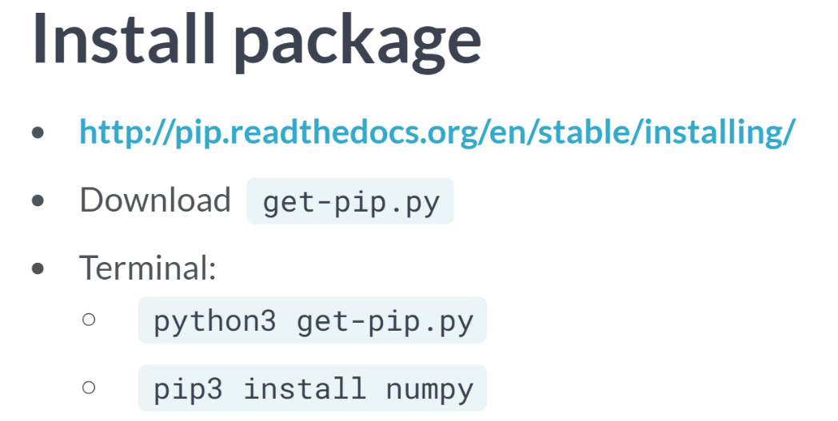  
To use Python packages, you'll first have to install them on your own system and put code in you script to tell Python that you want to use these packages.

DataCamp already has all necessary packages installed for you, but if you want to install them on our own system, you will want to use pip, a package maintenance system for Python. If you go to this URL above, you can download the file "get-pip.py". Next, you go to the terminal, and execute python3 "get-pip.py". Please note that Python version 3.4 has this already installed.

Now you can use pip to actually install a Python package of your choosing. Suppose that we want to install the NumPy package, which we will learn about in the next chapter. You type *"pip3 install numpy"*. You have to use the commands python3 and pip3 here to tell our system that we are working with Python version 3. Now the package is installed, you can start using it in one of your Python scripts.

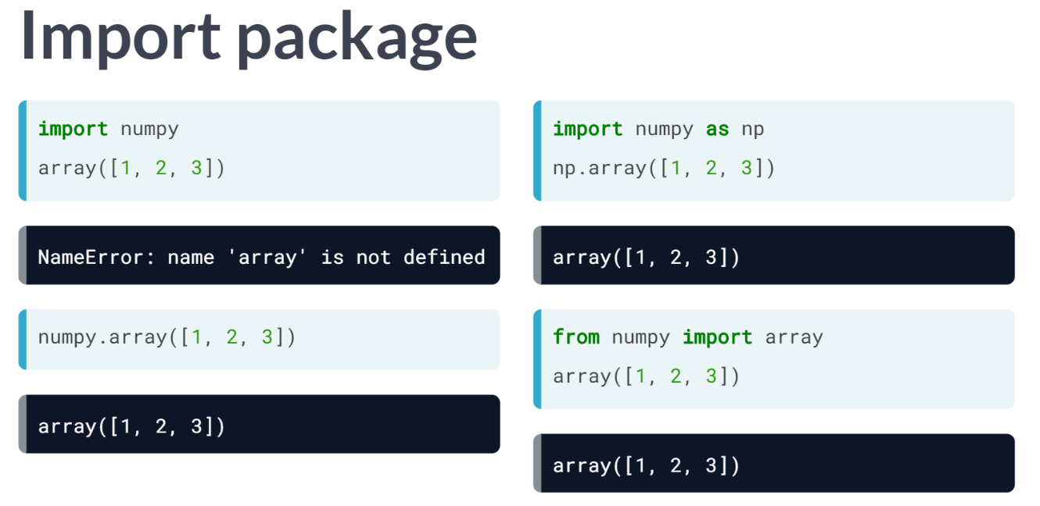  
Before you can do this, you should import the package, or a specific module of the package. You can do this with import statement. To import the entire numpy package, you can do *import numpy*, like this above. A commonly used function in Numpy is array. It takes a list as input. Simply calling the array function like this above, will generate an error, though.

To refer to the array function from the numpy package, you will instead use ***nump.array()***. This time it works. The Numpy array is very useful to do data science, but more on that later.

Using this *numpy.* prefix all the time can become pretty tedious, so you can import the package and refer to it with a different name. You can do this by extending your import statement with 'as', like the above (*import numpy as np*). Now, we can simply use ***np.array()*** function to perform the same task.

There are cases in which you only need one specific function of a package. Python allows you to make this explicit in your code. Suppose that we only want to use the ***array()*** function from the Numpy package. Instead of doing import numpy, you can instead do ‘*from numpy import array’*, like this above.

This time, we can simply call the array function like this, no need to use *numpy.* here. This from import version to use specific parts of a package can be useful to limit the amount of coding, but you are also losing some of the context,

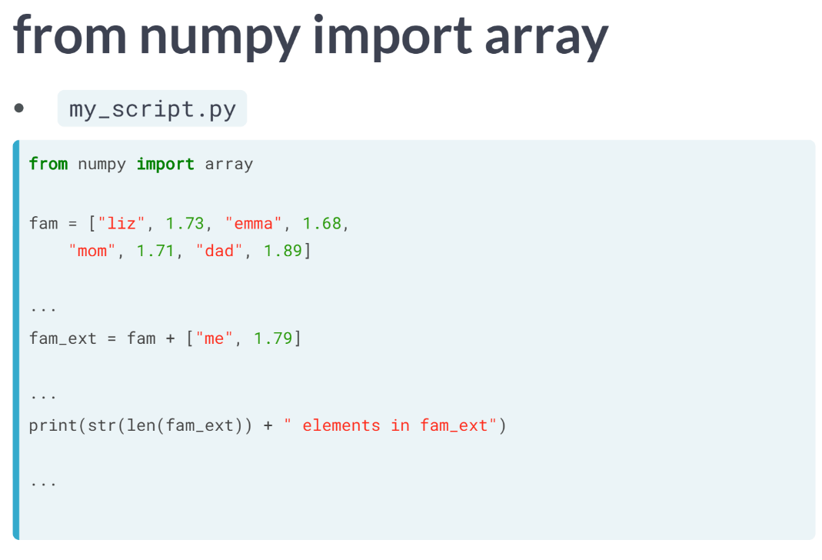  
Suppose you are working in a long Python script. You import the array function from numpy at the very top, and way later, you actually use this array function. Somebody else who's reading your code might have forgotten that this array function is a specific Numpy function; it is not clear from the function call. In that respect, the more standard import numpy call is preferred.

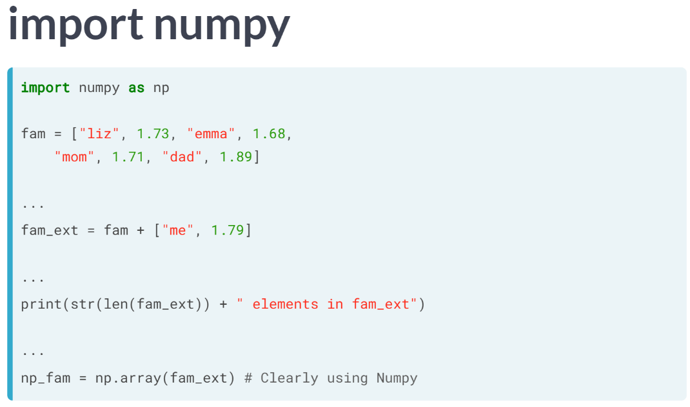  
In this case, your function call is *np.array*, making it very clear that you are working with Numpy. Off to the exercises now, where you can practice different ways of importing packages and modules yourself.

# Import package

As a data scientist, some notions of geometry never hurt. Let's refresh some of the basics.

For a fancy clustering algorithm, you want to find the circumference, $C$  , and area, $A$ , of a circle. When the radius of the circle is r, you can calculate $C$  and $A$  as:

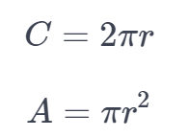

To use the constant pi, you'll need the math package. A variable r is already coded in the script. Fill in the code to calculate C and A and see how the [**print()**](https://docs.python.org/3/library/functions.html#print) functions create some nice printouts.

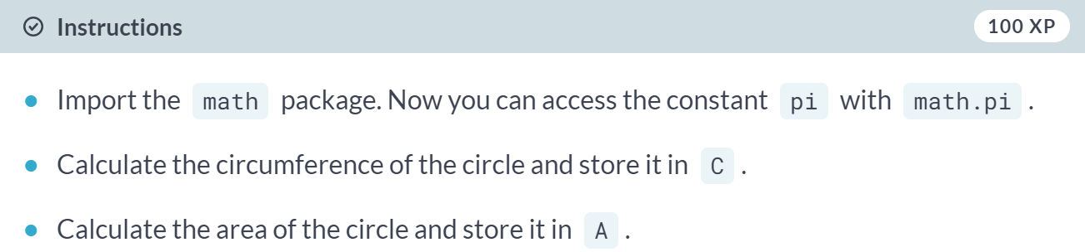  
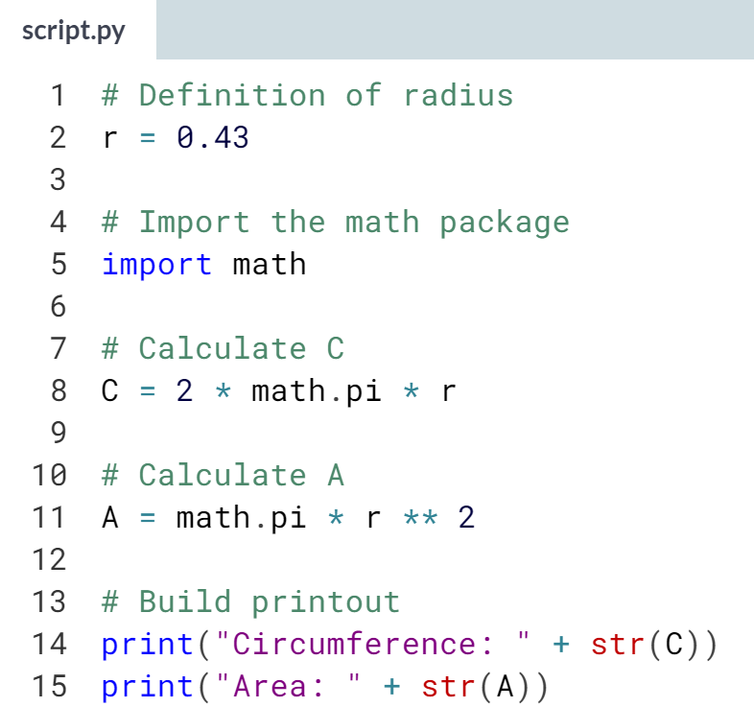  
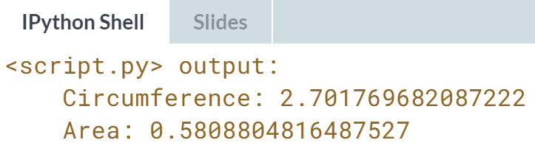   
Nice! If you know how to deal with functions from packages, the power of a lot of Python programmers is at your fingertips!

# Selective import

General imports, like import math, make **all** functionality from the math package available to you. However, if you decide to only use a specific part of a package, you can always make your import more selective:

from math import pi

Let's say the Moon's orbit around planet Earth is a perfect circle, with a radius r (in km) that is defined in the script.

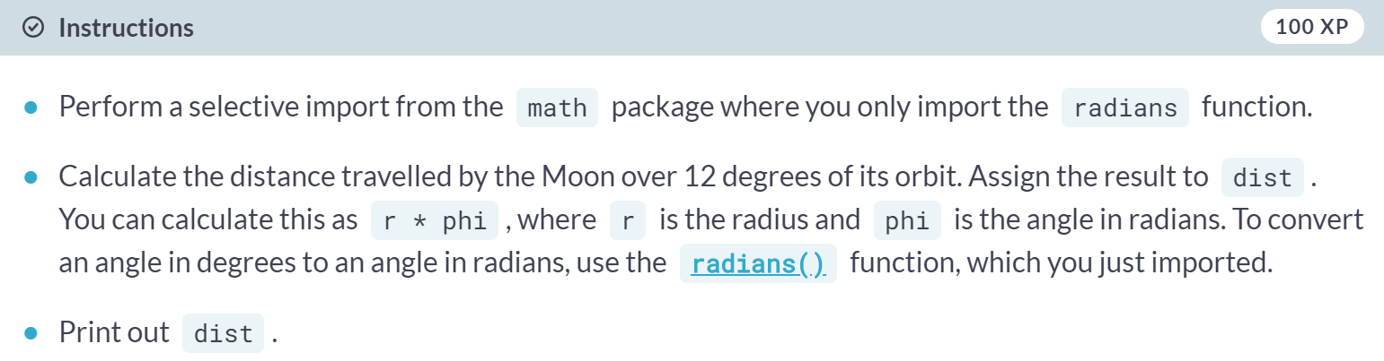

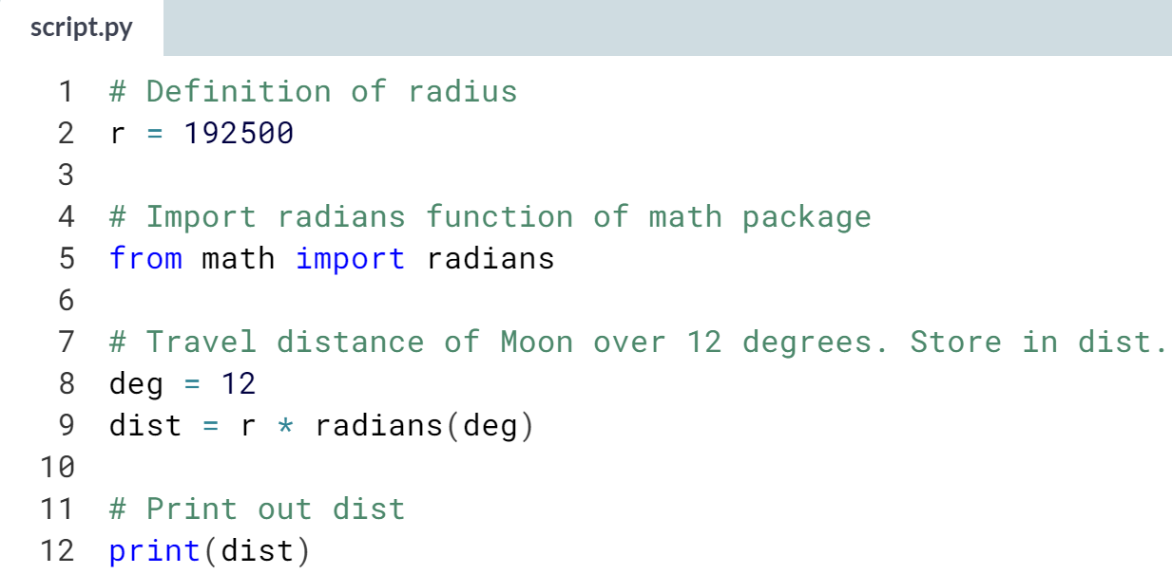

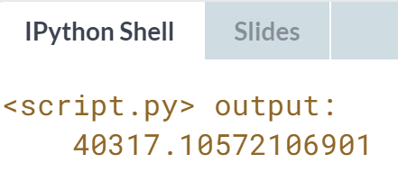

# Different ways of importing

There are several ways to import packages and modules into Python. Depending on the import call, you'll have to use different Python code.

Suppose you want to use the function [**inv()**](http://docs.scipy.org/doc/numpy-1.10.0/reference/generated/numpy.linalg.inv.html), which is in the linalg subpackage of the scipy package. You want to be able to use this function as follows:

my_inv([[1,2], [3,4]])

Which import statement will you need in order to run the above code without an error?

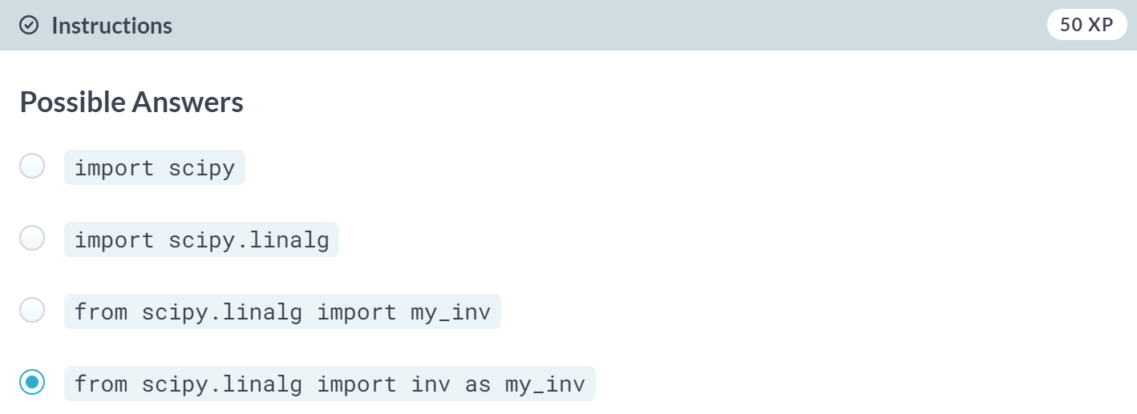  
Correct! The **as** word allows you to create a local name for the function you're importing: ***inv()***is now available as ***my_inv()***.

**4. NumPy**

NumPy is a fundamental Python package to efficiently practice data science. Learn to work with powerful tools in the NumPy array and get started with data exploration.

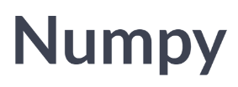

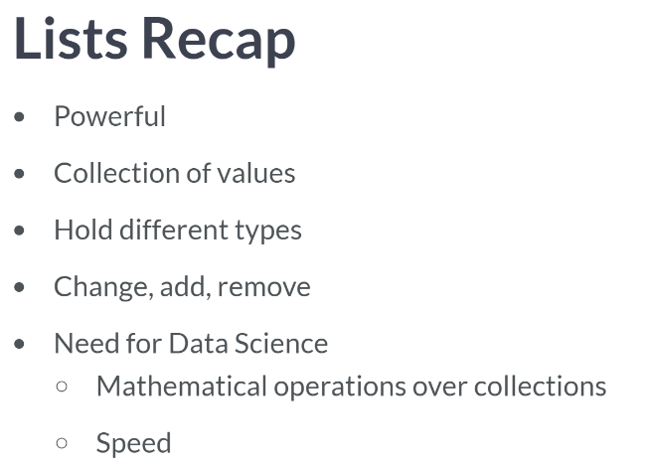

Recall that a list can hold any type and can hold different types at the same time. We can also change, add, and remove elements. But one feature is missing. When analyzing data, you'll often want to carry out operations over entire collections of values, and you want to do this fast. With lists, this is a problem.

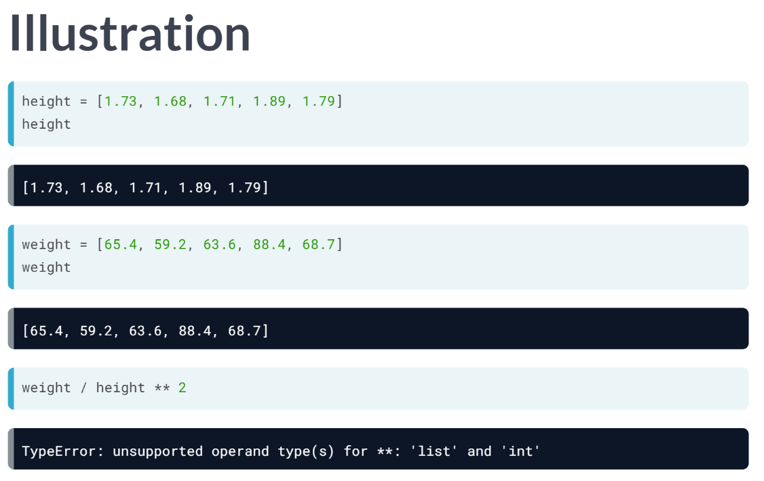  
Let's retake the height of your family and yourself. Suppose you've also asked for everybody's weight. You end up with two lists, height and weight. The first person is 1.73 meters tall and weighs 65.4 kilograms. If you want to calculate the BMI for each family member, you'd hope that this call works, making the calculations elementwise.

Unfortunately, Python throws an error because it has no idea how to do calculations on lists. You could solve this by going through each list elements one after the other, and calculating the BMI for each person separately, but this is terribly tedious.

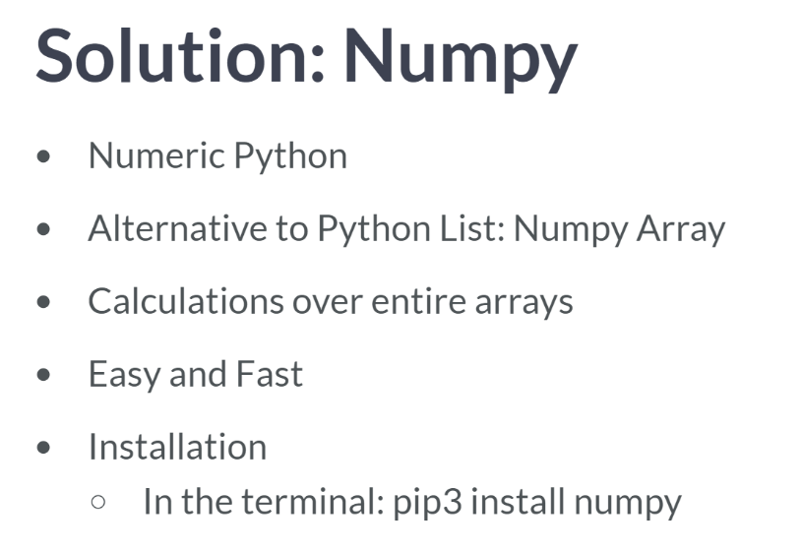  
A way more elegant solution is to use NumPy, or Numeric Python. It's a Python package that, among others, provides a alternative to the regular python list: the NumPy array. The NumPy array is pretty similar to the list but has one additional feature: you can perform calculations over entire arrays. It's really easy, and super-fast as well. If you intend to work with this package in your own system, go to the command line and execute *'pip3 install numpy'*.

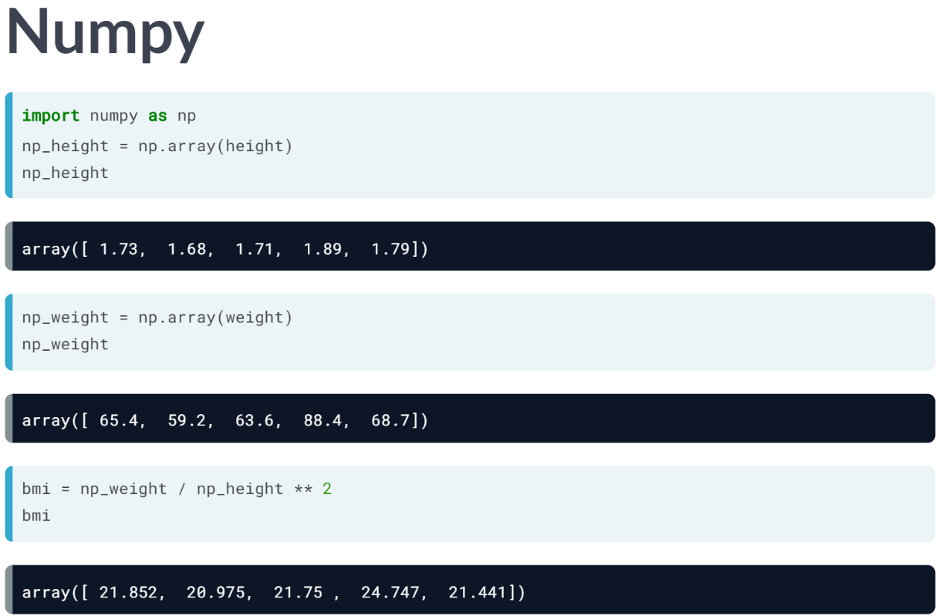  
Next, to actually use Numpy in your Python session, you can import the numpy package, like this. Let's start with creating a numpy array.

You do this with NumPy’s array function: the input is a regular Python list. We are using the array twice here, to create Numpy versions of the height and weight lists from before: *np_height* and *np_weight*. Let's try to calculate everybody's BMI with a single call again. This time, it works fine!

The calculations were performed elementwise. The first person's BMI was calculated by dividing the first element in *np_weight* by the square of the first element in *np_height*, the second person's BMI was calculated with the second height and weight elements, and so on.

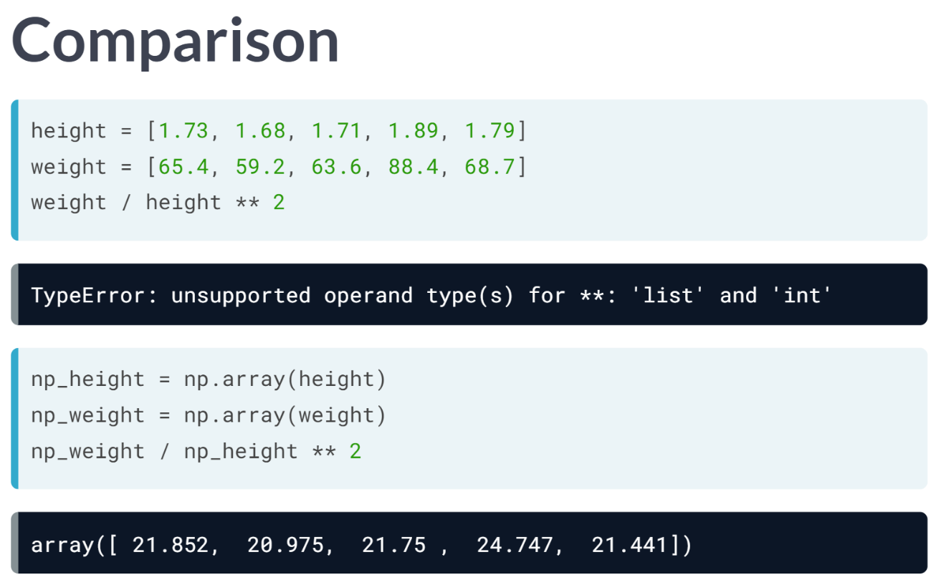  
Let's do a quick comparison here. First, we tried to do calculations with regular lists, like this, but this gave us an error because Python doesn't know how to do calculations with lists like we want them to. Next, these regular lists where converted to NumPy arrays. The same operations now work without any problem: Numpy knows how to work with arrays as if they are single values, which is quite awesome.

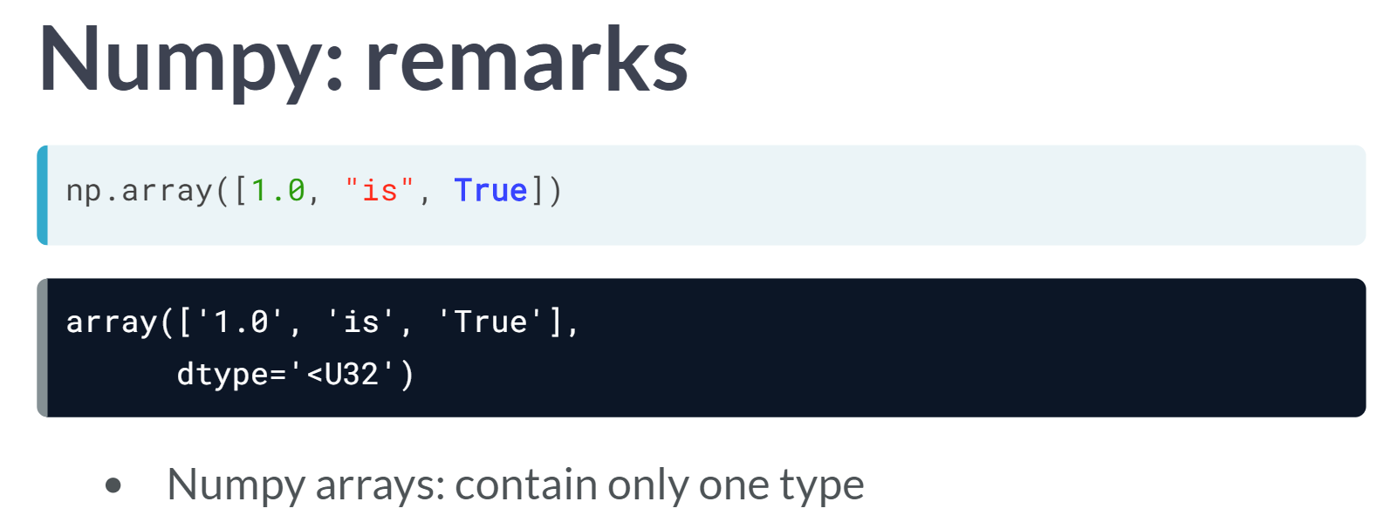  
You should still pay attention, though. First of all, Numpy can do all of this so easily because it assumes that your NumPy array can only contain values of a single type. It's either an array of floats, either an array of Booleans, and so on.

If you do try to create an array with different types, like this for example, the resulting Numpy array will contain a single type, string in this case. The Boolean and the float were both converted to strings.

Second, you should know that a Numpy array is simply a new kind of Python type, like the float, string, and list types from before. This means that it comes with its own methods, which can behave differently than you'd expect.

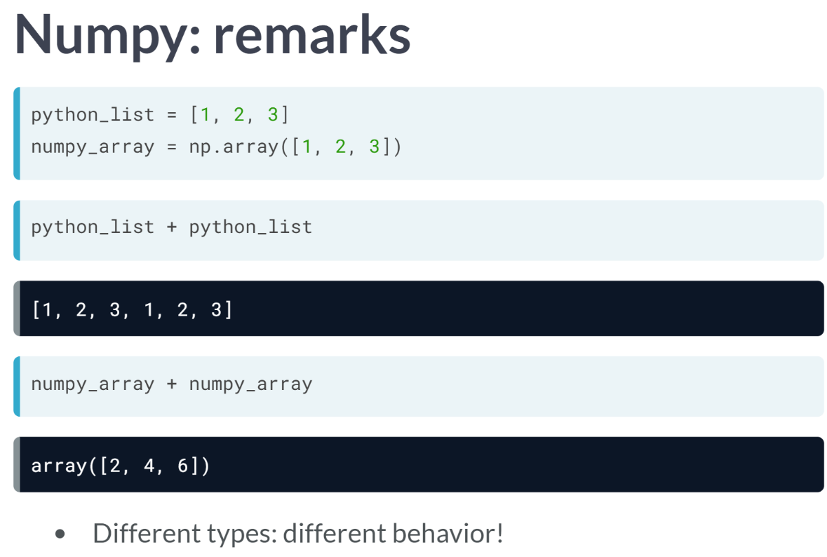

Take this Python list and this numpy array for example. If you perform *python_list* + *python_list*, the list elements are pasted together, generating a list with 6 elements.

If you do this with the numpy array, on the other hand, Python will do an elementwise sum of the arrays.

Just make sure to pay attention when you're juggling around with different Python types, because the outcomes can differ a lot. Apart from these subtleties, you can work with Numpy arrays pretty much the same as you can with regular Python lists.

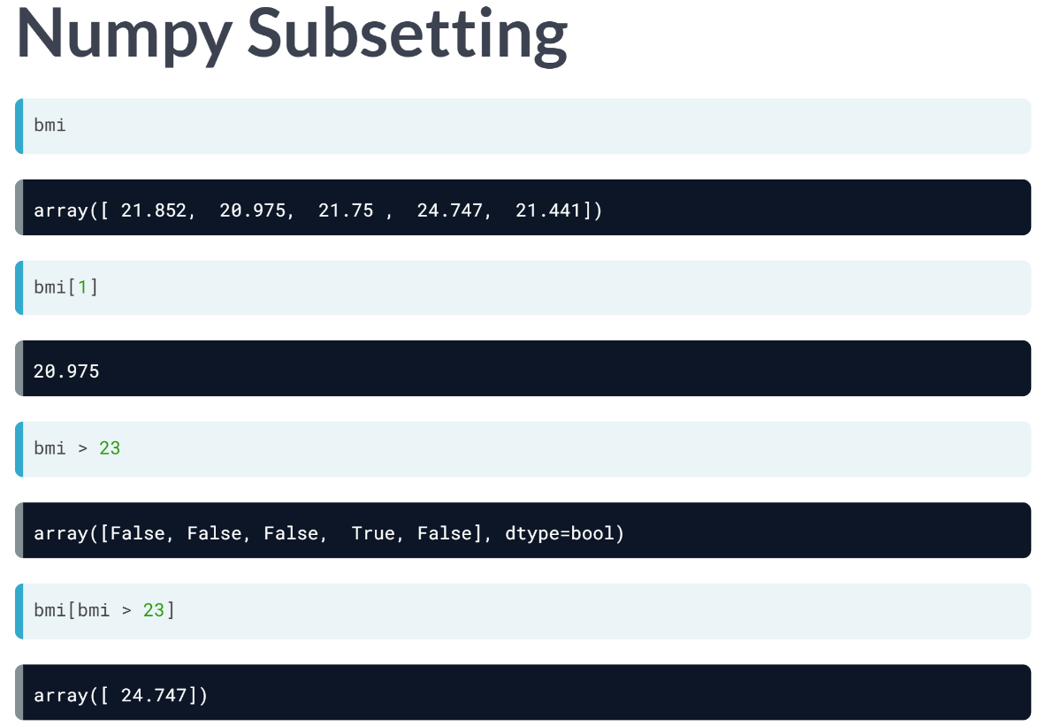  
When you want to get elements from your array, for example, you can use square brackets. Suppose you want to get the BMI for the second person, so at index 1. This will do the trick.

Specifically, for NumPy, there's also another way to do list subsetting: using an array of Booleans. Say you want to get all BMI values in the *bmi* array that are over 23. A first step is using the greater than sign, like the third example. The result is a Numpy array containing Booleans: True if the corresponding BMI is above 23 and False otherwise.

Next, we can use this Boolean array inside square brackets to do subsetting. Only the elements in BMI that are above 23, so for which the corresponding Boolean value is TRUE, is selected. There's only one BMI that's above 34, so we end up with a Numpy array with a single value, that specific BMI. Using the result of a comparison to select your data is a very common way to get surprising insights.

# Your First NumPy Array

In this chapter, we're going to dive into the world of baseball. Along the way, you'll get comfortable with the basics of numpy, a powerful package to do data science.

A list baseball has already been defined in the Python script, representing the height of some baseball players in centimeters. Can you add some code here and there to create a numpy array from it?

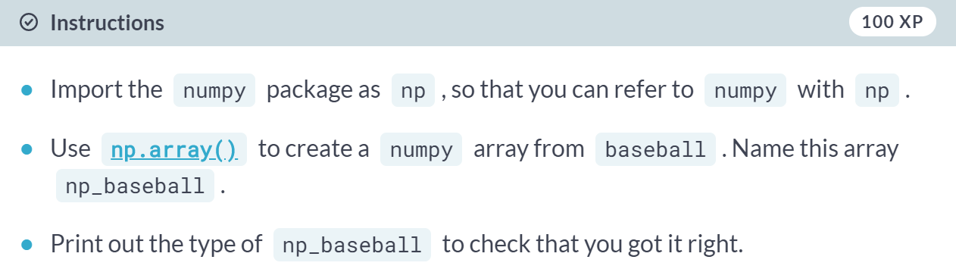

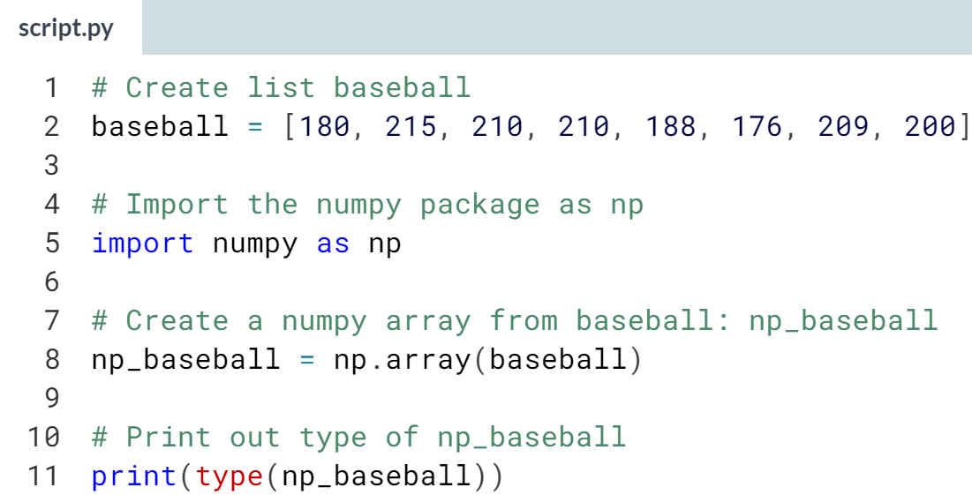  
  
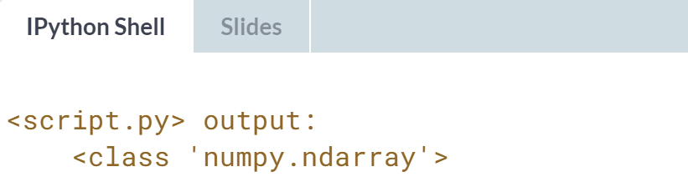

# Baseball players' height

You are a huge baseball fan. You decide to call the MLB (Major League Baseball) and ask around for some more statistics on the height of the main players. They pass along data on more than a thousand players, which is stored as a regular Python list: height_in. The height is expressed in inches. Can you make a numpy array out of it and convert the units to meters?

height_in is already available and the numpy package is loaded, so you can start straight away (Source: [**stat.ucla.edu**](http://wiki.stat.ucla.edu/socr/index.php/SOCR_Data_MLB_HeightsWeights)).

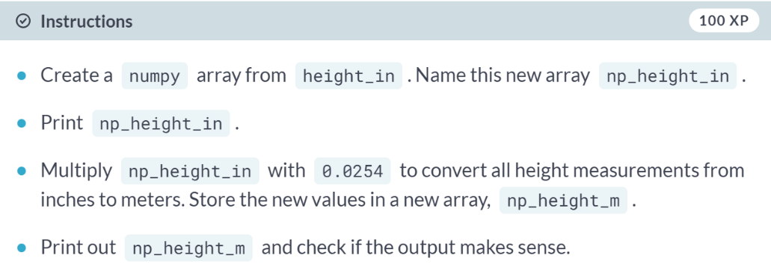

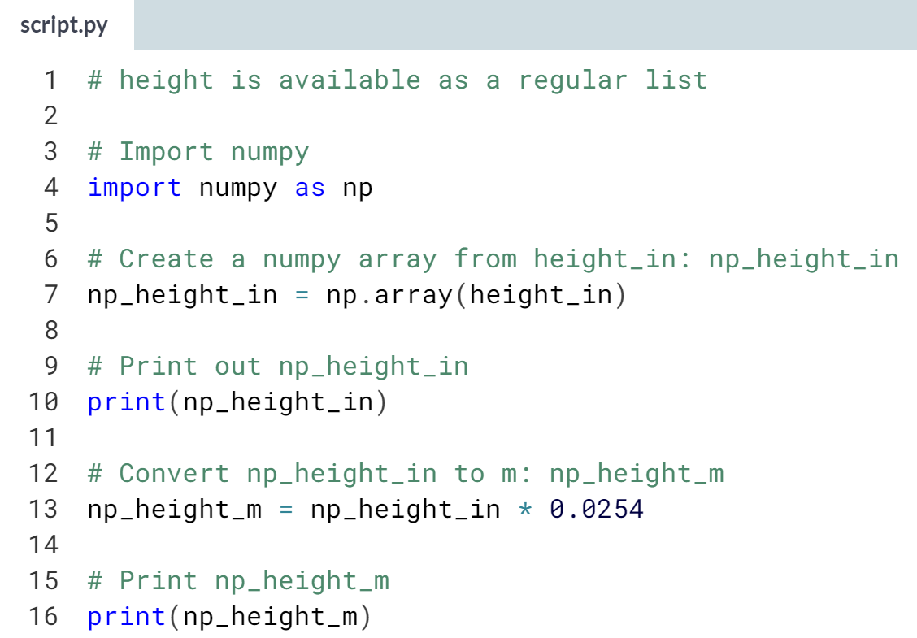

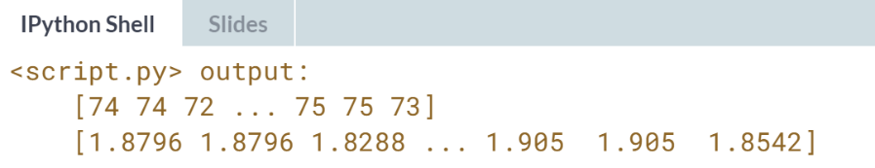  
Nice! In the blink of an eye, numpy performs multiplications on more than 1000 height measurements.

# Baseball player's BMI

The MLB also offers to let you analyze their weight data. Again, both are available as regular Python lists: height_in and weight_lb. height_in is in inches and weight_lb is in pounds.

It's now possible to calculate the BMI of each baseball player. Python code to convert height_in to a numpy array with the correct units is already available in the workspace. Follow the instructions step by step and finish the game!

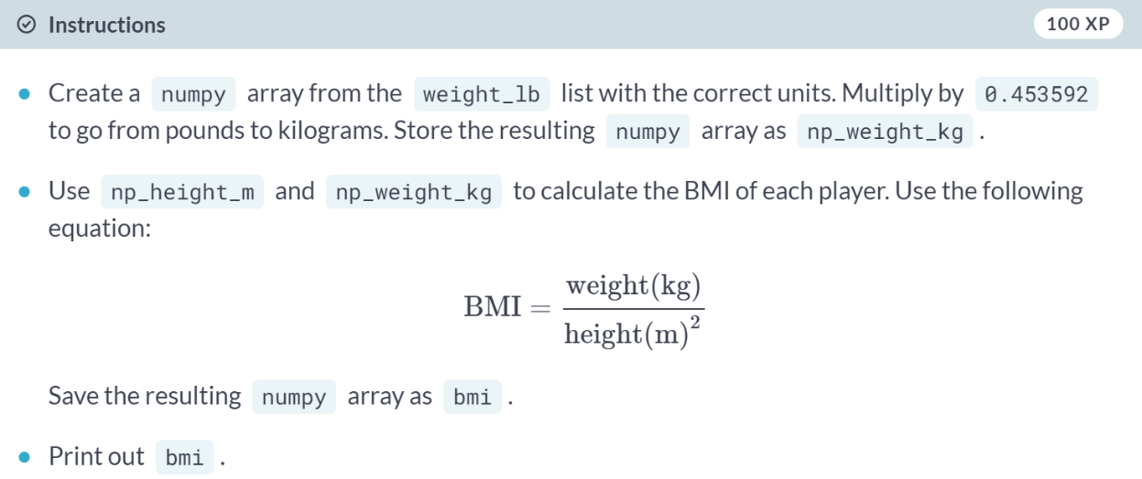

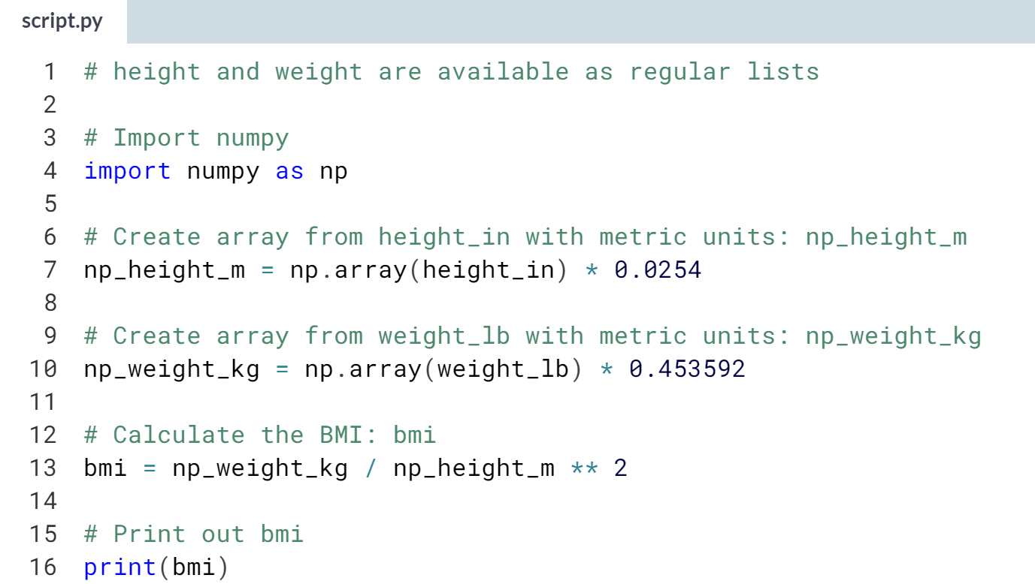  
  
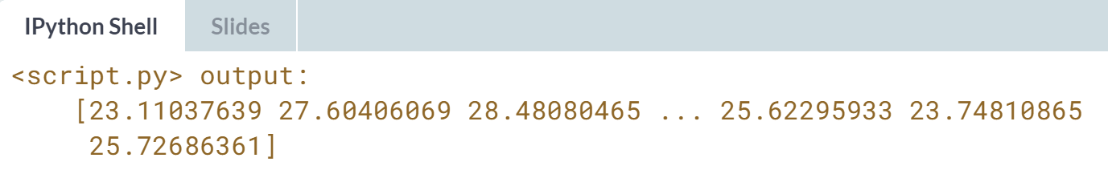

# Lightweight baseball players

To subset both regular Python lists and numpy arrays, you can use square brackets:

x = [4 , 9 , 6, 3, 1]

x[1]

import numpy as np

y = np.array(x)

y[1]

For numpy specifically, you can also use Boolean numpy arrays:

high = y > 5

y[high]

The code that calculates the BMI of all baseball players is already included. Follow the instructions and reveal interesting things from the data!

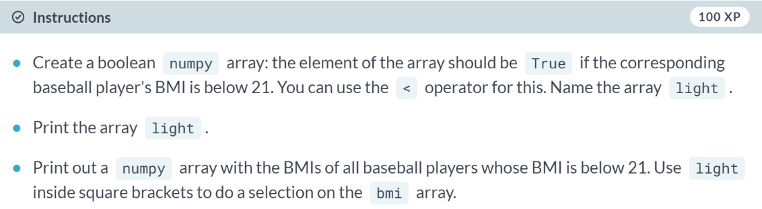  
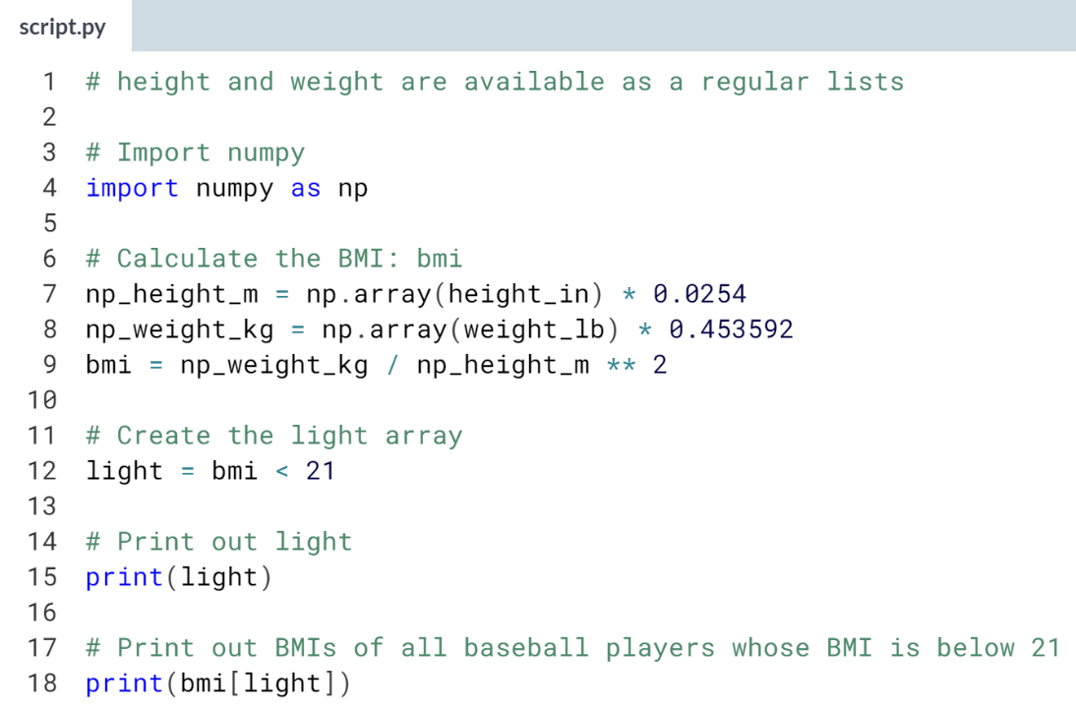  
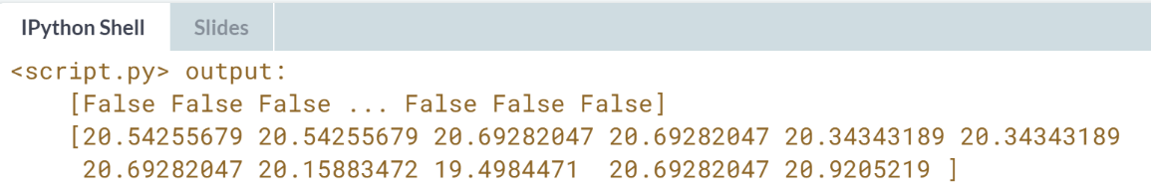  
Wow! It appears that only 11 of the more than 1000 baseball players have a BMI under 21!

# NumPy Side Effects

As Hugo explained before, numpy is great for doing vector arithmetic. If you compare its functionality with regular Python lists, however, some things have changed.

First of all, numpy arrays cannot contain elements with different types. If you try to build such a list, some of the elements' types are changed to end up with a homogeneous list. This is known as type coercion.

Second, the typical arithmetic operators, such as +, -, * and / have a different meaning for regular Python lists and numpy arrays.

Have a look at this line of code:

np.array([True, 1, 2]) + np.array([3, 4, False])

Can you tell which code chunk builds the exact same Python object? The numpy package is already imported as np, so you can start experimenting in the IPython Shell straight away!

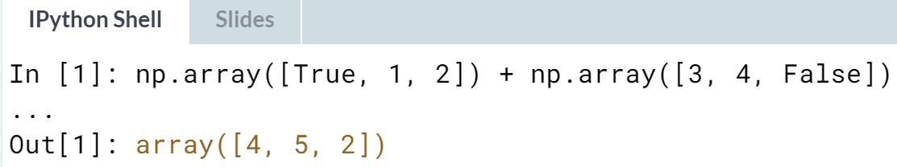

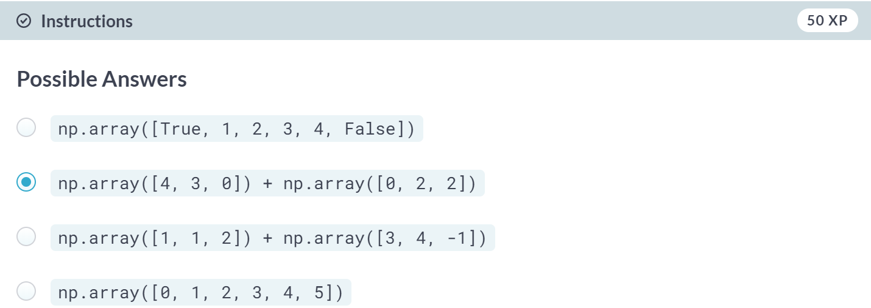

Great job! True is converted to 1, False is converted to 0.

# Subsetting NumPy Arrays

You've seen it with your own eyes: Python lists and numpy arrays sometimes behave differently. Luckily, there are still certainties in this world. For example, subsetting (using the square bracket notation on lists or arrays) works exactly the same. To see this for yourself, try the following lines of code in the IPython Shell:

x = ["a", "b", "c"]

x[1]

np_x = np.array(x)

np_x[1]

The script on the right already contains code that imports numpy as np, and stores both the height and weight of the MLB players as numpy arrays.

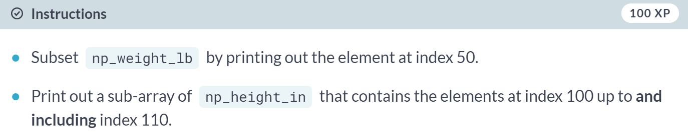

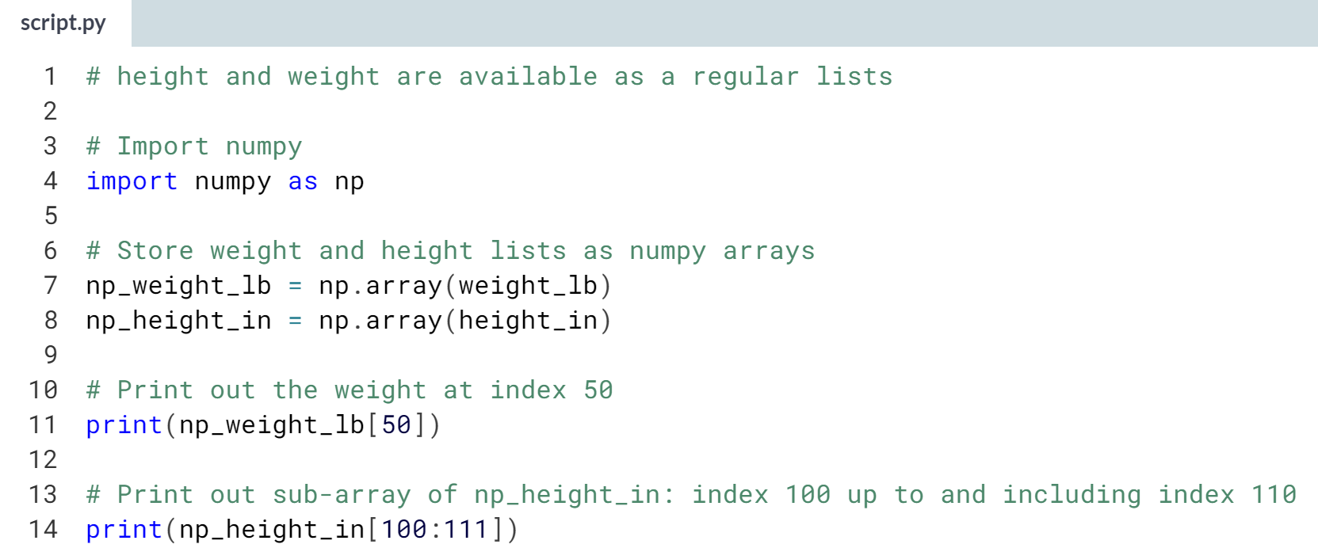  
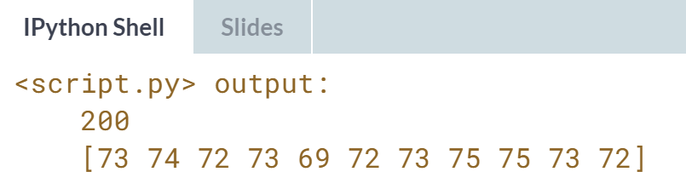

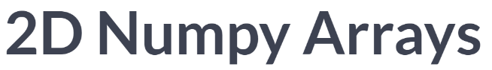

Let's now recreate the NumPy arrays from the previous video.

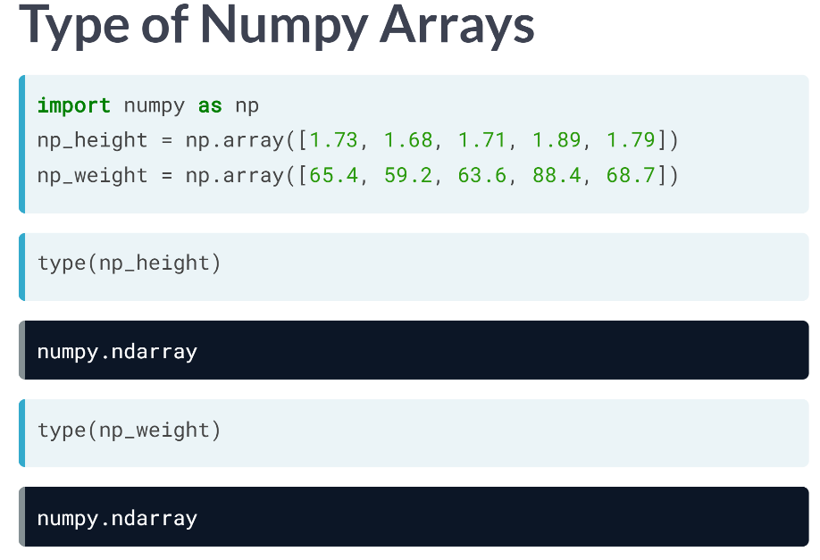  
If you ask for the type of these arrays, Python tells you that they are *numpy.ndarray*.

***numpy.*** tells you it's a type that was defined in the NumPy package. ***ndarray*** stands for n-dimensional array. The arrays *np_height* and *np_weight* are one-dimensional arrays, but it's perfectly possible to create two-dimensional, three-dimensional, heck even seven dimensional arrays. Let's stick to 2 in this lesson, though.

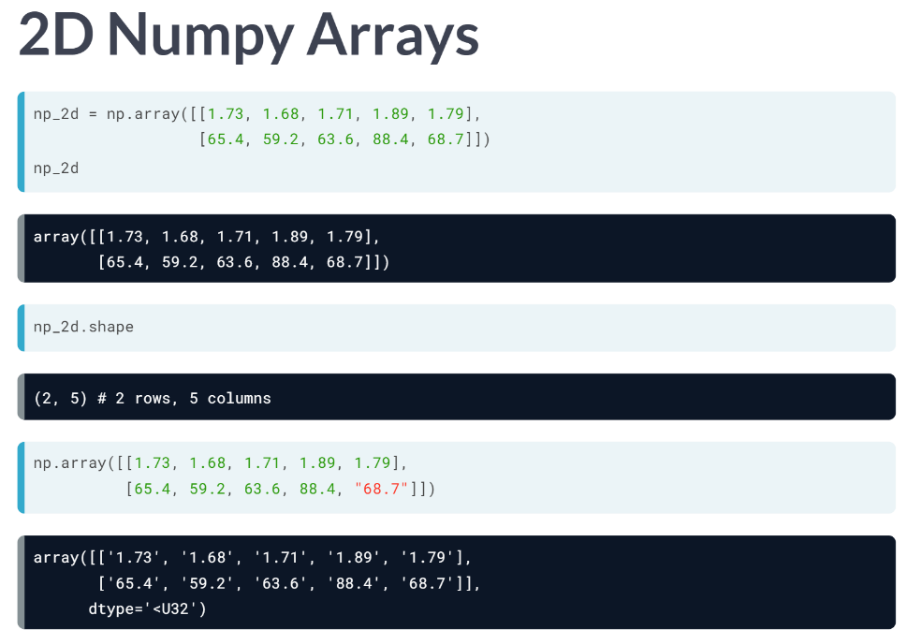  
You can create a 2D numpy array from a regular Python list of lists. Let's try to create one numpy array for all height and weight data of your family, like the first example. If you print out np_2d now, you'll see that it is a rectangular data structure: each sublists in the list, corresponds to a row in the two-dimensional numpy array. From *np_2d.shape*, we can see that we have two rows and 5 columns. *shape* is a so-called attribute of the np2d array, that can give you more information about what the data structure looks like. Also, for 2D arrays, the Numpy rule applies: an array can only contain a single type. If you change one float to be string, all the array elements will be coerced to strings, to end up with a homogeneous way.

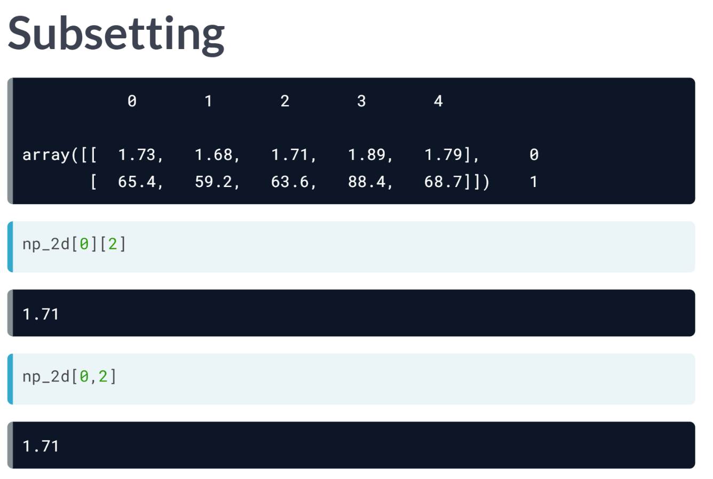  
You can think of the 2D numpy array as an improved list of lists: you can perform calculations on the arrays, like it is shown before, and you can do more advanced ways of subsetting.

Suppose you want the first row, and then the third element in that row. To select the row, you need the index 0 in square brackets. Don't forget about zero indexing.

To then select the third element, you can extend the same call with another pair of brackets, this time with the index 2, like this. Basically, you are selecting the row, and then from that row, do another selection.

There's also an alternative way of subsetting, using single square brackets and a comma. This call returns the exact same value as before. The value before comma specifies the row, the value after the comma specifies the column.

The intersection of the rows and columns you specified, are returned. Once you get used to it, this syntax is more intuitive and opens up more possibilities.

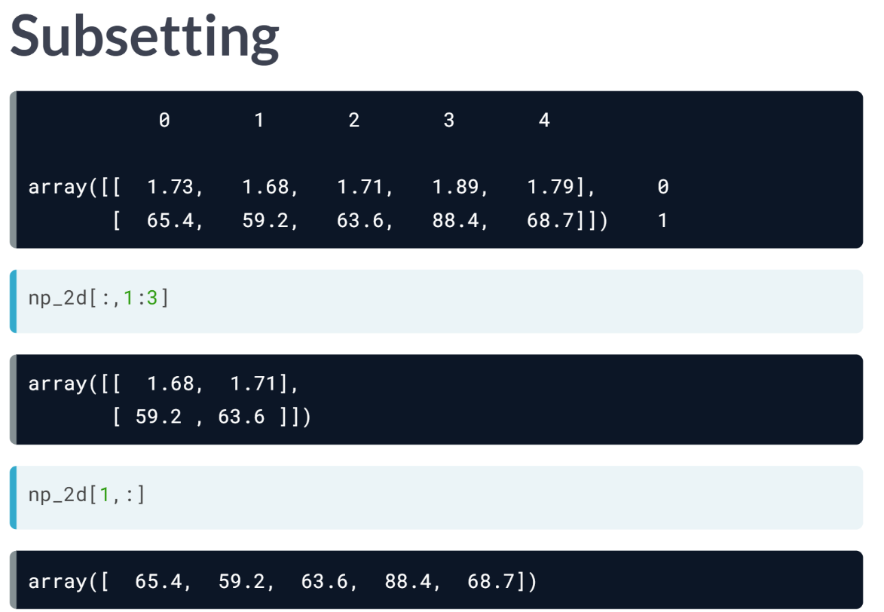  
Suppose that you want to select the height and weight of the second and third family member. You want both rows, so you put in a colon before the comma.

You only want the second and third column, so you put in the indices 1 to 3 after the comma. Remember that the third index is not included here. The intersection gives us a 2D array with 2 rows and 2 columns.

Similarly, you can select the weight of all family members like this: you only want the second row, so put 1 before the comma. You want all columns, so you use a colon after the comma. The intersection gives us the entire second row.

Finally, 2D NumPy arrays enable you to do elementwise calculations, the same way you did it with 1D numpy arrays. Let's practice these things in the following exercises.

# Your First 2D NumPy Array

Before working on the actual MLB data, let's try to create a 2D numpy array from a small list of lists.

In this exercise, baseball is a list of lists. The main list contains 4 elements. Each of these elements is a list containing the height and the weight of 4 baseball players, in this order. baseball is already coded for you in the script.

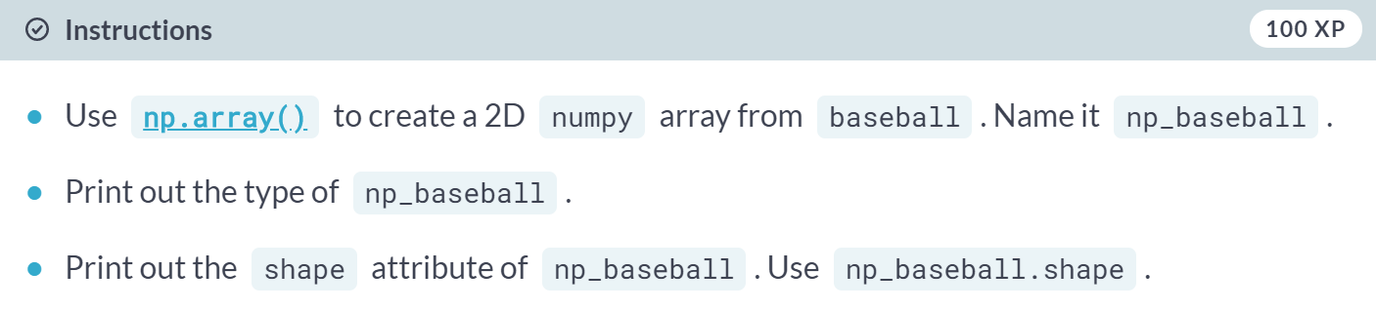  
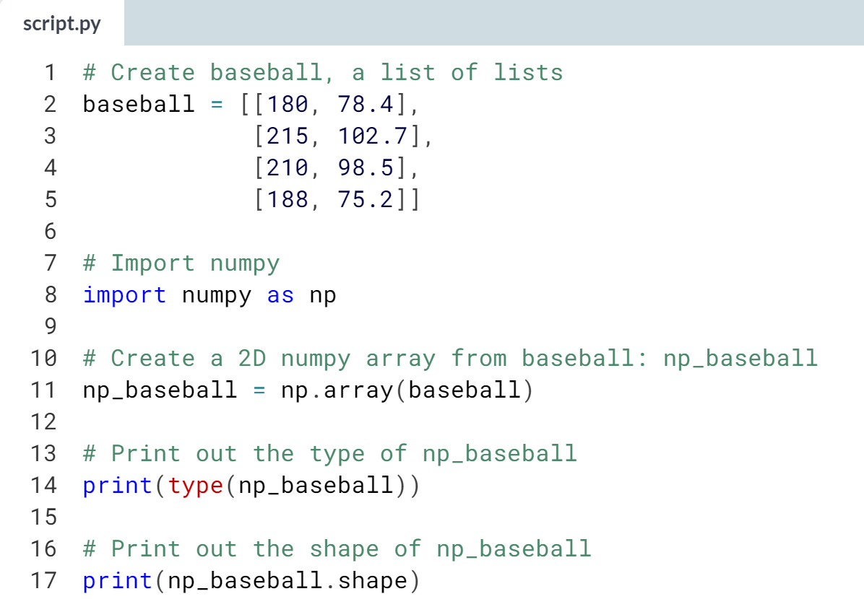  
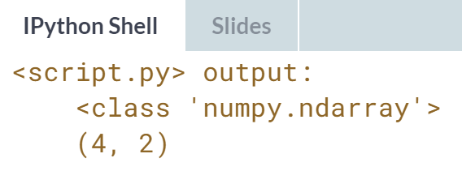  
Great! You're ready to convert the actual MLB data to a 2D NumPy array now!

# Baseball data in 2D form

You have another look at the MLB data and realize that it makes more sense to restructure all this information in a 2D numpy array. This array should have 1015 rows, corresponding to the 1015 baseball players you have information on, and 2 columns (for height and weight).

The MLB was, again, very helpful and passed you the data in a different structure, a Python list of lists. In this list of lists, each sublist represents the height and weight of a single baseball player. The name of this embedded list is baseball.

Can you store the data as a 2D array to unlock numpy's extra functionality?

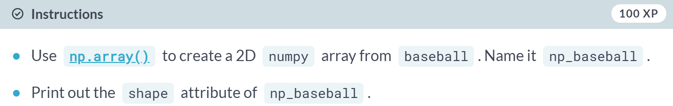

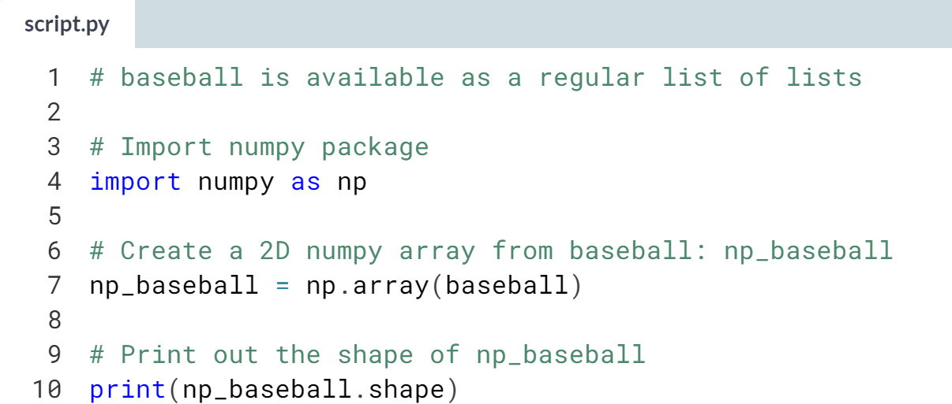  
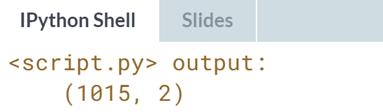  
Slick! Time to show off some killer features of multi-dimensional numpy arrays!

# Subsetting 2D NumPy Arrays

If your 2D numpy array has a regular structure, i.e. each row and column has a fixed number of values, complicated ways of subsetting become very easy. Have a look at the code below where the elements "a" and "c" are extracted from a list of lists.

# regular list of lists

x = [["a", "b"], ["c", "d"]]

[x[0][0], x[1][0]]

# numpy

import numpy as np

np_x = np.array(x)

np_x[:,0]

For regular Python lists, this is a real pain. For 2D numpy arrays, however, it's pretty intuitive! The indexes before the comma refer to the rows, while those after the comma refer to the columns. The : is for slicing; in this example, it tells Python to include all rows.

The code that converts the pre-loaded baseball list to a 2D numpy array is already in the script. The first column contains the players' height in inches and the second column holds player weight, in pounds. Add some lines to make the correct selections. Remember that in Python, the first element is at index 0!

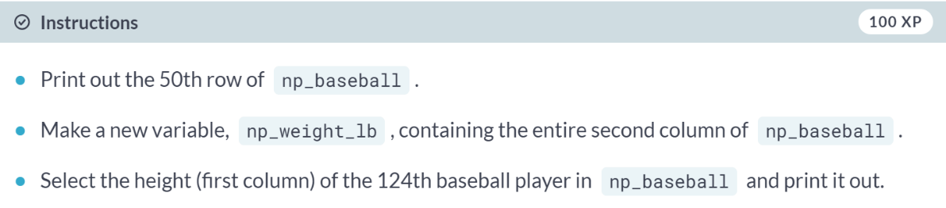  
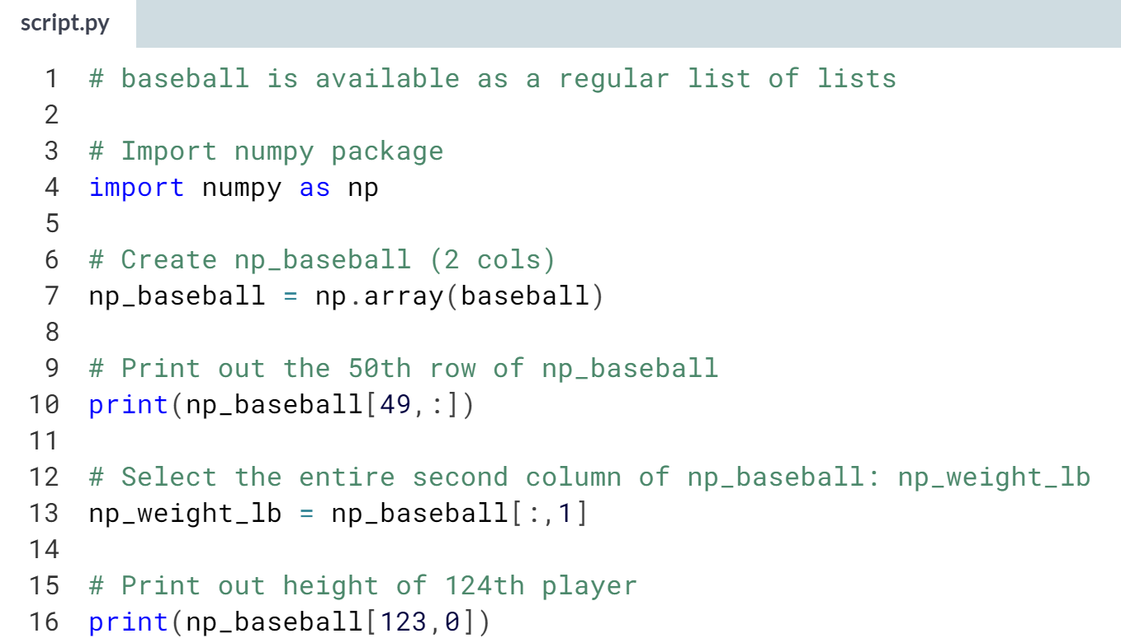  
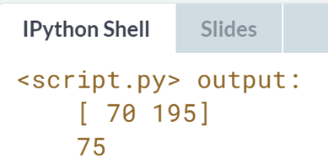

# 2D Arithmetic

Remember how you calculated the Body Mass Index for all baseball players? numpy was able to perform all calculations elementwise (i.e. element by element). For 2D numpy arrays this isn't any different! You can combine matrices with single numbers, with vectors, and with other matrices.

Execute the code below in the IPython shell and see if you understand:

import numpy as np

np_mat = np.array([[1, 2],

[3, 4],

[5, 6]])

np_mat * 2

np_mat + np.array([10, 10])

np_mat + np_mat

np_baseball is coded for you; it's again a 2D numpy array with 3 columns representing height (in inches), weight (in pounds) and age (in years).

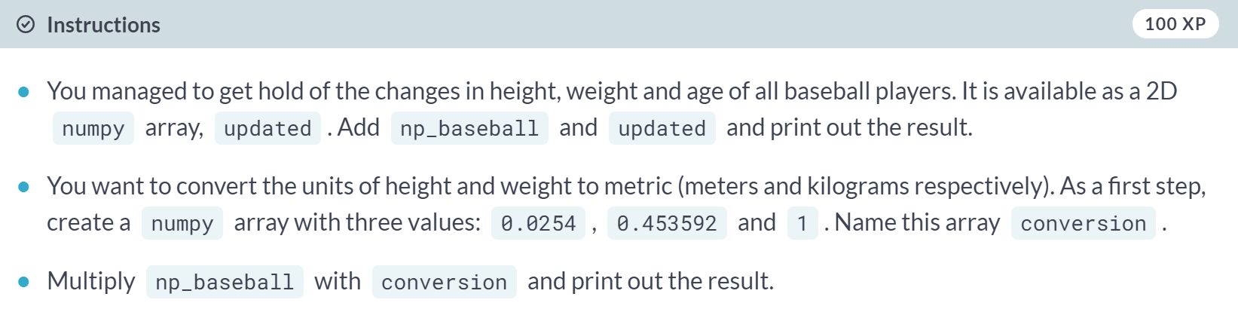  
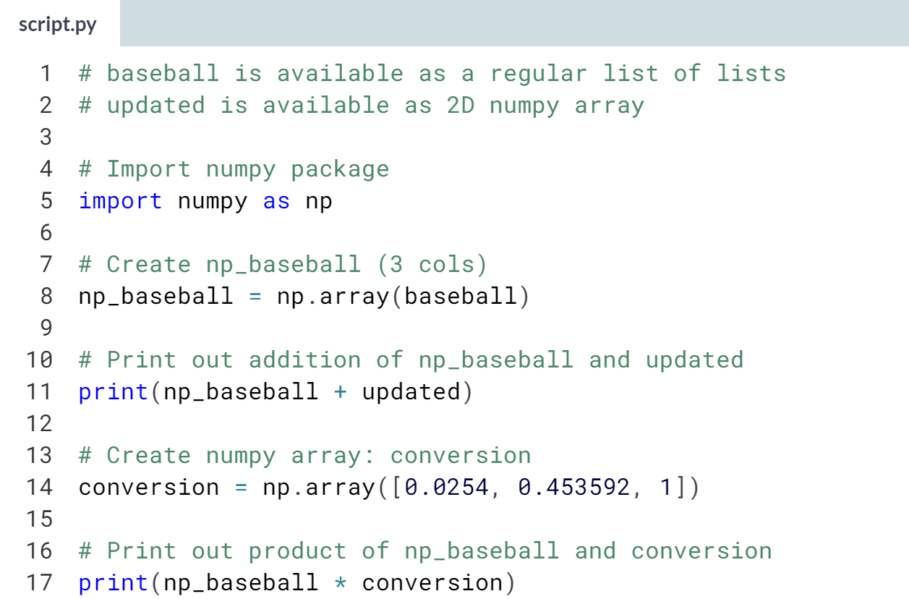  
(Results aren’t shown) Great job! Notice how with very little code, you can change all values in your numpy data structure in a very specific way. This will be very useful in your future as a data scientist!



A typical first step in analyzing your data, is getting to know your data in the first place.

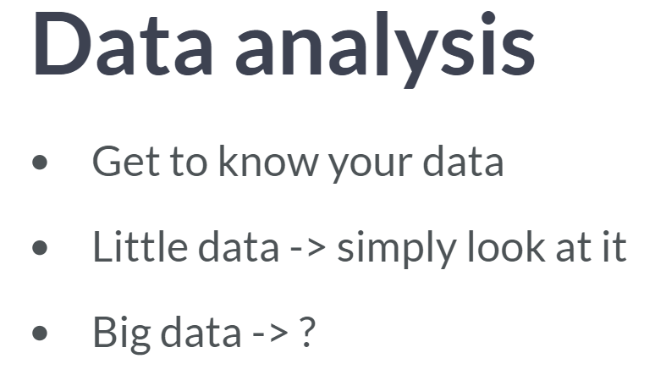

For the Numpy arrays from before, this is pretty easy, because it isn't a lot of data. However, as a data scientist, you'll be crunching thousands, if not millions or billions of numbers.

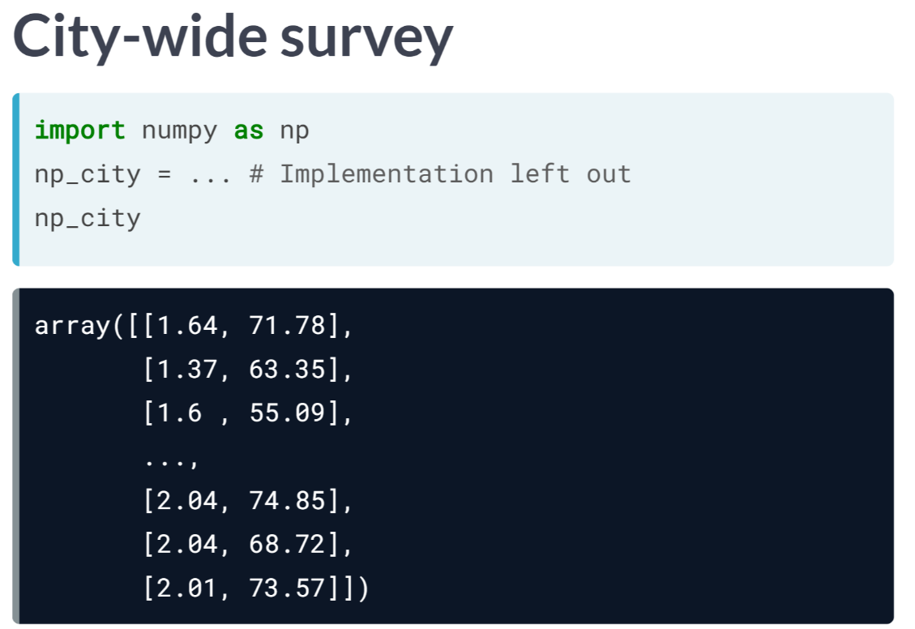  
Imagine you conduct a city-wide survey where you ask 5,000 adults about their height and weight. You end up something like this: a 2D numpy array, which I named *np_city*, that has 5,000 rows, corresponding to the 5,000 people, and two columns, corresponding to the height and the weight. Simply staring at these numbers like a zombie won't give you any insights. What you can do though, is generate summarizing stats about your data.

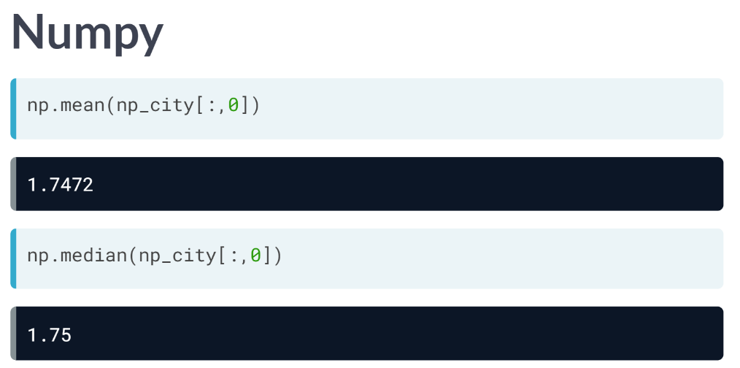  
Aside from an efficient data structure for number crunching, it happens that Numpy is also good at doing these kinds of things. For starters, you can try to find out the average height of these 5,000 people, with NumPy’s mean function. Because it's a function from the Numpy package, don't forget to start with np.; Of course, we first have to do a subsetting operation to get the height column from the 2D array. It appears that on average, people are 1.75 meters tall.

What about the median height? We can simply use ***np.median()*** function to find out. We can do similar things for the weight column in *np_city*. Often, these summarizing stats will provide you with a "sanity check" of your data. If you end up with an average weight of 2,000 kilograms, your measurements are most likely incorrect if these data were collected from human.

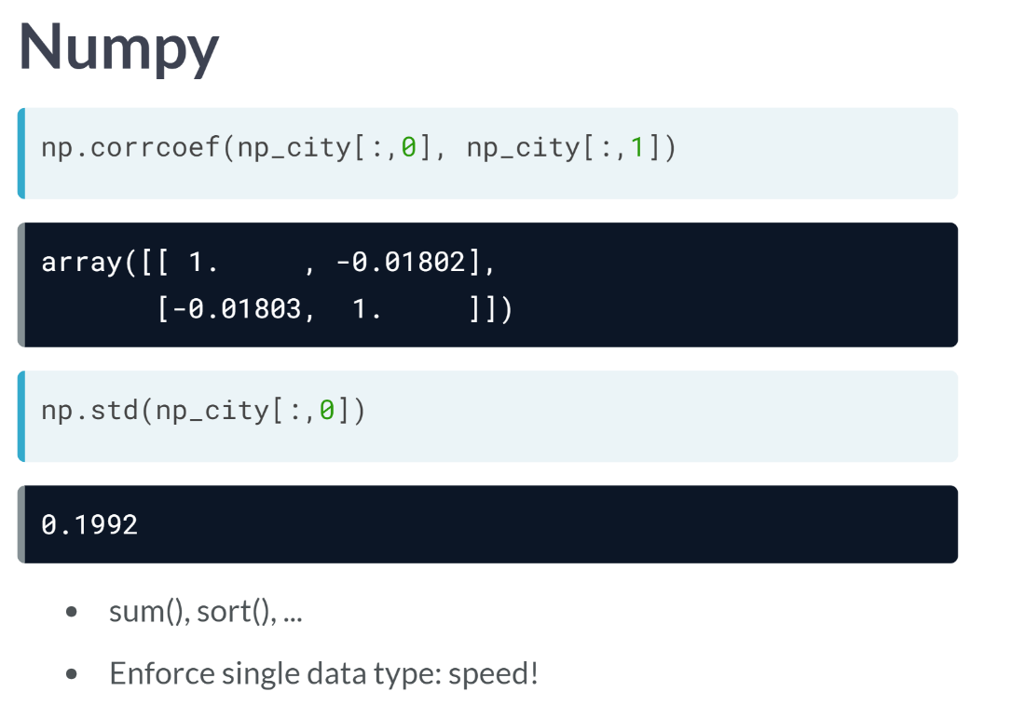  
Apart from mean and median, there's also other functions

like ***corrcoef()*** to check if, for example, height and weight are correlated, and ***std()***, for standard deviation. Numpy also features more basic functions, such as ***sum()*** and ***short()***, which also exist in the basic Python distribution. However, the big difference here is speed. Because Numpy enforces a single data type in an array, it can drastically speed up the calculations.

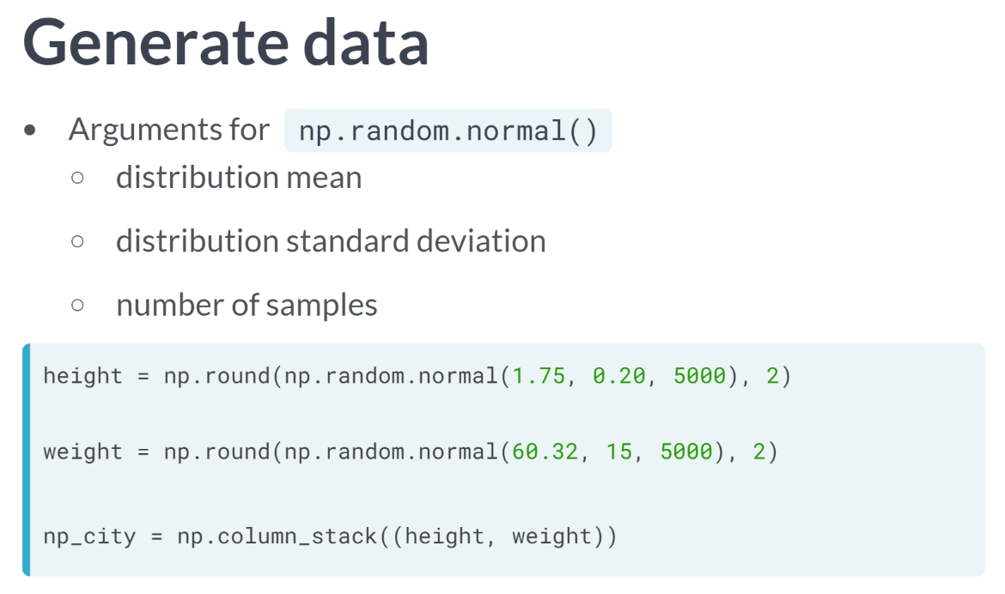  
Just as a side note, if you are wondering where the data comes from in this lesson, it is derived with NumPy functions. We sampled two random normal distributions 5,000 times to create the height and weight arrays, and then used *column_stack* to paste them together as two columns. Another awesome thing that NumPy can do!

Another great toll to get some sense of your data is to visualize it, but that's something for the next course. Let’s practice what we’ve discussed so far.

# Average versus median

You now know how to use numpy functions to get a better feeling for your data. It basically comes down to importing numpy and then calling several simple functions on the numpy arrays:

import numpy as np

x = [1, 4, 8, 10, 12]

np.mean(x)

np.median(x)

The baseball data is available as a 2D numpy array with 3 columns (height, weight, age) and 1015 rows. The name of this numpy array is np_baseball. After restructuring the data, however, you notice that some height values are abnormally high. Follow the instructions and discover which summary statistic is best suited if you're dealing with so-called outliers.

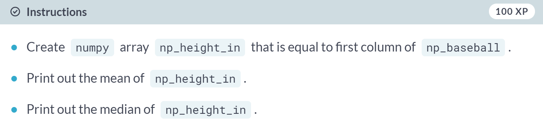

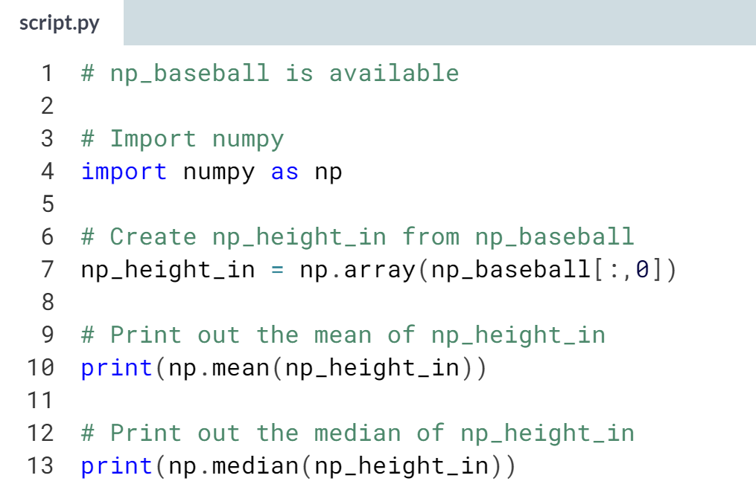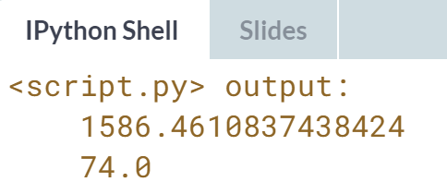

An average height of 1586 inches, that doesn't sound right, does it? However, the median does not seem affected by the outliers: 74 inches makes perfect sense. It's always a good idea to check both the median and the mean, to get an idea about the overall distribution of the entire dataset.

# Explore the baseball data

Because the mean and median are so far apart, you decide to complain to the MLB. They find the error and send the corrected data over to you. It's again available as a 2D Numpy array np_baseball, with three columns.

The Python script on the right already includes code to print out informative messages with the different summary statistics. Can you finish the job?

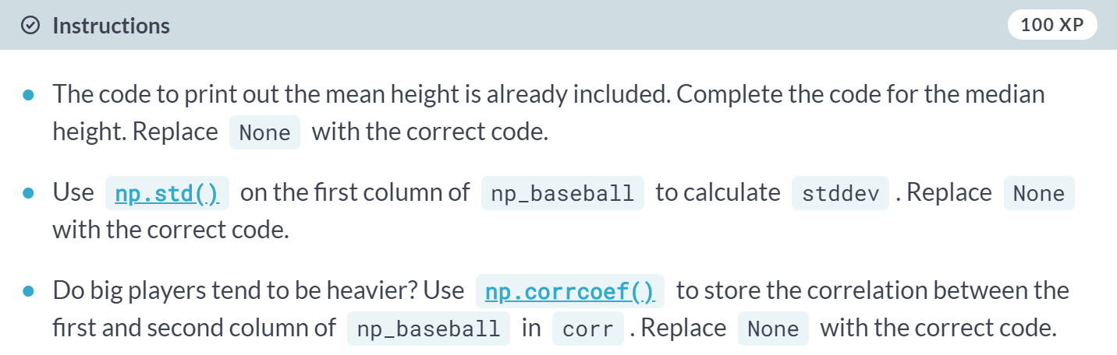

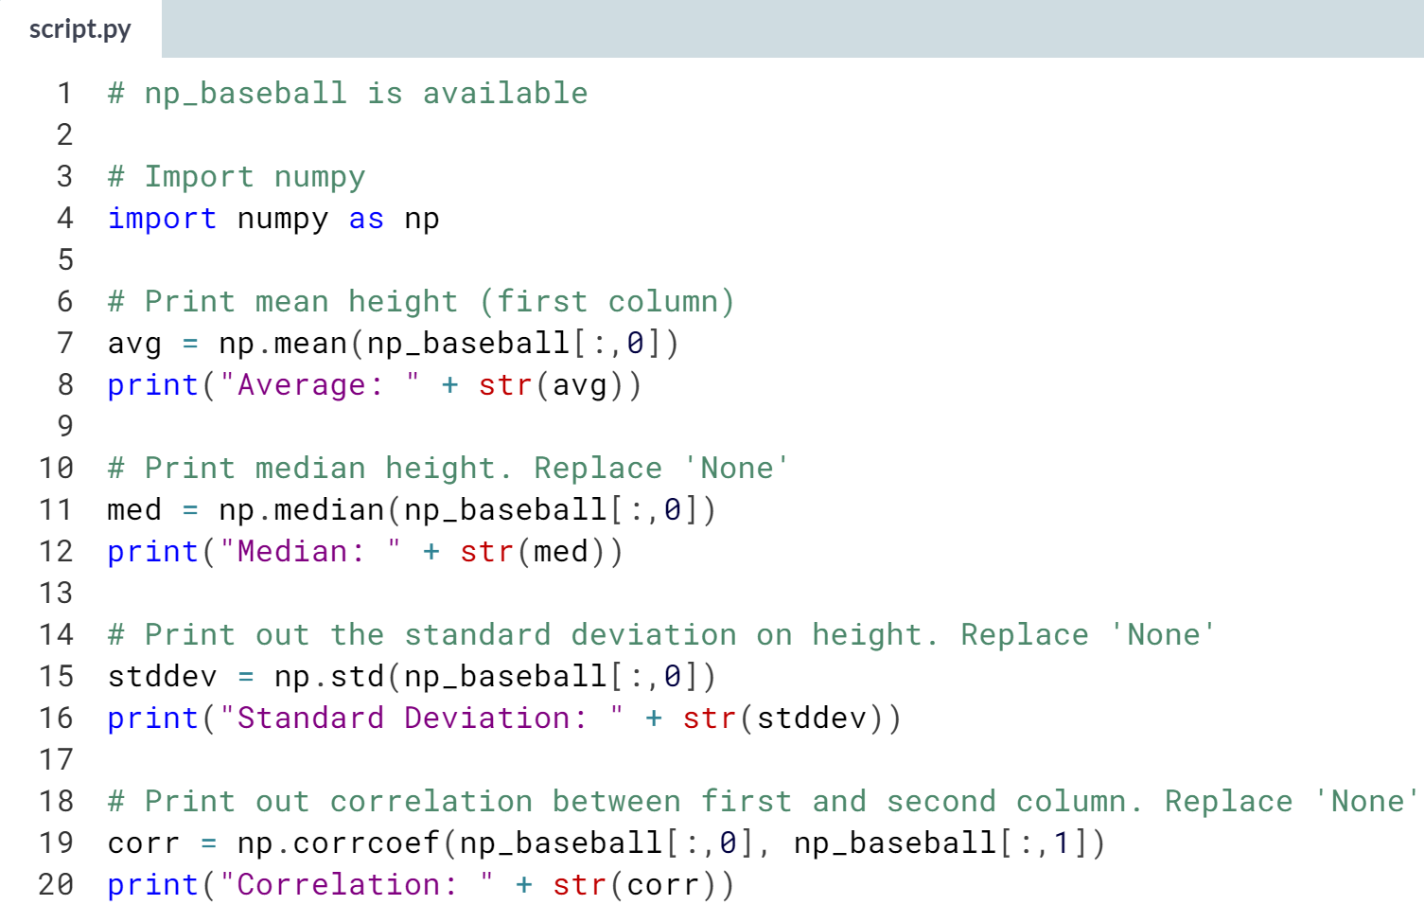  
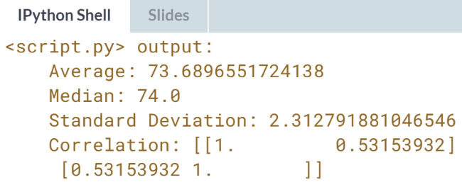Great! Time to use all of your new data science skills in the last exercise!

# Blend it all together

In the last few exercises, you've learned everything there is to know about heights and weights of baseball players. Now it's time to dive into another sport: soccer.

You've contacted FIFA for some data and they handed you two lists. The lists are the following:

positions = ['GK', 'M', 'A', 'D', ...]

heights = [191, 184, 185, 180, ...]

Each element in the lists corresponds to a player. The first list, positions, contains strings representing each player's position. The possible positions are: 'GK' (goalkeeper), 'M' (midfield), 'A' (attack) and 'D' (defense). The second list, heights, contains integers representing the height of the player in cm. The first player in the lists is a goalkeeper and is pretty tall (191 cm).

You're fairly confident that the median height of goalkeepers is higher than that of other players on the soccer field. Some of your friends don't believe you, so you are determined to show them using the data you received from FIFA and your newly acquired Python skills.

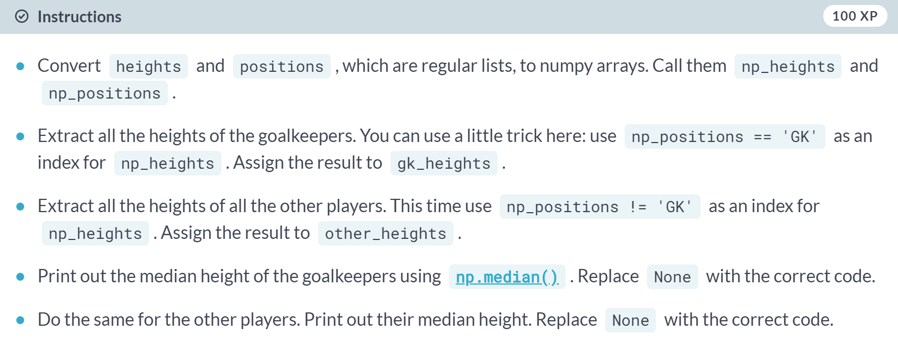

(exercises on the next page)

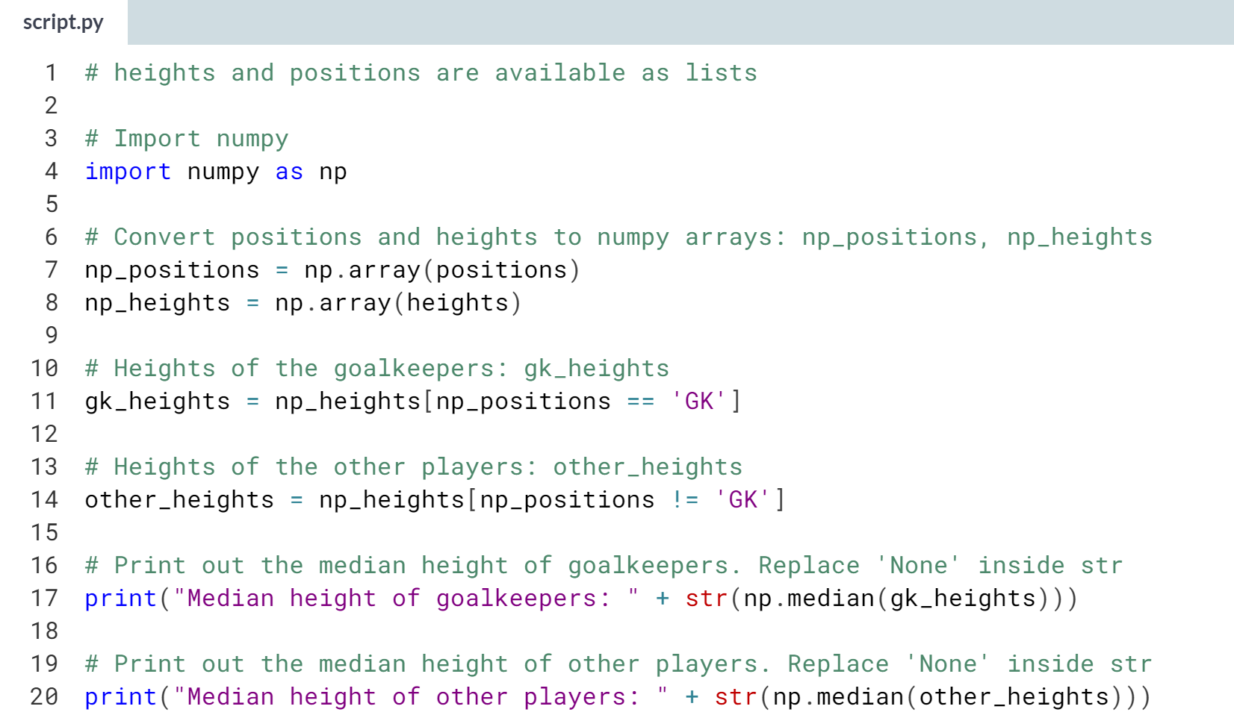

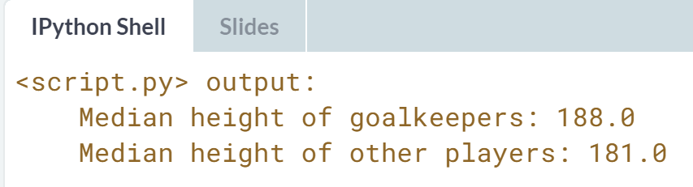

Wonderful! You were right and the disbelievers were wrong! This exercise marks the end of the Intro to Python for Data Science course. See you in another course!